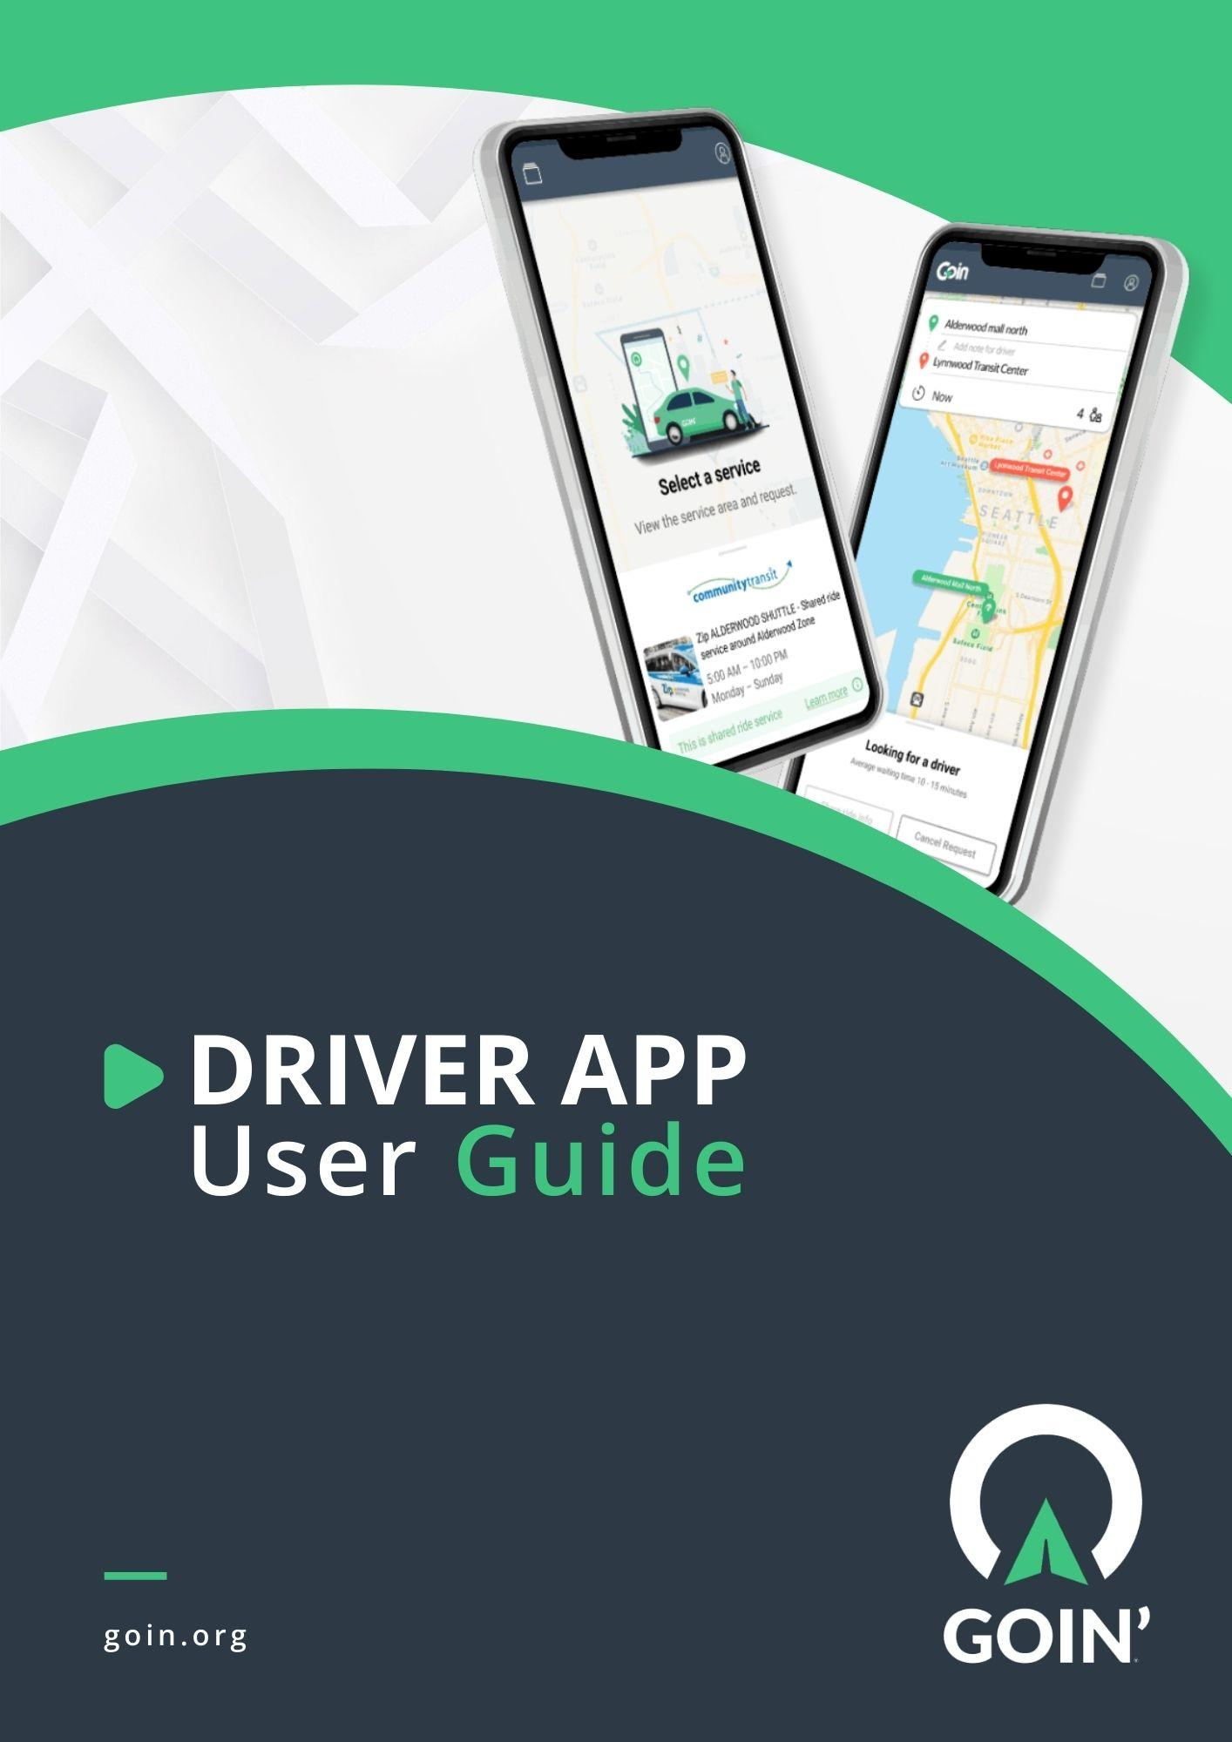
The Goin’ Driver App is intended for Goin’ drivers. The detailed step-by-step instructions below will show drivers how to utilize the GOIN’ Provider app efficiently. This guide also includes Frequently Asked Questions about the app and how it works.
The guide is based on Android Driver App version 2.1.76. Always checkout for updates in Play Store or App Store to optimize the Driver App’s latest features.
Reminder:
After completing the training, open and fill-out this form:
https://forms.gle/rzkGjeb92DNmJTgv6

Table of Contents
Table of Contents 3
Downloading the GOIN’ Provider App 4
Logging-in 6
Accepting On-demand Requests 11
Scheduled Trips 16
Collecting Rider’s Signature 18
Payment Methods 21
Selecting Payment Option 21
Chat Feature 23
Driver Products 25
Cancelled Rides 26
Revenue Page 27
Personal Profile 28
Logging out 29
What is Group Ride? 30
How To Receive and Complete a Group Ride? 30
How To Complete a Scheduled Group Ride? 35
FAQs 36

Downloading the GOIN’ Provider App
1. Open Play Store (for Android users) or Apple Store (for iPhone users) and search for ‘Goin’ Provider’.
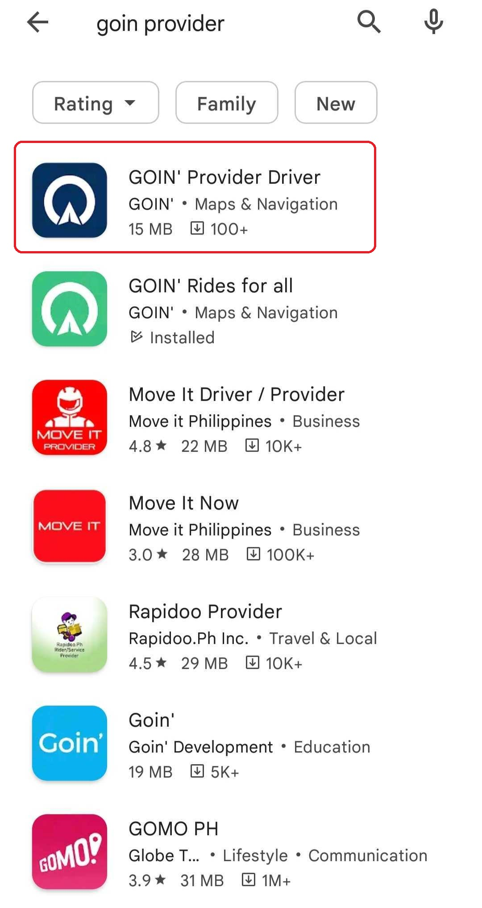
2. Click Install to install the Goin’ Provider app on your phone.
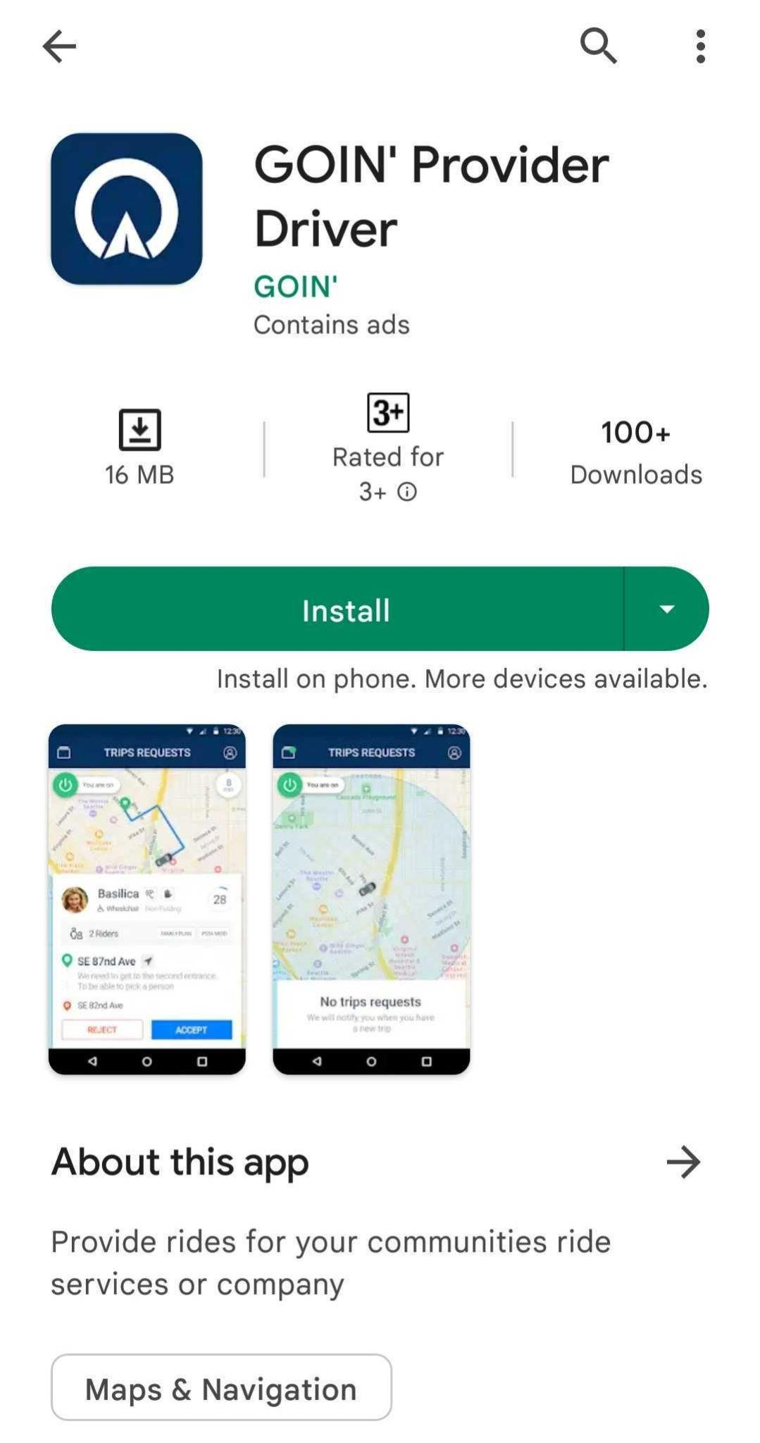

3. Once installed, open the Goin’ Provider app from your phone and you will see the app’s front page.
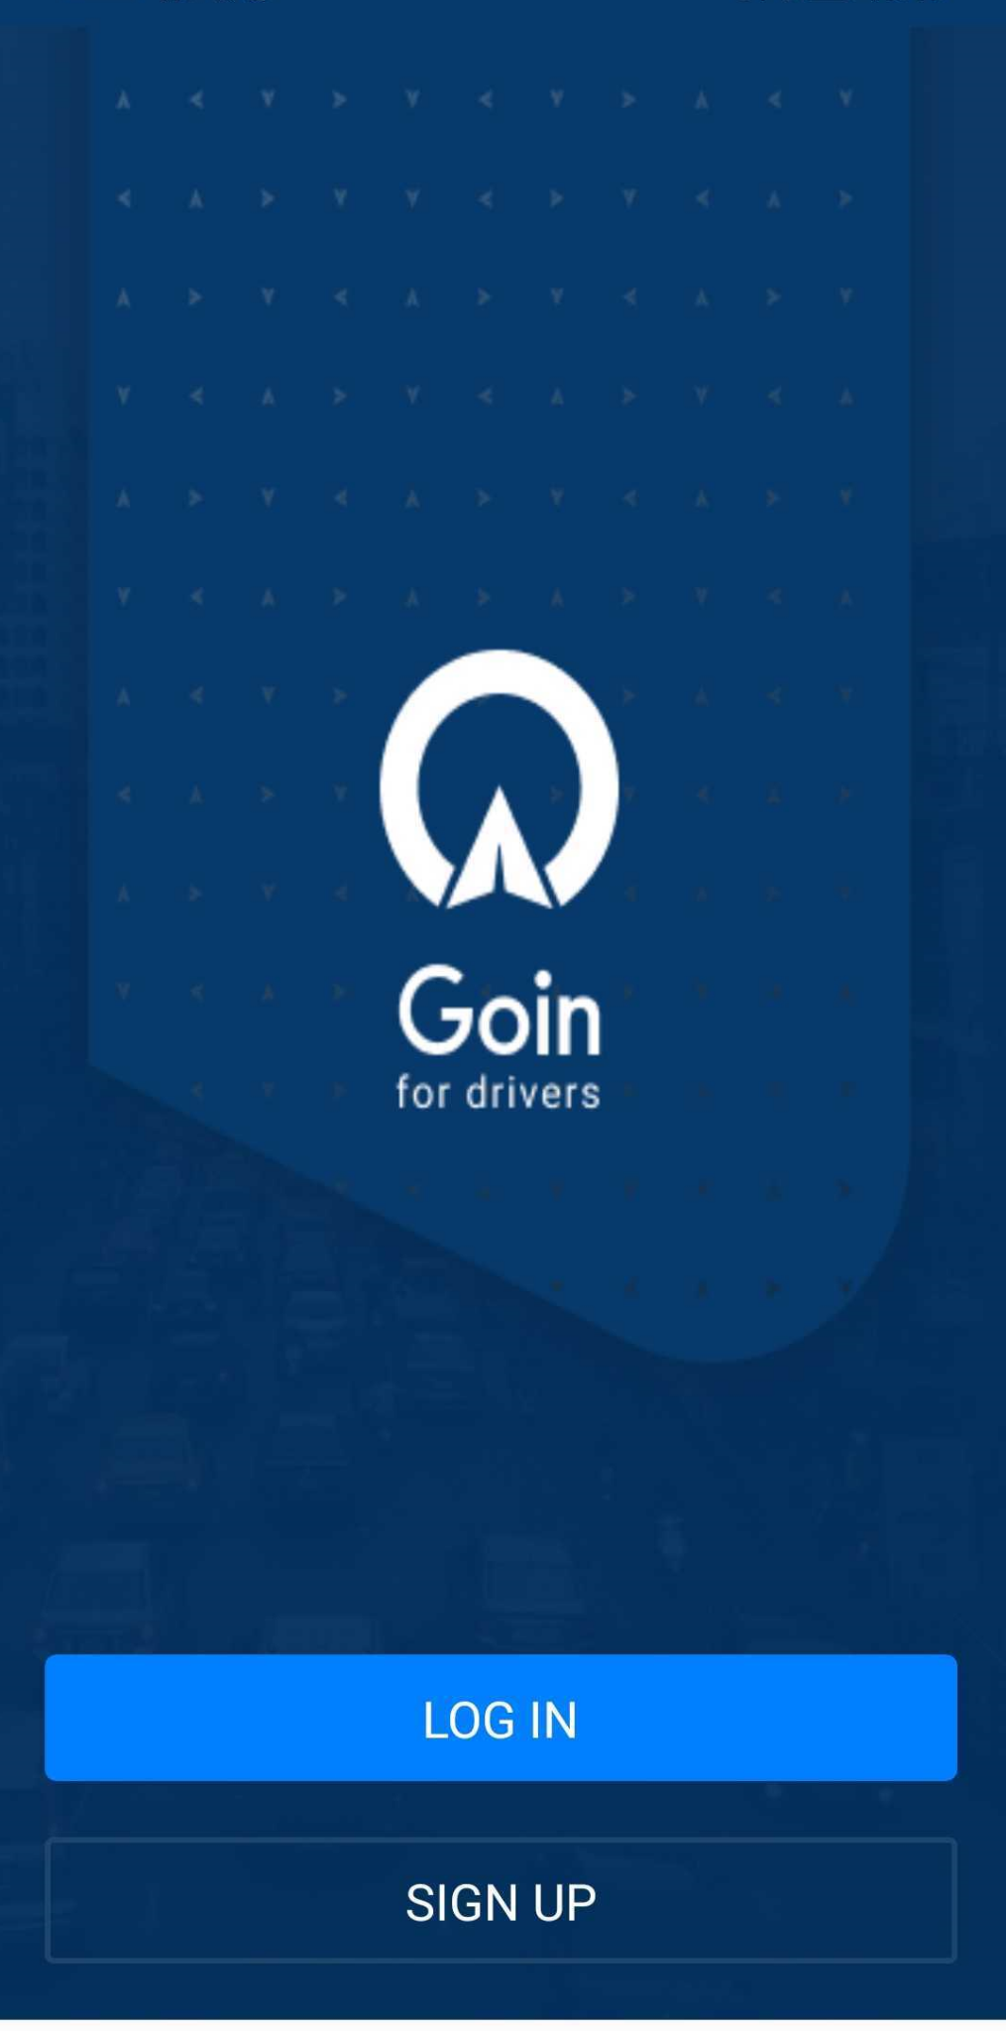

Logging-in
1. Tap Log in on Goin’s front page.
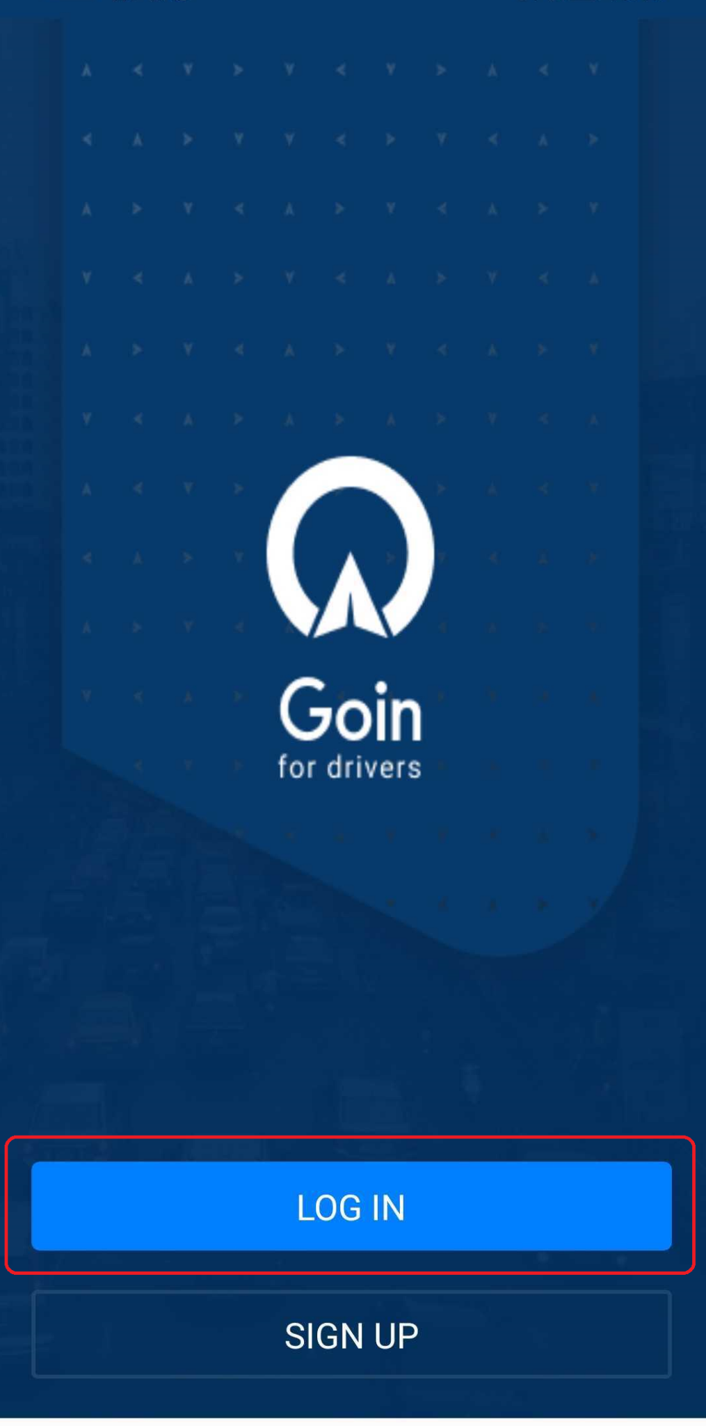
2. To correctly assign trips, Goin’ would need your permission to share your location information. Go through the next page for our Privacy Policy regarding sharing your location information. If you agree, tap Continue.
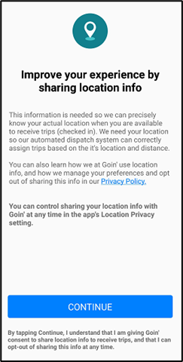
3. Turn on location tracking by tapping Enable Location.
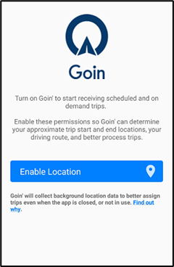
4. After you have been registered in our system, you will receive an email invite from Goin’ to create a password. If you did not get an email, click Forgot password to get an email. Just click send once. Once you have set your password, log-in using your registered email and password. Tap Log-in.
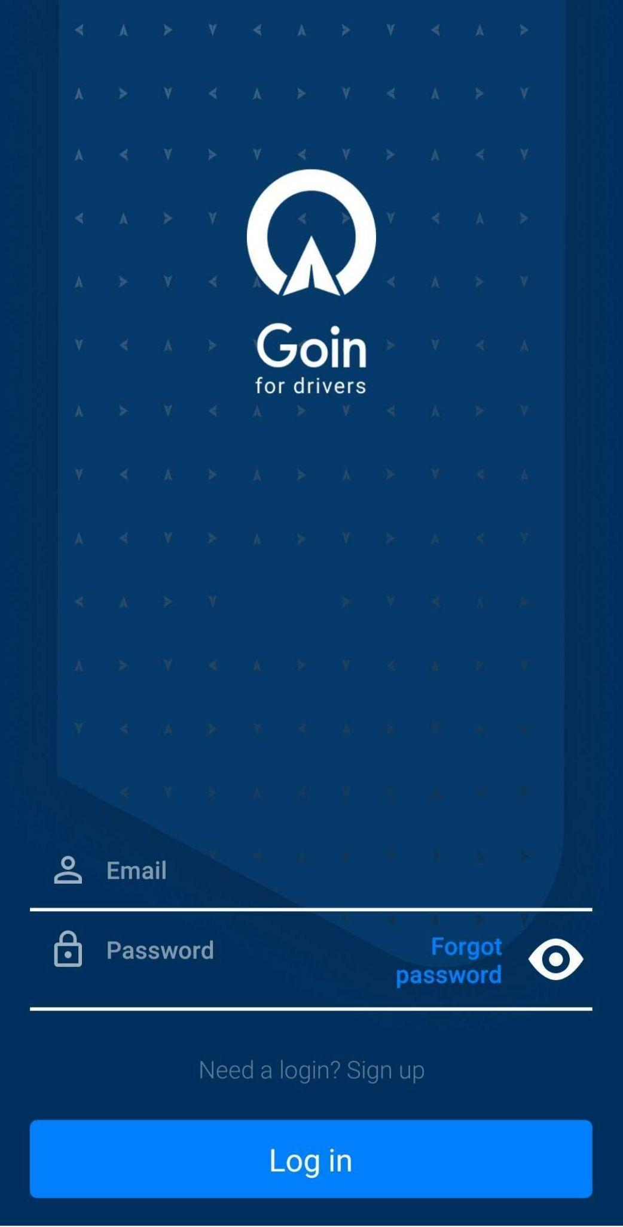
5. Select Medstar as the organization.

6. Select your vehicle by tapping Active Vehicle. Tap Done.
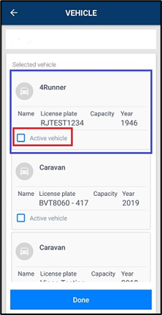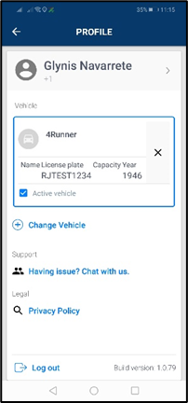
Note: You can search for a vehicle by license plate or vehicle number.
7. Check that your status is online.
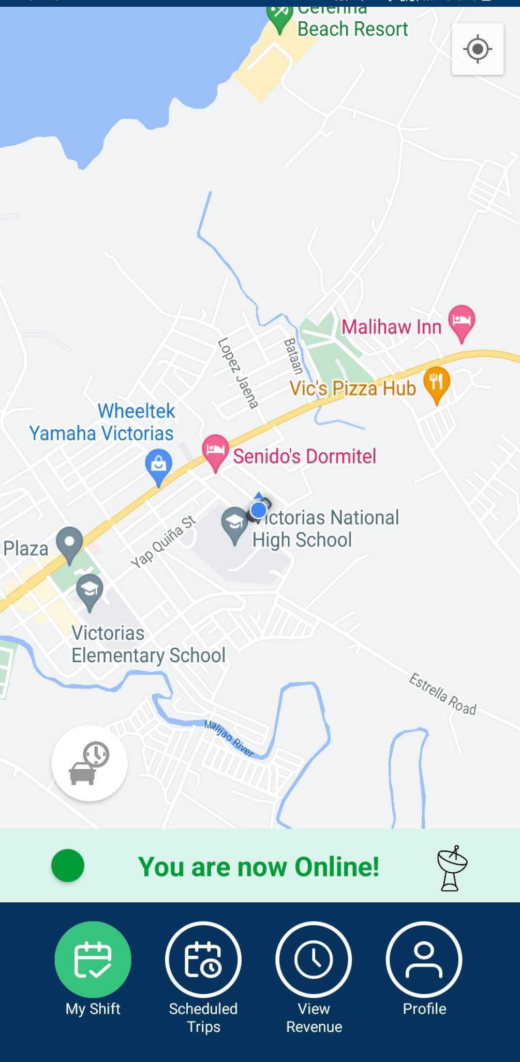
8. If offline, tap the Session button and toggle the Available button to mark yourself as available to receive trip requests.
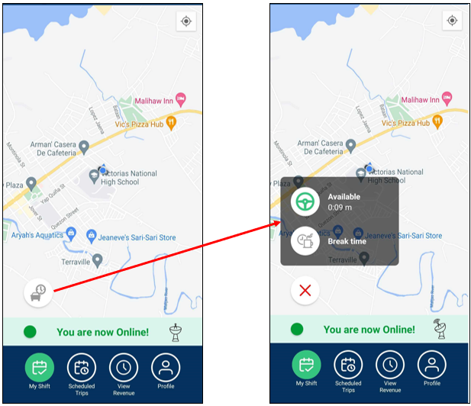
Note: You won’t be able to receive requests if you’re offline.
Session Buttons:
Available - Turns green when activated. Your status will be Online and you will be available to receive new on-demand trips. You will also be able to start the scheduled trips in this mode.
Break - Turns red when activated. This is the time that you are on break and won’t be receiving any trips. You also won’t be able to start the scheduled trips when on break.

Accepting On-demand Requests
Once a customer makes a request, it will go to the nearest driver and then round robin until it is accepted within 15 minutes. If it is not accepted after 15 minutes, the requester gets ‘No Response’.
1. When a request comes in, you have the option to Accept or Reject a trip.
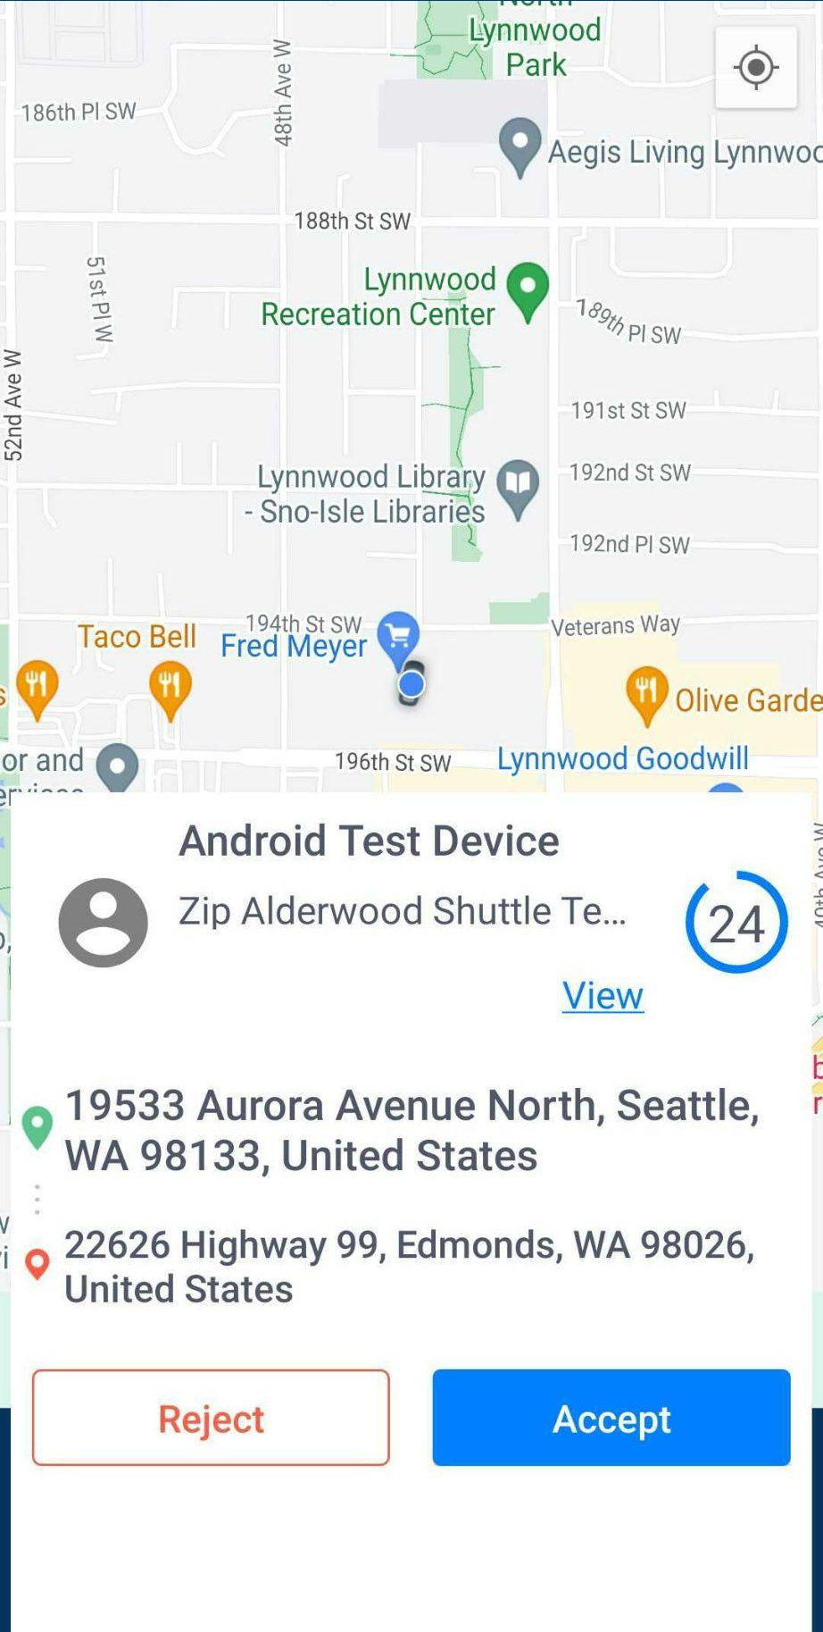
Once you accept a trip, you will see the Arrived at start status in the blue bar below the screen. You will also see the rider and trip details.
To view the type of payment that the rider selected for the trip, tap Payment Method.
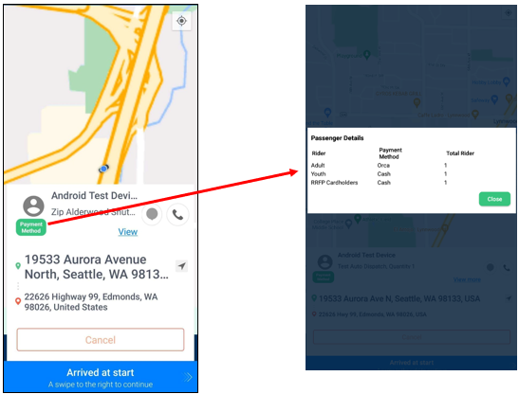
Swipe the blue bar at the bottom once you have parked the vehicle at the pickup location to progress to the next step.
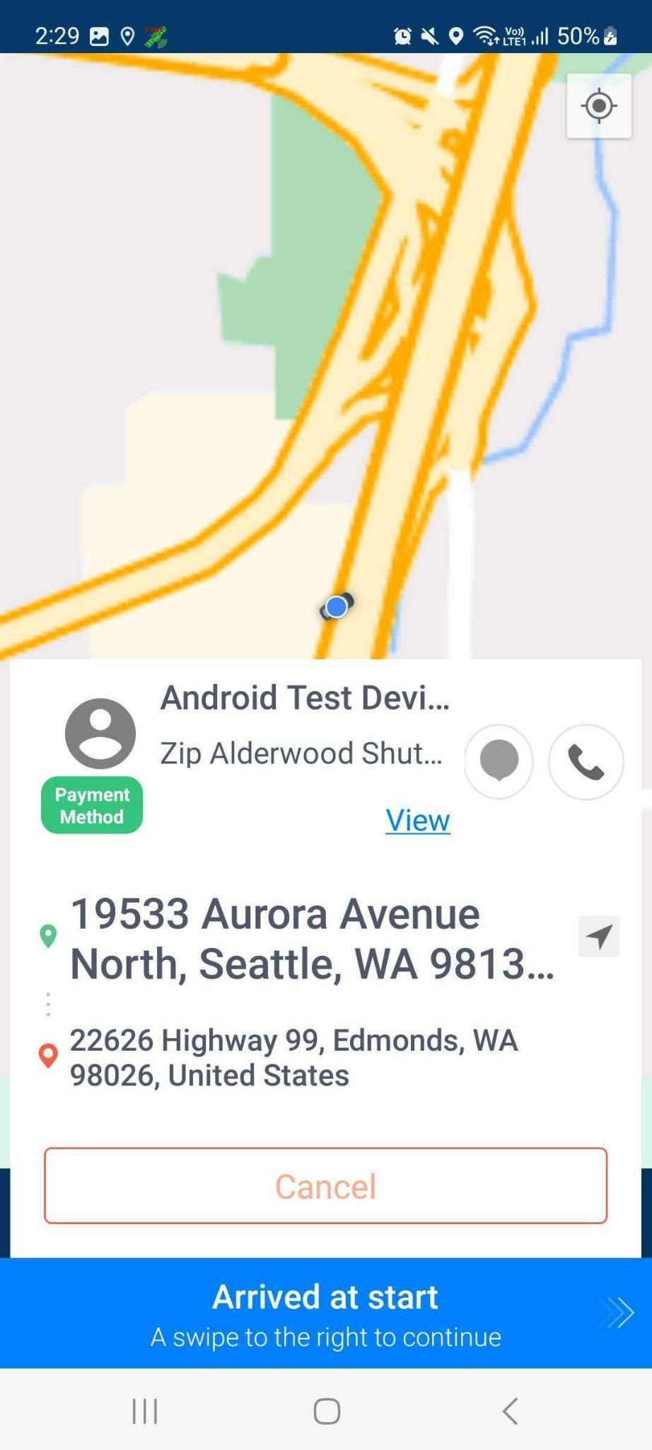
Note: If you must cancel the request, you may choose from the following options or just choose ‘Other’ for a custom note.
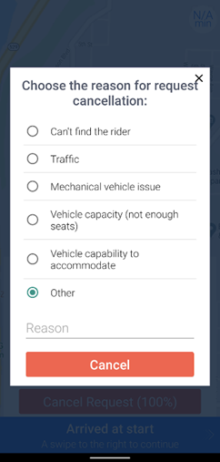
3. The status will change to Picked up. Once you have picked up the rider and you’re about to proceed to the destination, swipe to complete the Picked Up status.
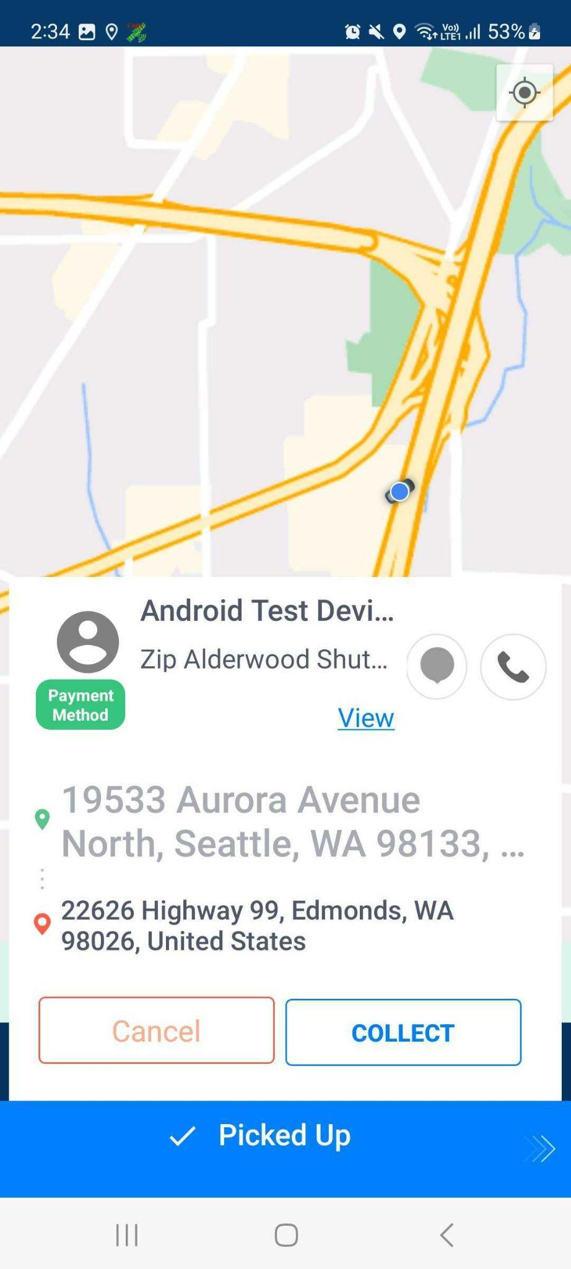
4. Once you have arrived at the destination, swipe the Arrived at destination status.
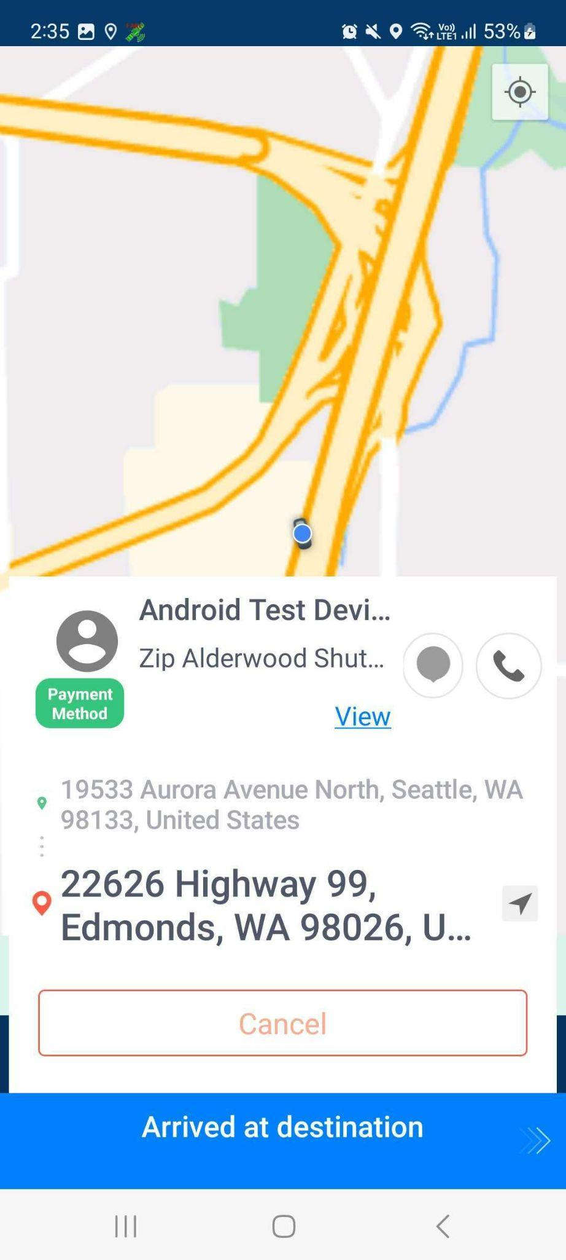
5. The status will change to Completed.
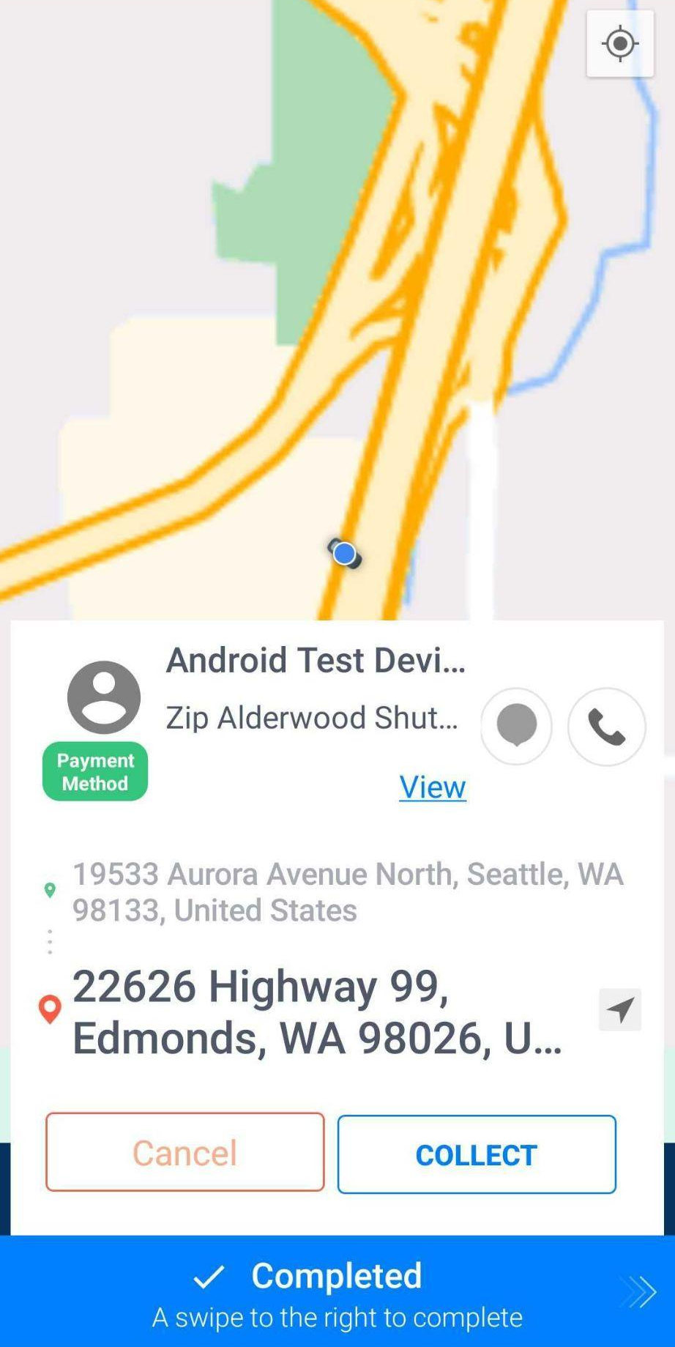
6. After the ride is completed, leave feedback regarding the ride. This will help us improve your ride experience as well as our customers’.
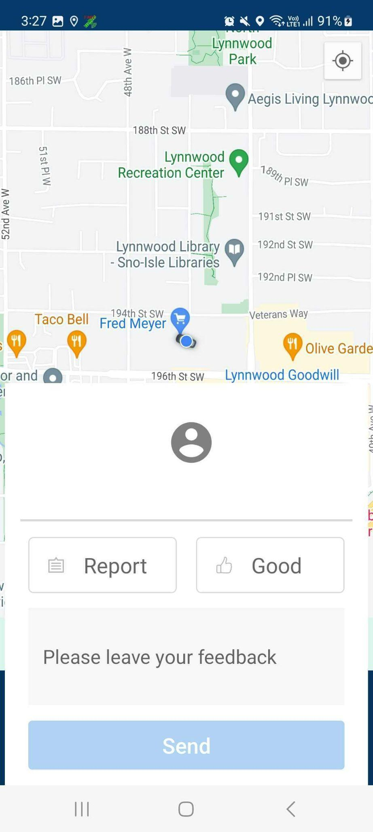

Scheduled Trips
Riders can also book scheduled rides. If scheduled rides have been assigned to you, you can then view the trips in the Scheduled Trips page. To access the Scheduled Trips page, tap the Scheduled Trips icon at the bottom menu of the screen.
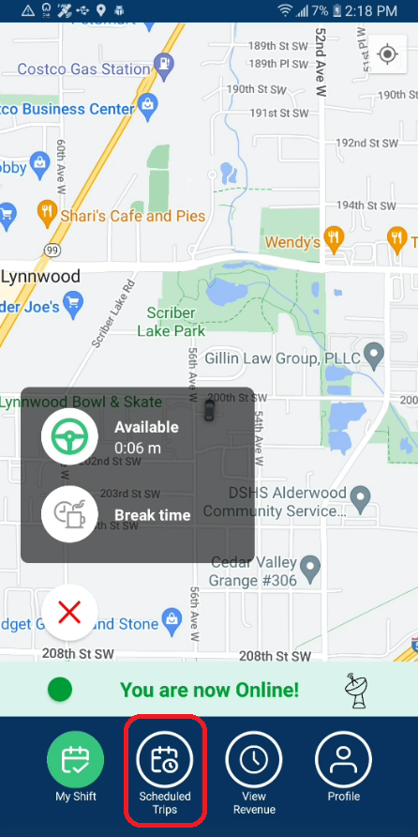
The Scheduled Trips page has two tabs - Trips and Future.
On the Trips tab, you will see the scheduled trips scheduled on the current date. Scheduled trips dated the next day onwards are displayed on the Future tab.
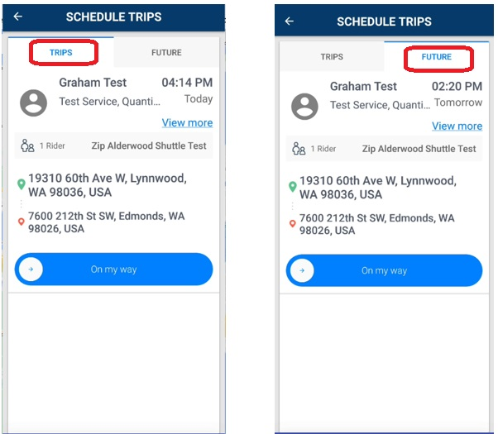
Trip details such as the pickup date and time, pickup and dropoff points, the product to be used, and the total number of riders are displayed for each trip. To view the rider’s notes, tap View more.
If you’re heading off to the pickup location already, swipe the On my way bar. This can only be swiped at least two hours prior to the scheduled pick-up time.
Follow Steps 2-8 of the Accepting On-demand Request section of this document to continue.

Collecting Rider’s Signature
For riders using Modivcare, Access2Care, Paratransit, PFP (Afterhours only) Products, and Yakima Dial-a-Ride services, the signature of the facility representative or the rider must be collected once you have picked up the rider or once you have arrived at the destination.
Once you have picked up the rider, tap the Collect button on the app and tap Rider Signature. If you need to collect the representative’s signature, tap Rep. Signature.
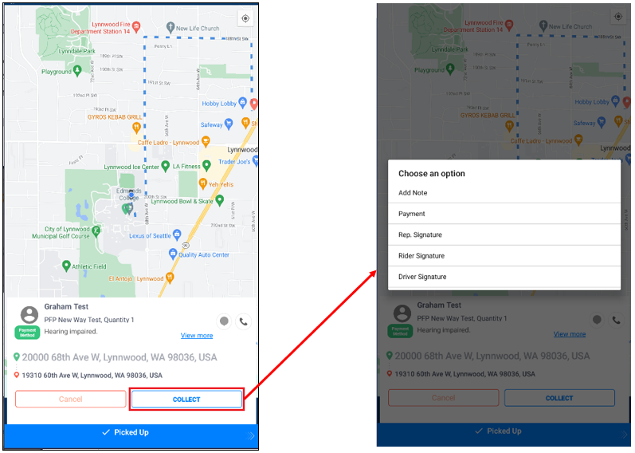
Ask the rider or the facility representative to type their name, draw their signature on the pad, and tap Save. The signature will then be uploaded to our system.

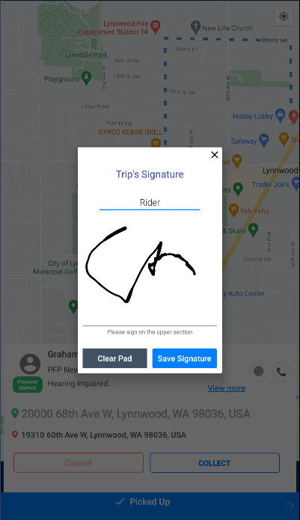
Note: For clients that don’t require the rider or facility representative’s signature, only the Add Note option is displayed when you tap the Collect button.

Driver’s Signature
The driver’s signature can also be collected in the same way. Tap Driver Signature if the driver’s signature is required. Type your name and then write your signature on the pad.

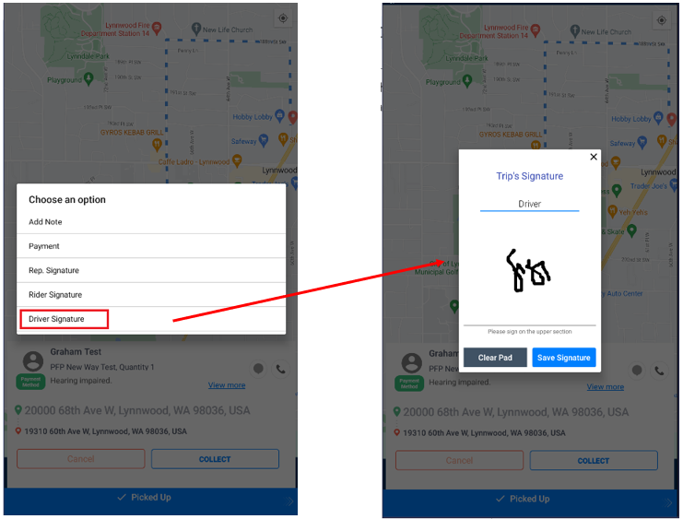

Payment Methods
Goin’ accepts the following payment methods:

- Credit cards
- Debit cards
- Prepaid cards
- ORCA cards
- Cash
- Checks
- Tickets

Notes:
- Electronic payments are processed securely using Stripe.
- Cash or check payments should be turned in to our Service Office. The amount will then be applied to the rider’s Goin’ wallet.

Selecting Payment Option
If riders do not have enough funds in their wallet, there are other payment methods available that they can use for their rides. Drivers can select the payment method according to the rider’s preference in the Driver App.

The payment method can be selected either after the ride status has changed to Picked Up or Completed. The Collect button will be displayed.
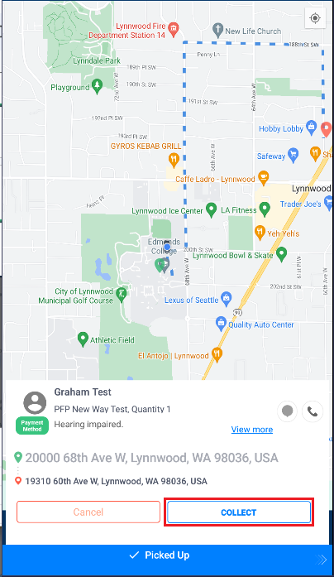
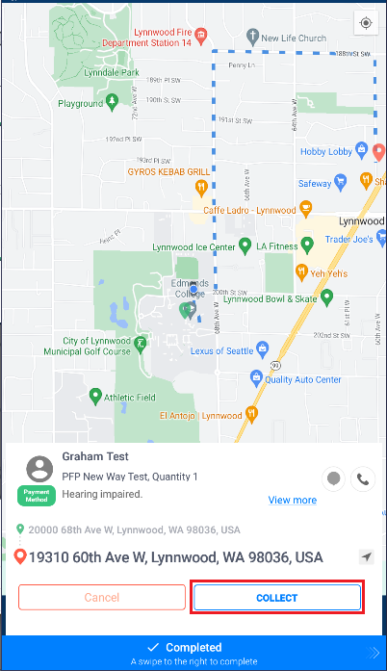

Tap Collect and tap Payment. Select the payment method to be used for the ride.

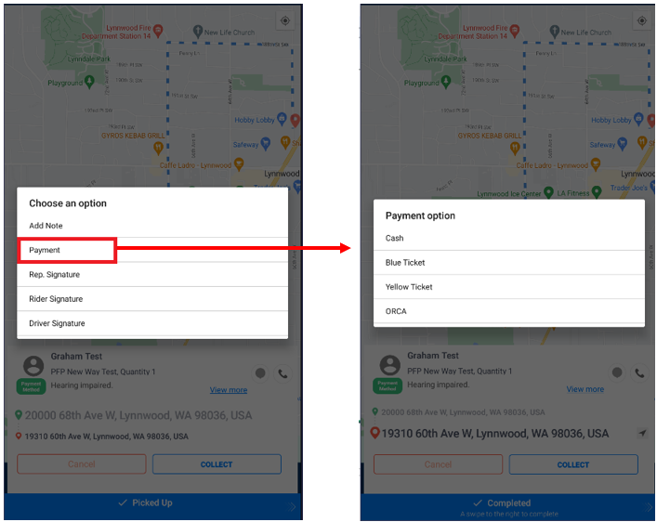

Chat Feature
Goin’s Driver App has a built-in chat function that allows drivers to send a chat message to the rider. This bridges the gap between the rider - driver communication.

To send a chat to the rider, tap the chat icon on the screen.

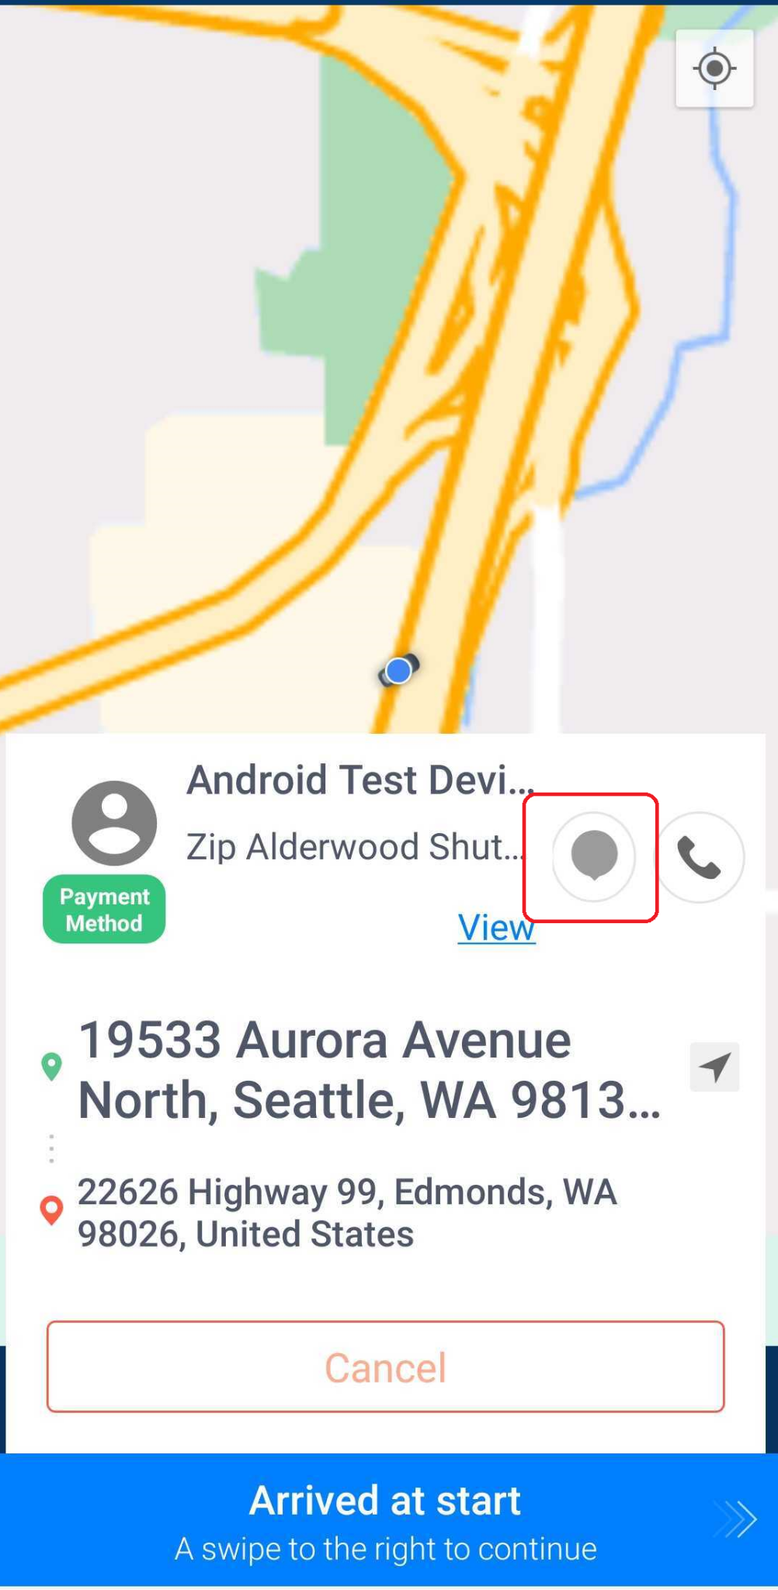

Type your message once the chat screen opens and press send.

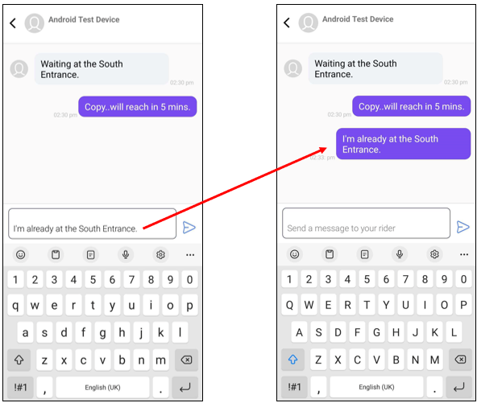

Likewise, the rider can send you a message. When you see a red dot on the chat icon, that means that you have a message from the rider. Tap the chat icon to view the message.

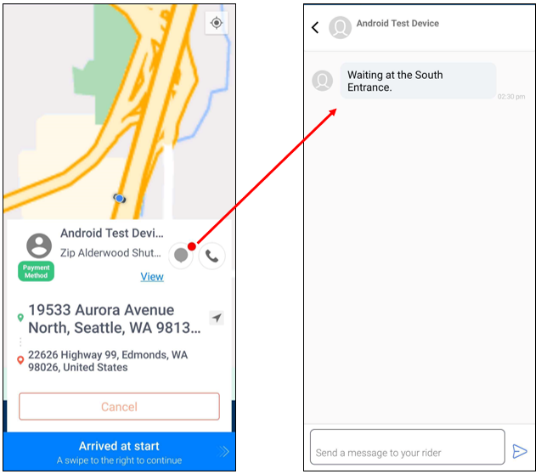

Driver Products
The products that drivers cater to would depend on the products that the vehicle currently assigned to them supports. Therefore, drivers will only receive trips that use the products that their current vehicle caters to.

The products that the vehicle supports can be viewed or edited from Goin’s web-based Management Platform (Radar).

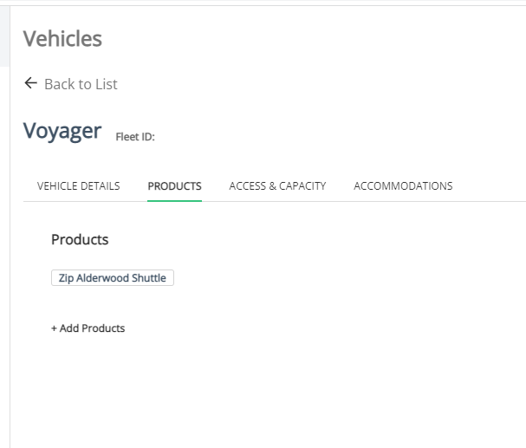

Cancelled Rides
If the rider cancels the ride through the app or the dispatcher through the web app, you will get this notification.
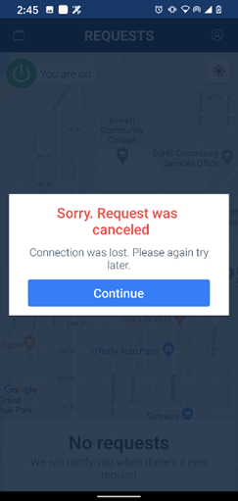
Also, if another driver accepts a trip first before you, a similar message will notify you that another driver has already accepted the request.

Revenue Page
The revenue page tracks the driver’s clock-in, clock-out, and break sessions during their shift. It also shows the driver’s total checked-in time. The report can be generated as a PDF file. To access the revenue page, tap the View Revenue button at the bottom menu on the home screen.
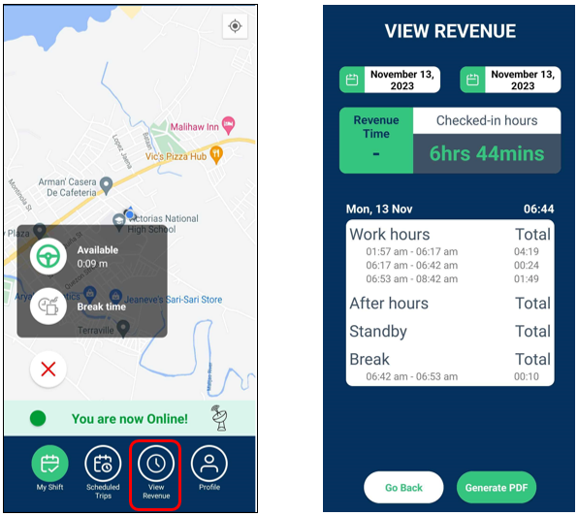

Personal Profile
To access your personal profile, tap the profile icon in the upper right-hand corner of the screen.
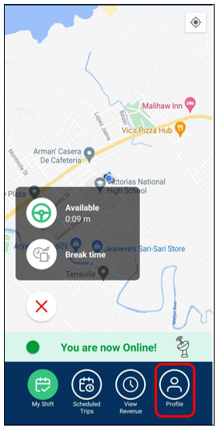
From the personal profile page, you can check your current vehicle, change your vehicle, chat with Customer Support and view Goin’s Privacy Policy.
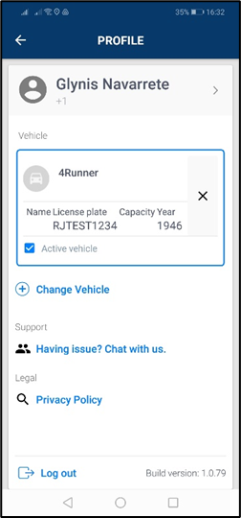

Logging out
Once you’re done with your shift, you can Log-out of the app from the personal profile page. Click the X icon to the right of the vehicle description, this will check you out of the vehicle for the day.
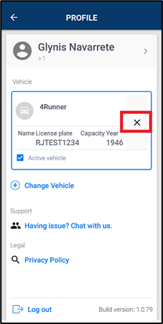
Then tap Log out at the bottom left of the screen.

Group Ride Step-by-Step Guide (Driver App)

What is Group Ride?
Group Ride is a Goin’ feature that allows a service to enable sharing a single ride with multiple trip requests. The number of trip requests that can be accepted by a single group ride depends on the vehicle’s capacity. The pick-up locations of the trip requests should be within the specified radius of the service with the first trip request as the reference point. Likewise, the drop-off locations should also be within the specified radius of the service with the first trip request as the reference point. The group ride will be dispatched to the nearest available driver.
Note: This guide is using Goin’s Driver App version 2.1.56 for Android.

How To Receive and Complete a Group Ride?
- Once a group ride is received, tap the ‘Accept’ button. If the group ride cannot be accepted at the moment, tap the Reject button.
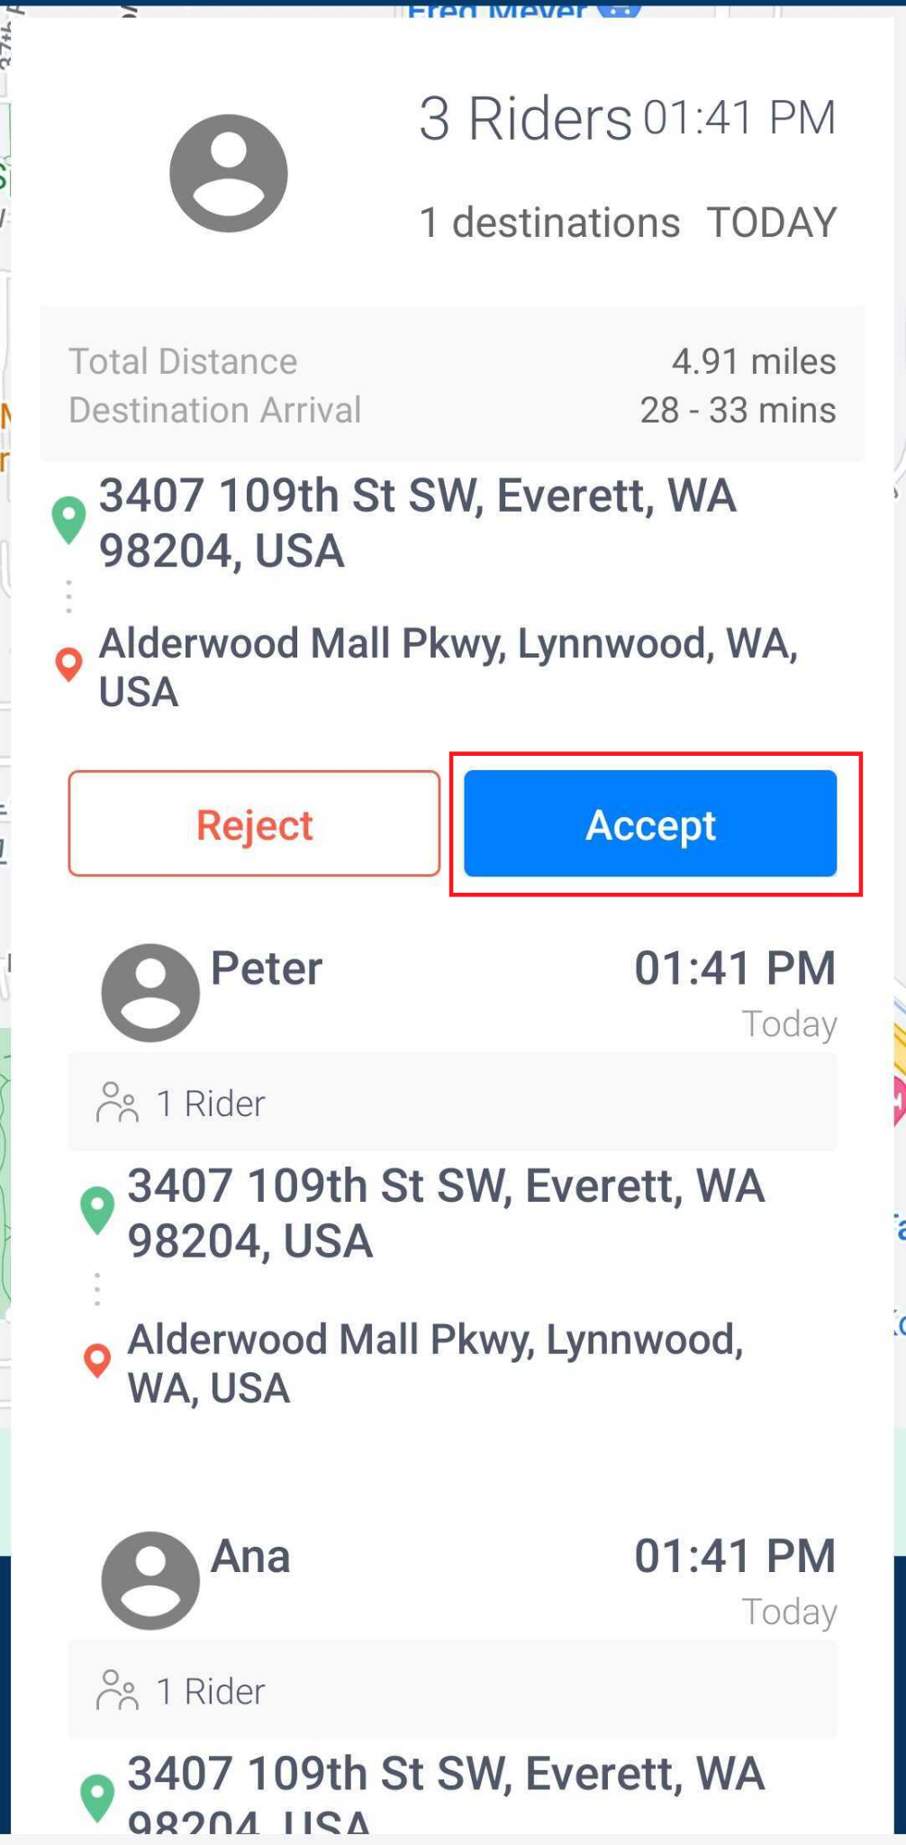
- After accepting the group ride, tap the ‘Start’ button to start driving to the first rider’s pick-up location.
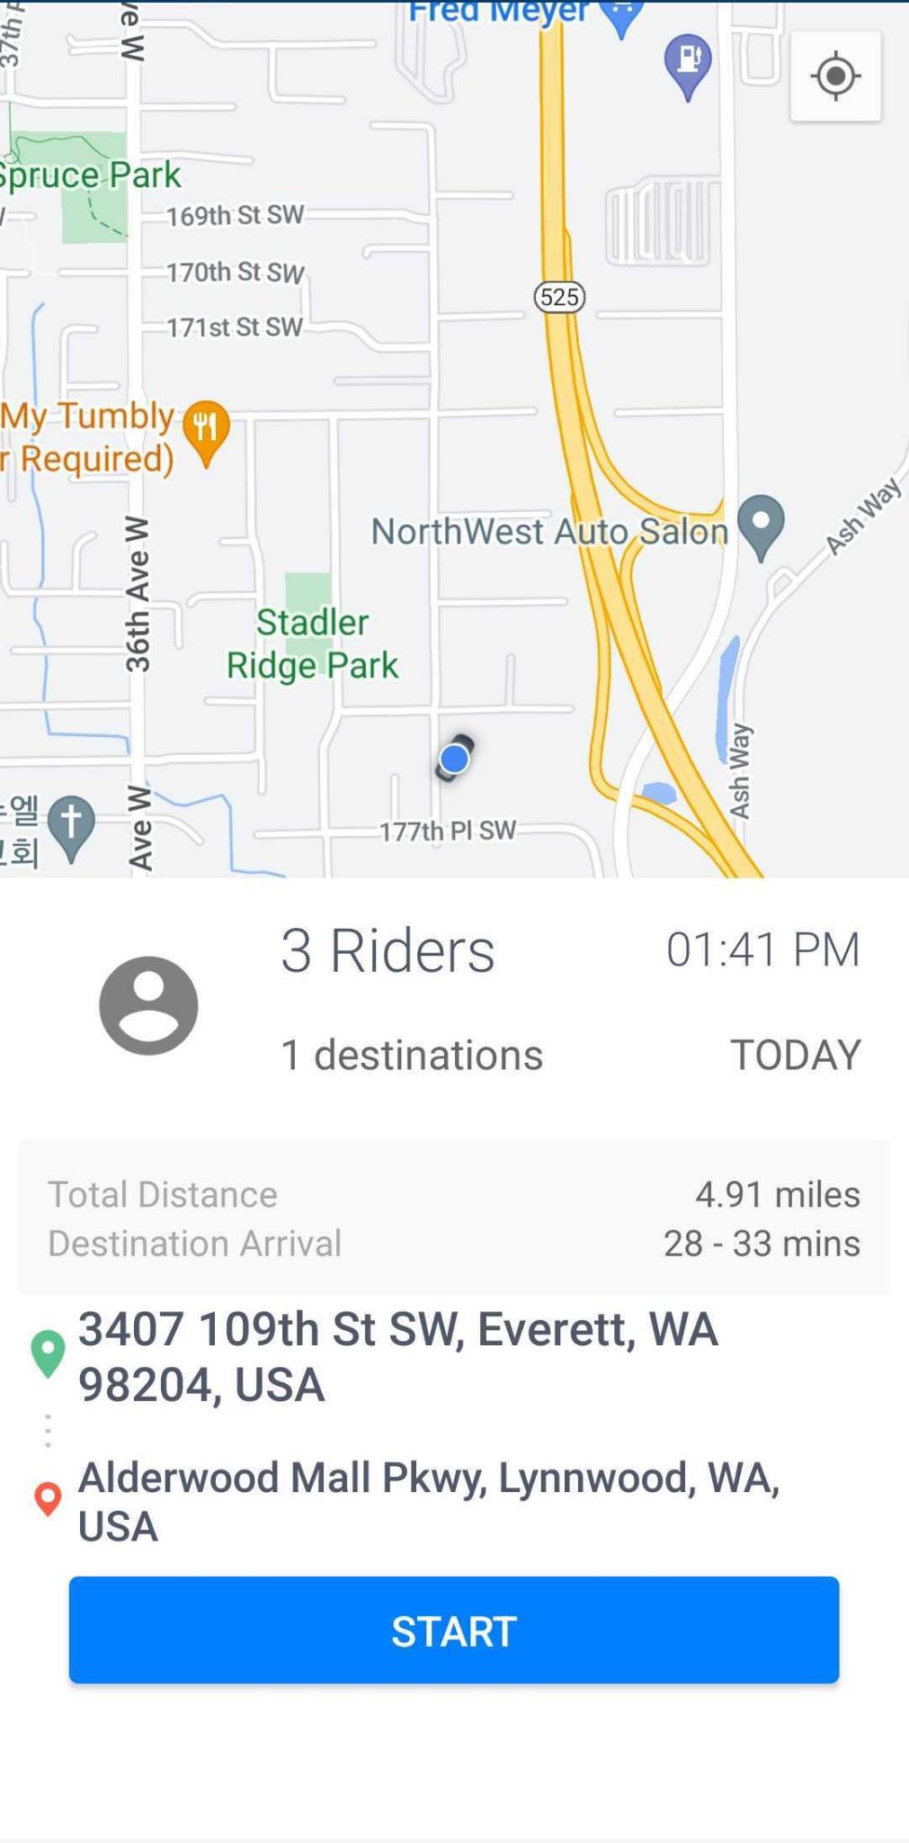
- Once you have arrived at the first rider’s pick-up location, swipe Arrived at Start at the bottom of the interface.
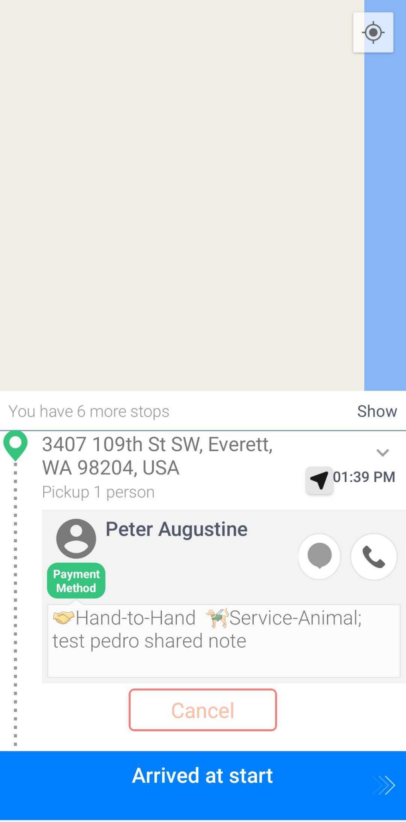
Note: You can view each ride’s location details by tapping Show at the top right of the user interface. To return to the group ride interface, tap Hide.
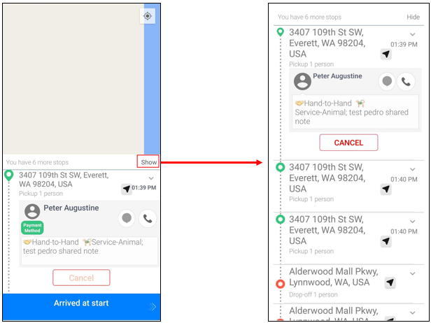
- Once the rider has been picked-up, swipe Picked Up at the bottom of the user interface.
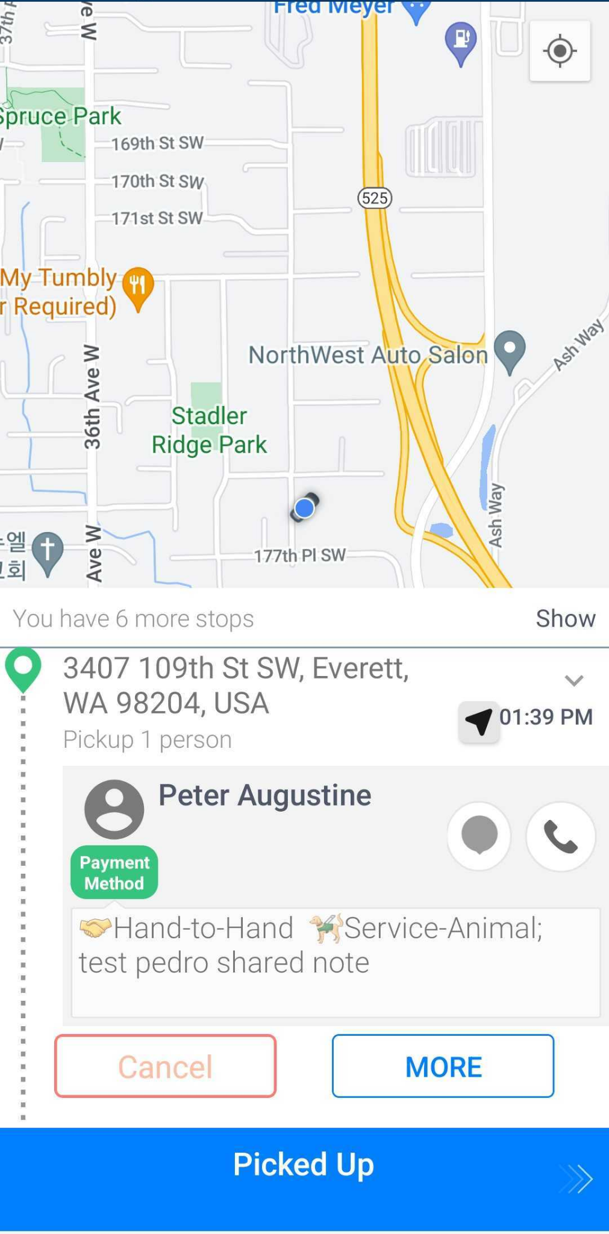
- Repeat Steps 3-4 to pick-up the remaining riders.
- After picking up all the riders, swipe Driving to Destination to drive the first rider off to the drop-off location.
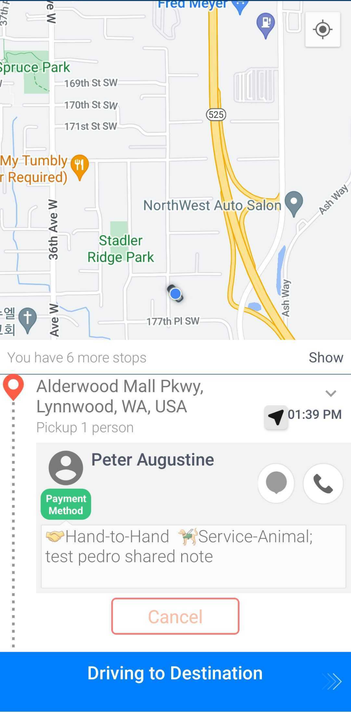
- Swipe Arrived at destination after reaching the first rider’s drop-off location.
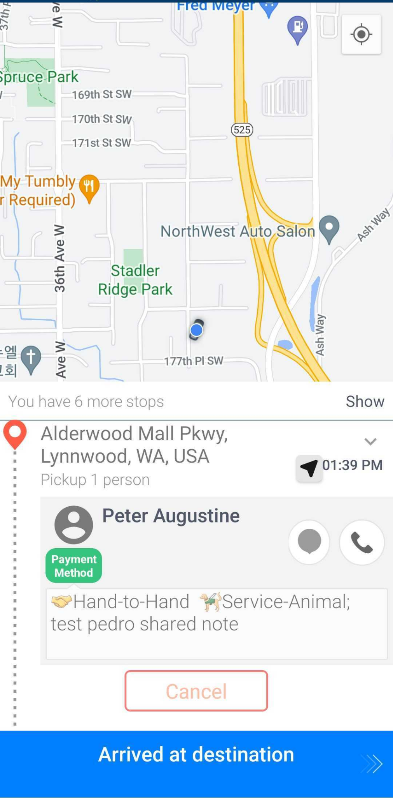
- Once the rider has been dropped off, swipe Completed.
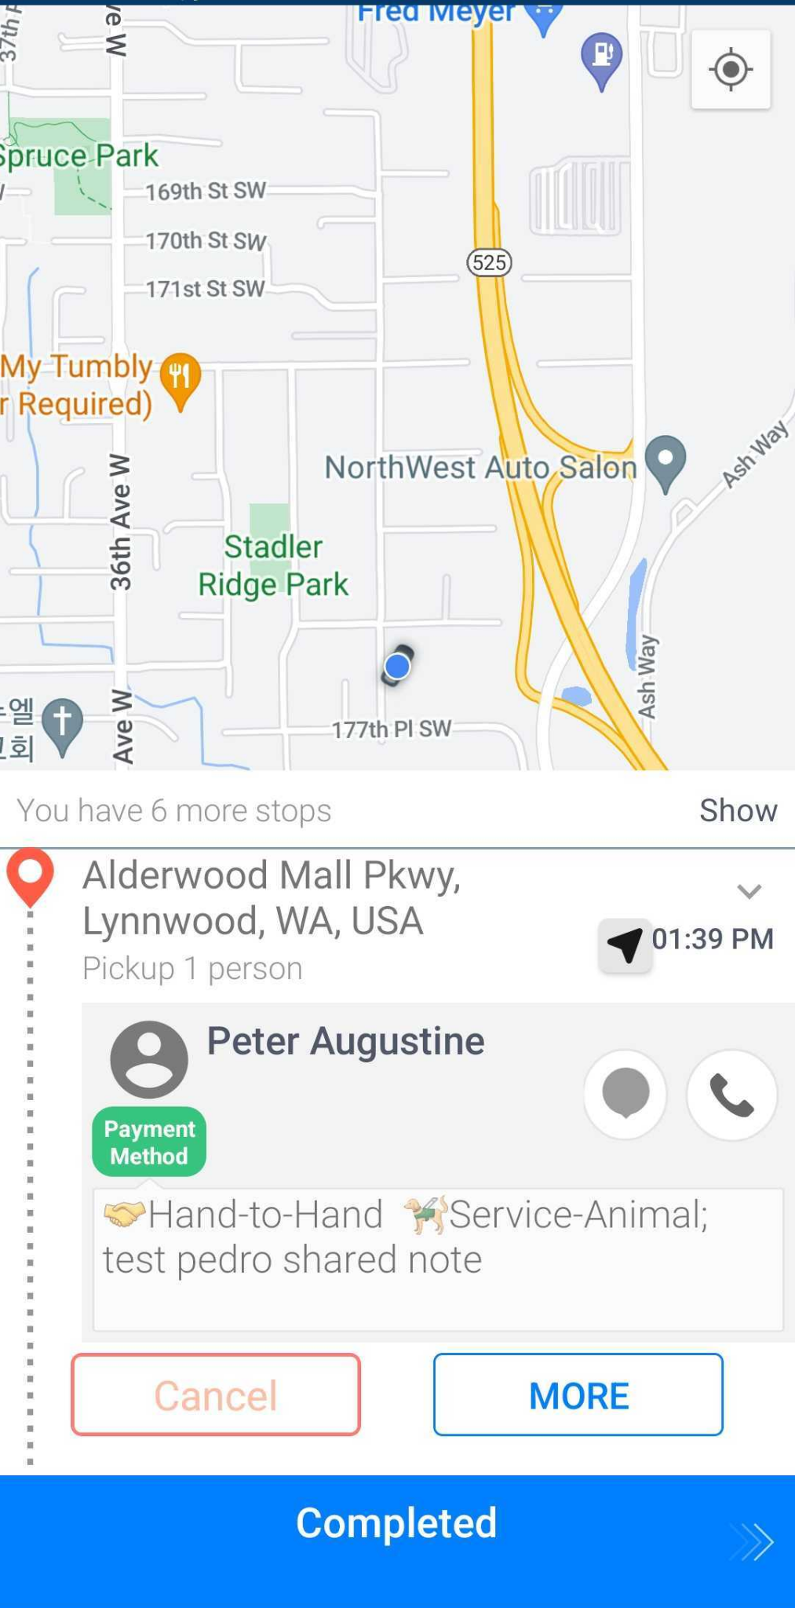
- Repeat steps 6-8 to drop off the remaining riders to their drop off locations.
- After completing the group ride, rate each trip. For positive ratings, tap the Good button, otherwise, provide feedback by tapping Report.
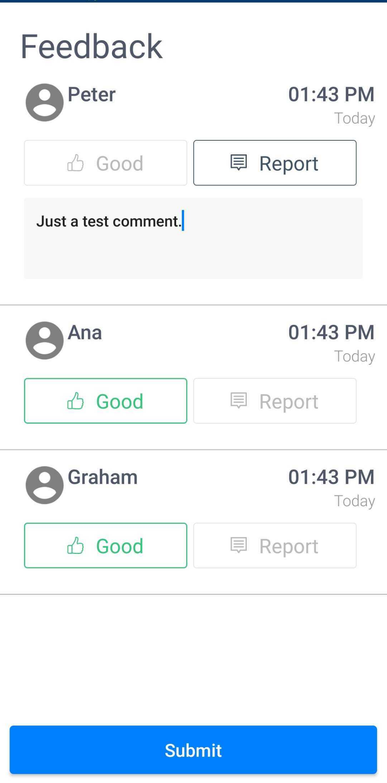
- Tap Submit to close the group ride.

How To Complete a Scheduled Group Ride?
Group rides for scheduled trips are done through imported trips. The same rules apply as in on-demand trips except that only a maximum of three passengers per group ride is allowed for scheduled group rides. After the trips have been imported to Goin’s Radar, the trips are grouped according to the products, the pick-up and drop-off locations’ radii, the date and time of pick-up and drop-off, and the total number of passengers. The trips will then be assigned to a driver. Once assigned, drivers can see the trips on the Scheduled Trips page of the driver app.

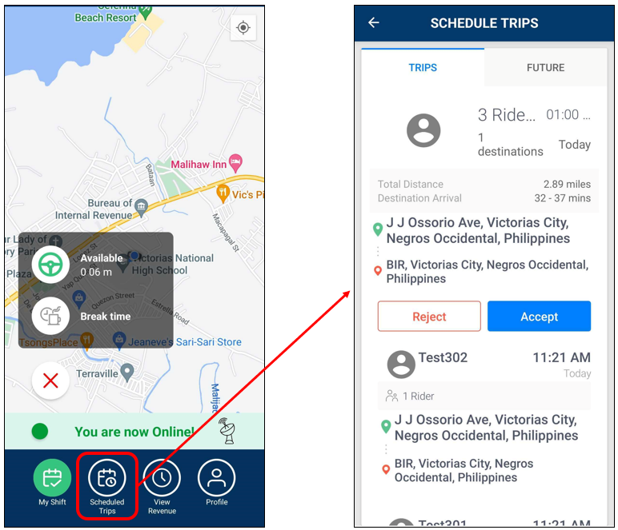
Scheduled group rides can only be started at least two hours prior to the earliest pick-up time in the group ride. To start the group-ride, tap ‘Accept’. After tapping ‘Accept’, follow the steps discussed in the ‘How To Receive and Complete a Group Ride (On-demand trips)?’ section of this guide to complete it.

FAQs
How does the GPS track my location?
The GPS works when you Check-in and turns off when you Check out. You’ll see a button in the app that says Check-in and Check-out. When you first login to the app you will be prompted to share your location. You need to allow location all the time in the background so we can get the GPS when you are driving to a trip or destination.

