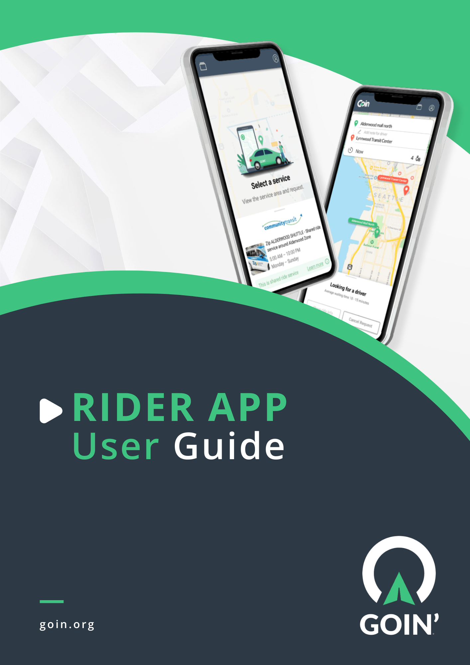
This guide is intended for new and existing customers of GOIN’. The detailed step-by-step instructions below will show riders how to utilize the GOIN’ Rider App efficiently.

The guide is based on Android Rider App version 1.2.60. Always checkout for updates in Play Store or App Store to optimize the Rider App’s latest features.

Table of Contents

Downloading the Goin’ Rider App 4
Signing Up 6
Logging-in 11
Requesting an On-demand Ride 16
Cancelling a Trip 25
Favorite/Saved Locations 26
Nearby Places 30
Chat Feature 31
Payment Methods 33
Confirmation Texts 33
Status Updates 35
Feedback 41
Checking Scheduled Rides 42
Personal Profile 43
Trip History 44
Favorite Locations 44
Notification Type 45
Marketplace 46
Wallet & Payment 47
Payment Method 50
Customer Support 50
Logging Out 51

Downloading the Goin’ Rider App

- Open Play Store (for Android users) or Apple Store (for iPhone users) and search for Goin’.

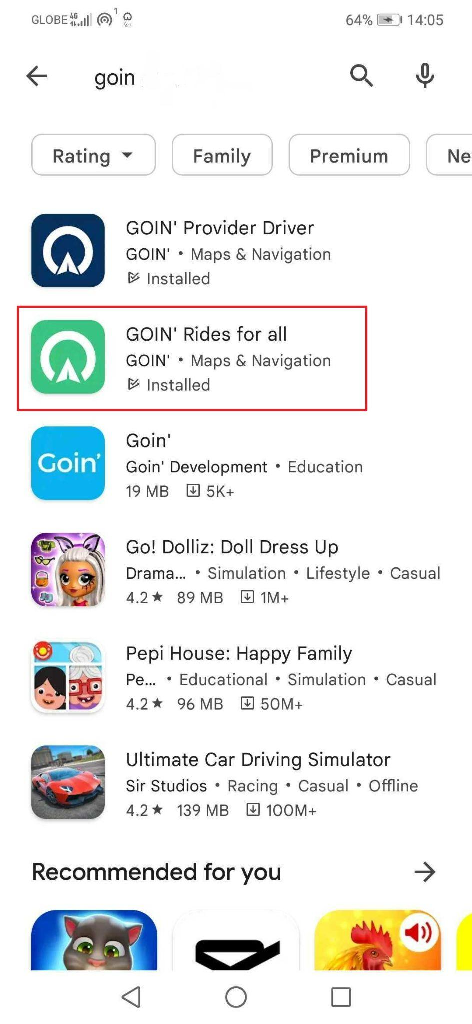

- Click Install to install the Goin’ Rider App on your phone.

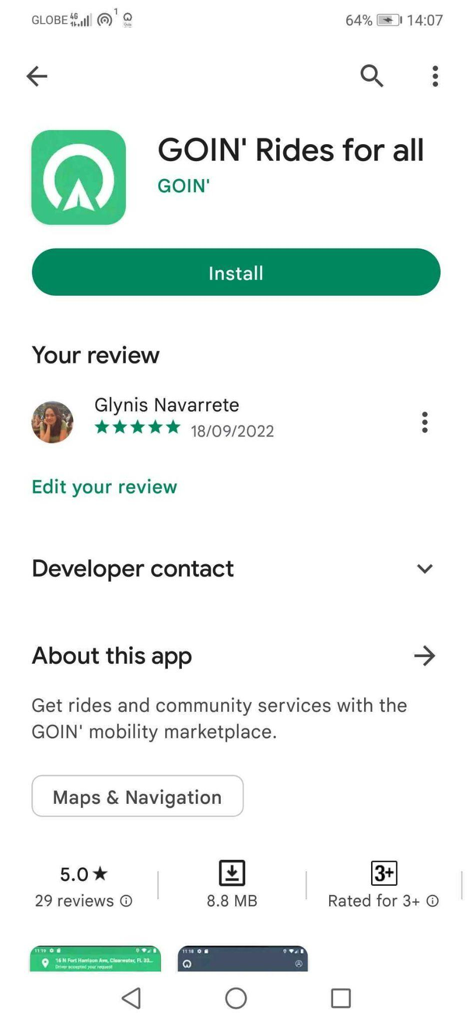

- Once installed, open the Goin’ Rider App from your phone and you will see Goin’s front page.

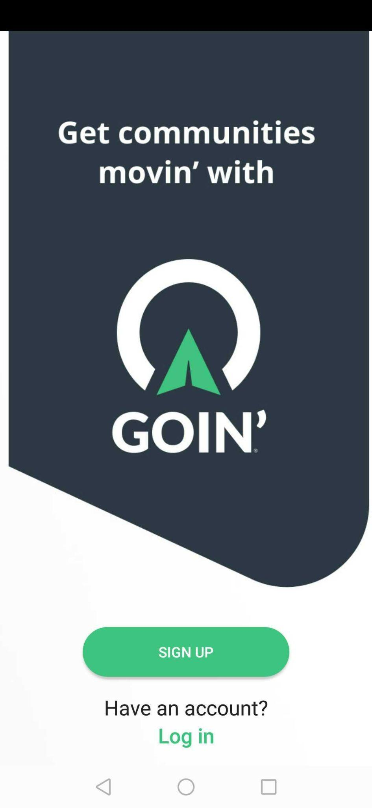

Signing Up

Riders can register an account through Goin’s Rider App.
- To start the registration process, tap Sign Up on the app’s front page.
- Next, you will have an overview of the Rider App’s features. Tap Sign Up once you reach the last slide.
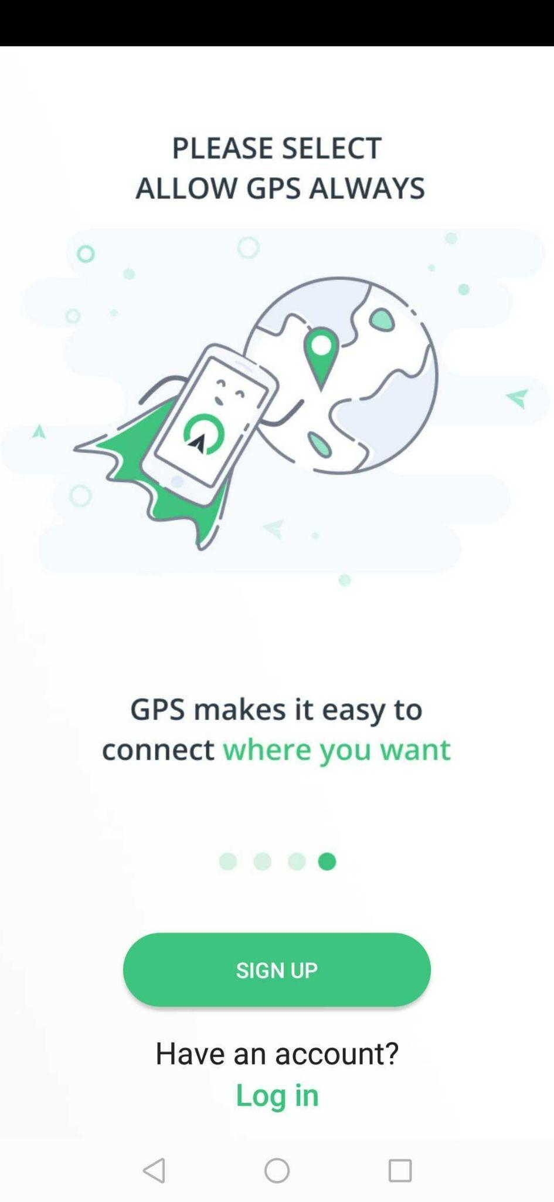
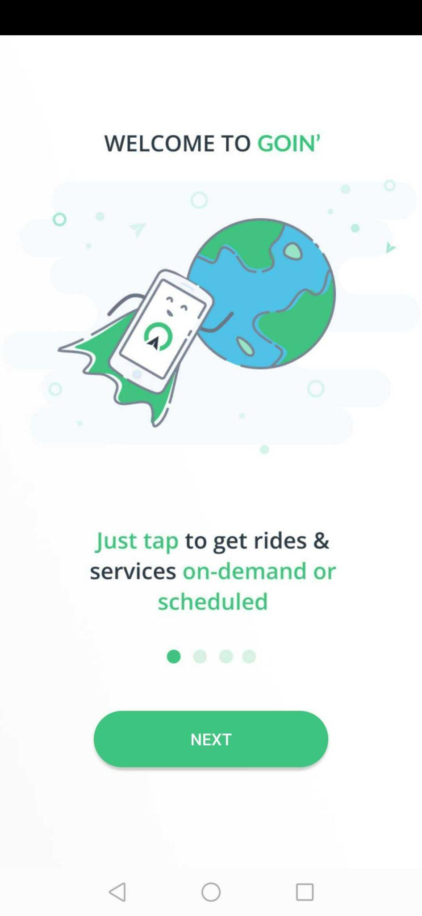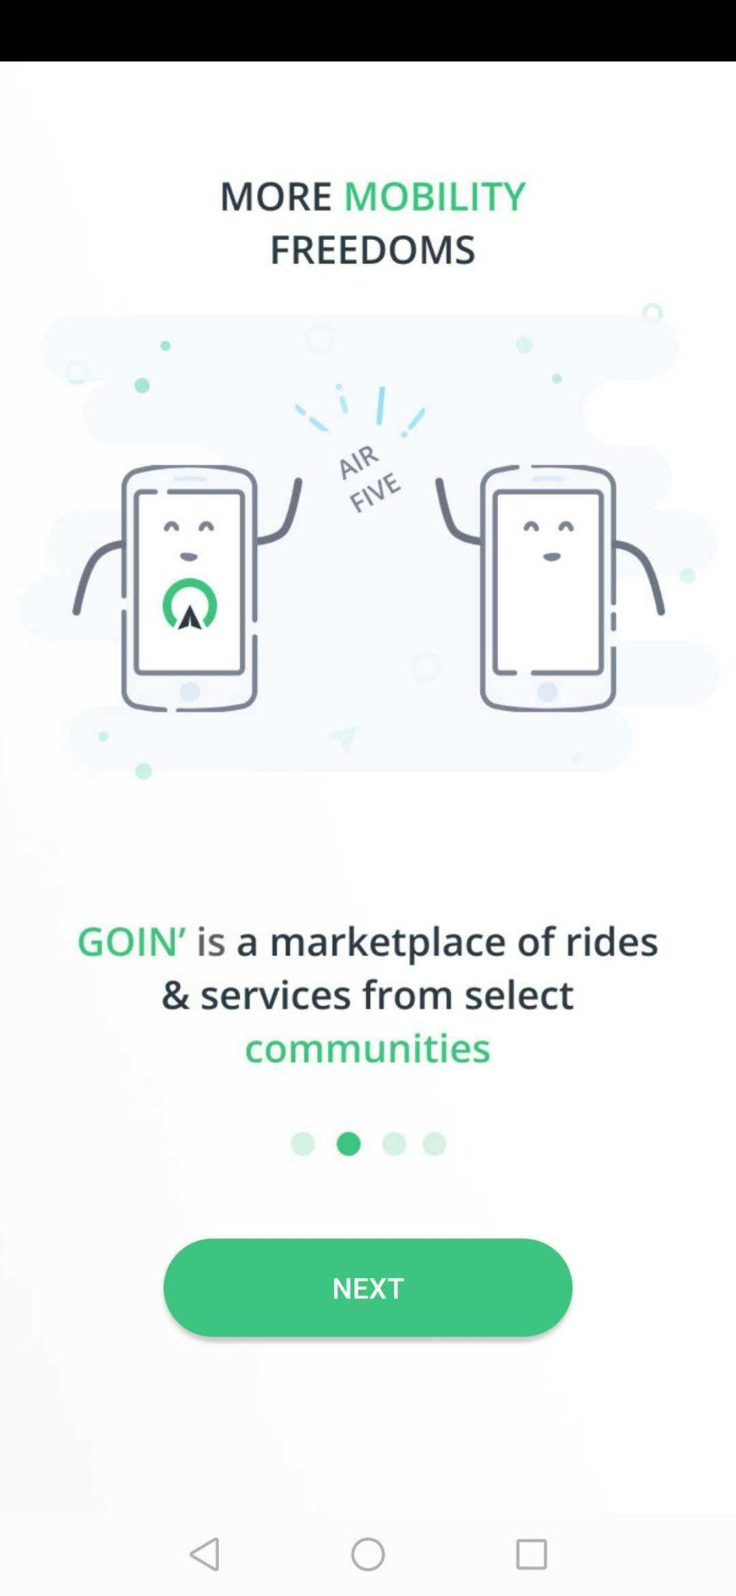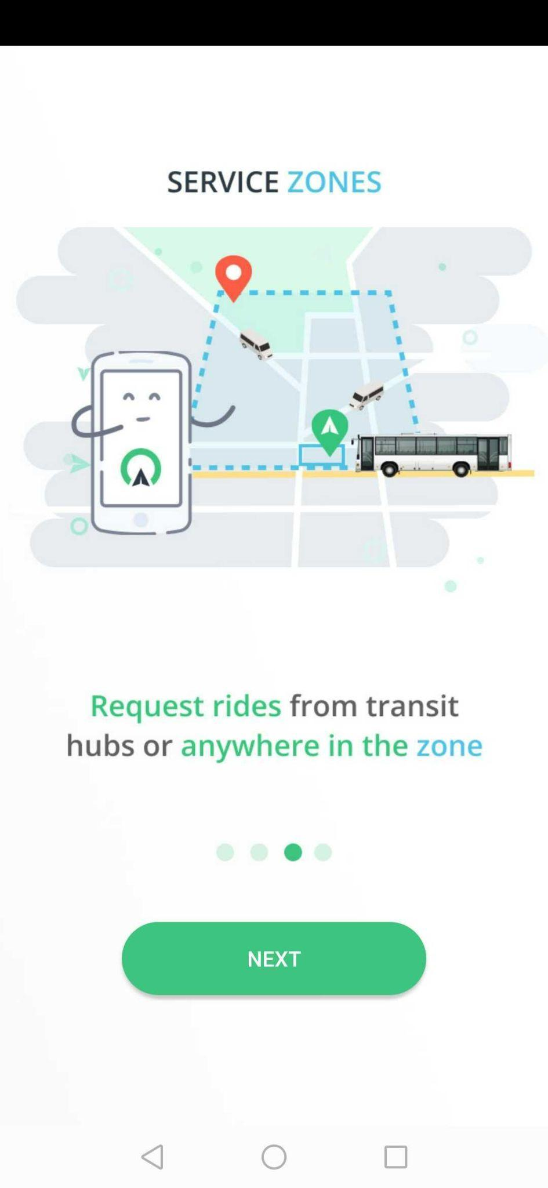
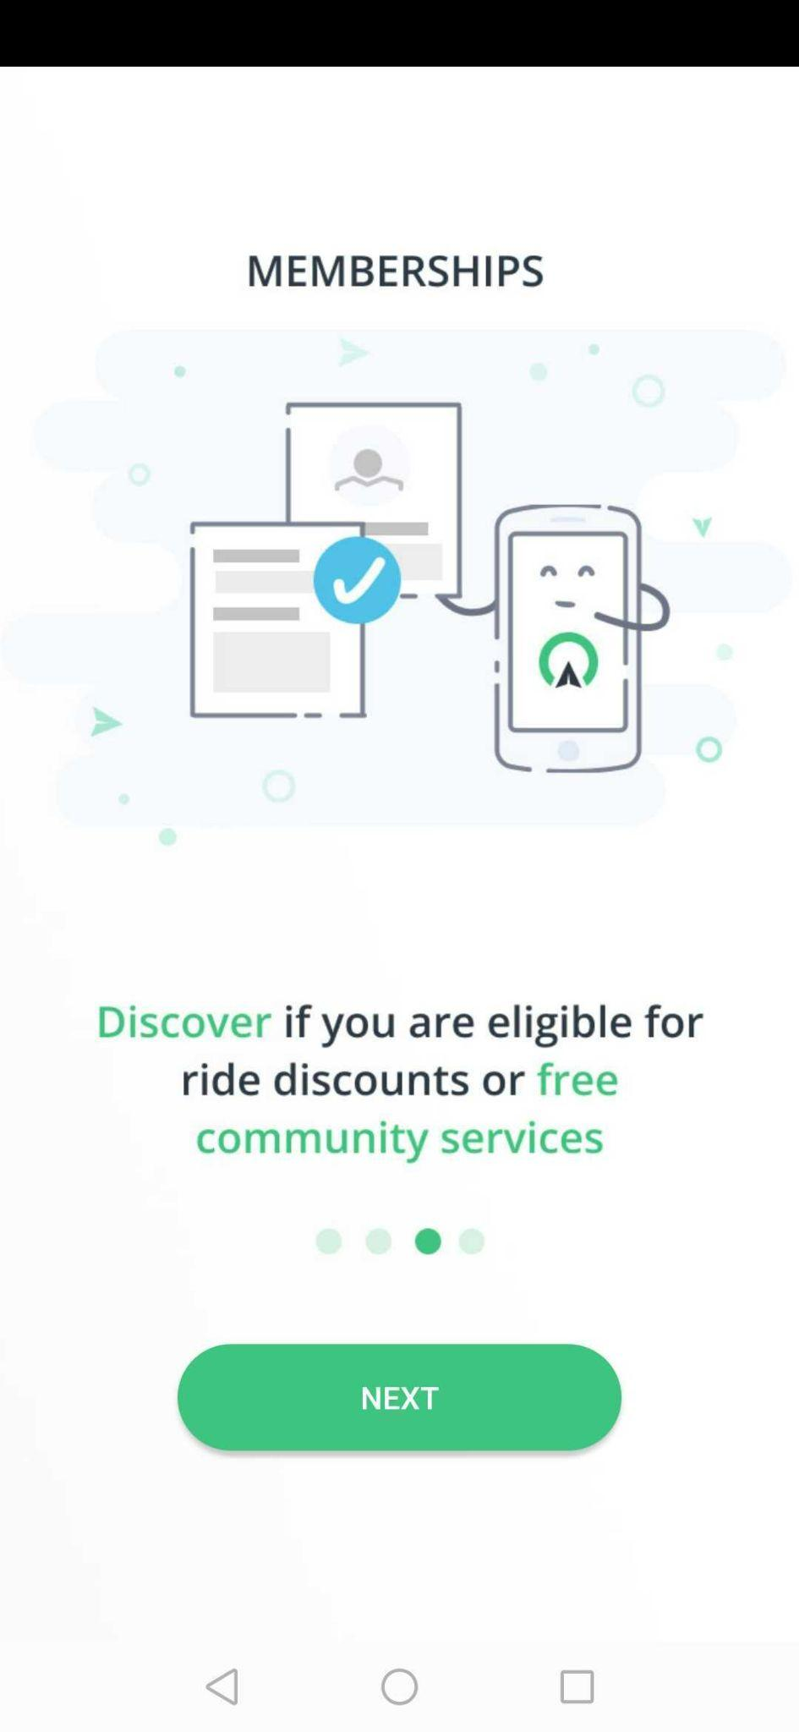

- Fill-out the required details. Make sure that the First name and Last name start with a capital letter. Click Continue once the fields have been filled out.
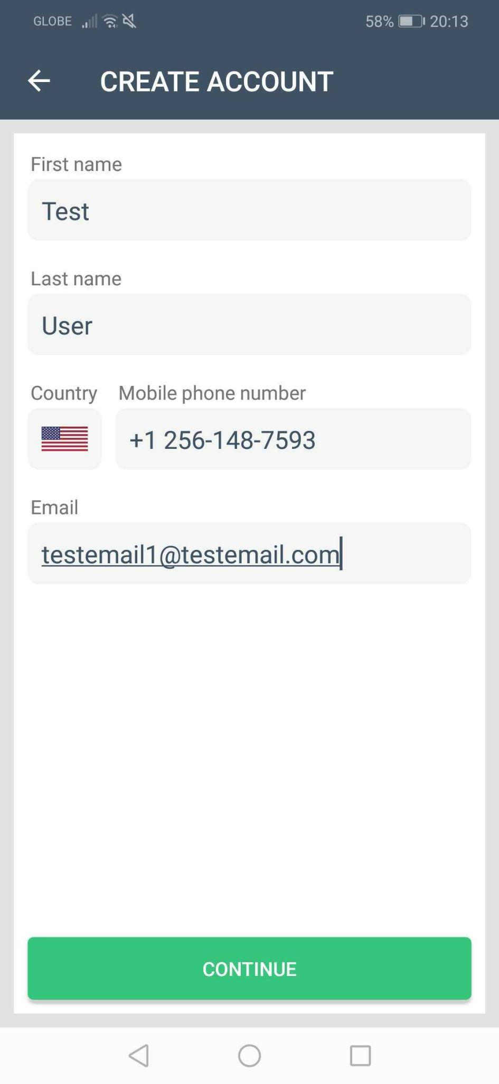
- On the next screen, tap the link of the app’s Terms and Conditions. Tap continue if you agree to the Terms & Conditions.
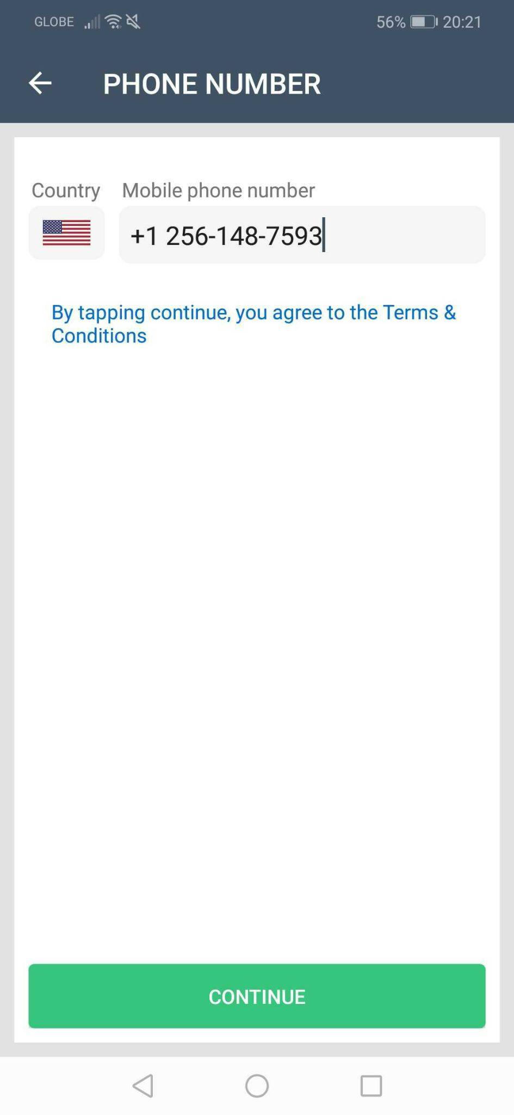
- A code will be sent to the phone number you’ve registered. Once you receive the code, type it in.
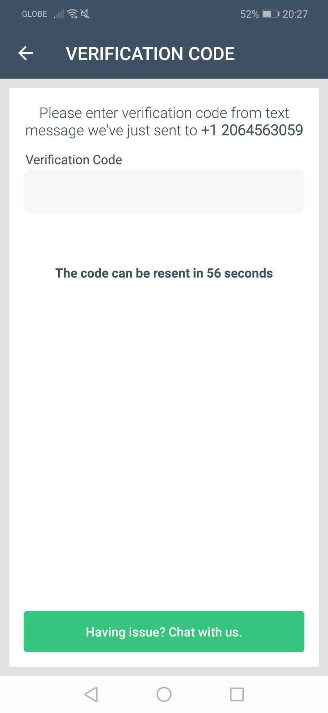
If you type in an invalid code, a pop up will appear to notify you. Recheck the code and type it in again.
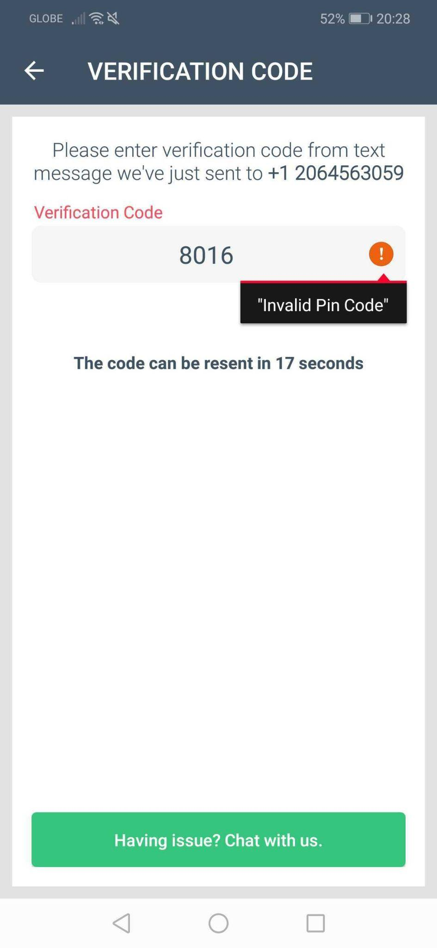
If you have not received the code, it can be resent after 60 seconds or you can choose to send it to your registered email address.
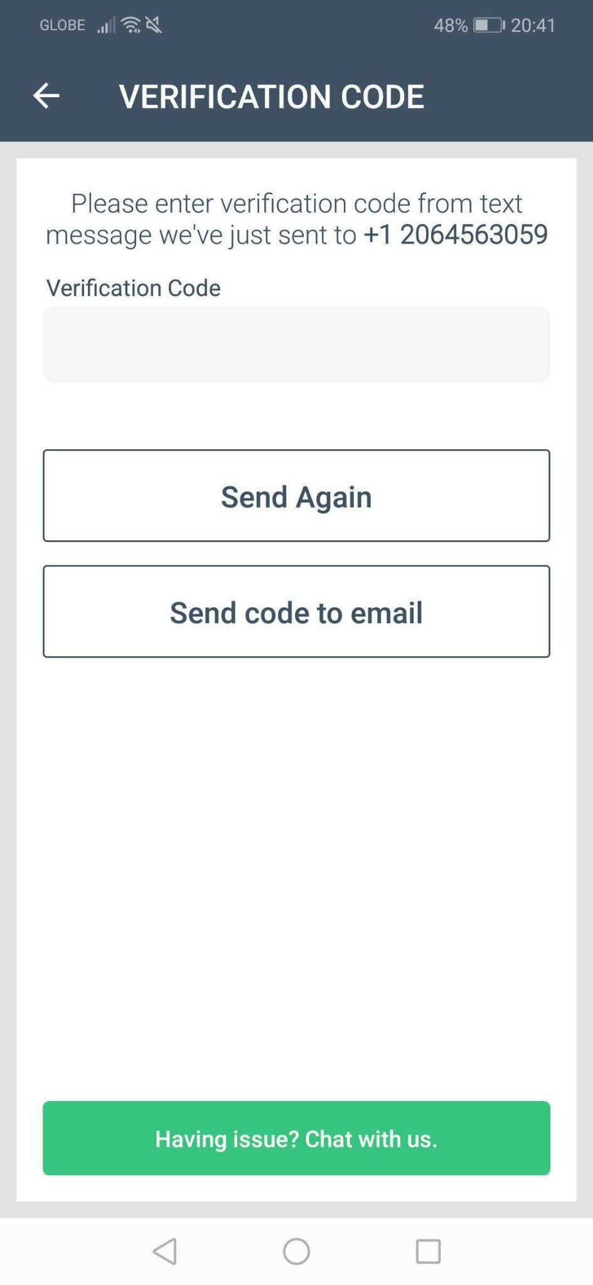
6. After you have successfully verified your account, you will be taken to the Rider App’s main screen and you can start booking your rides.
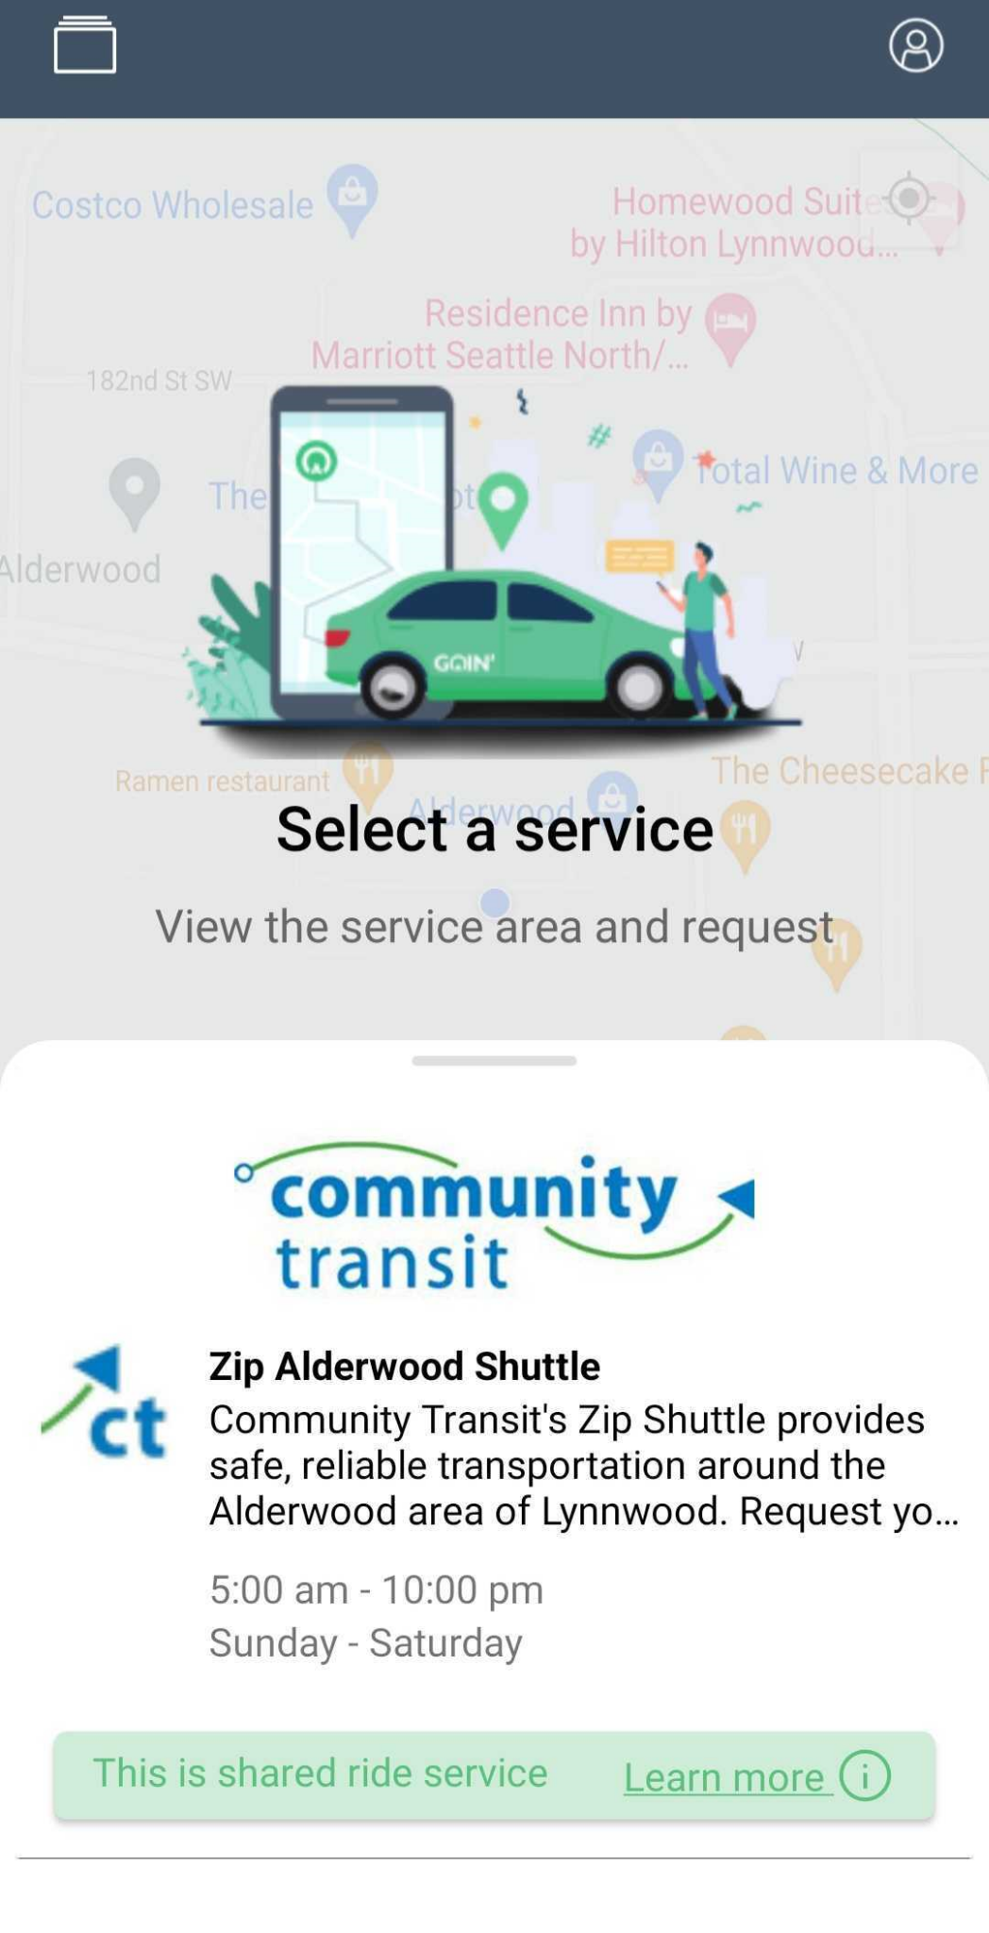
Make sure that the Location service in your mobile device is turned on otherwise, you will not be able to book your rides.
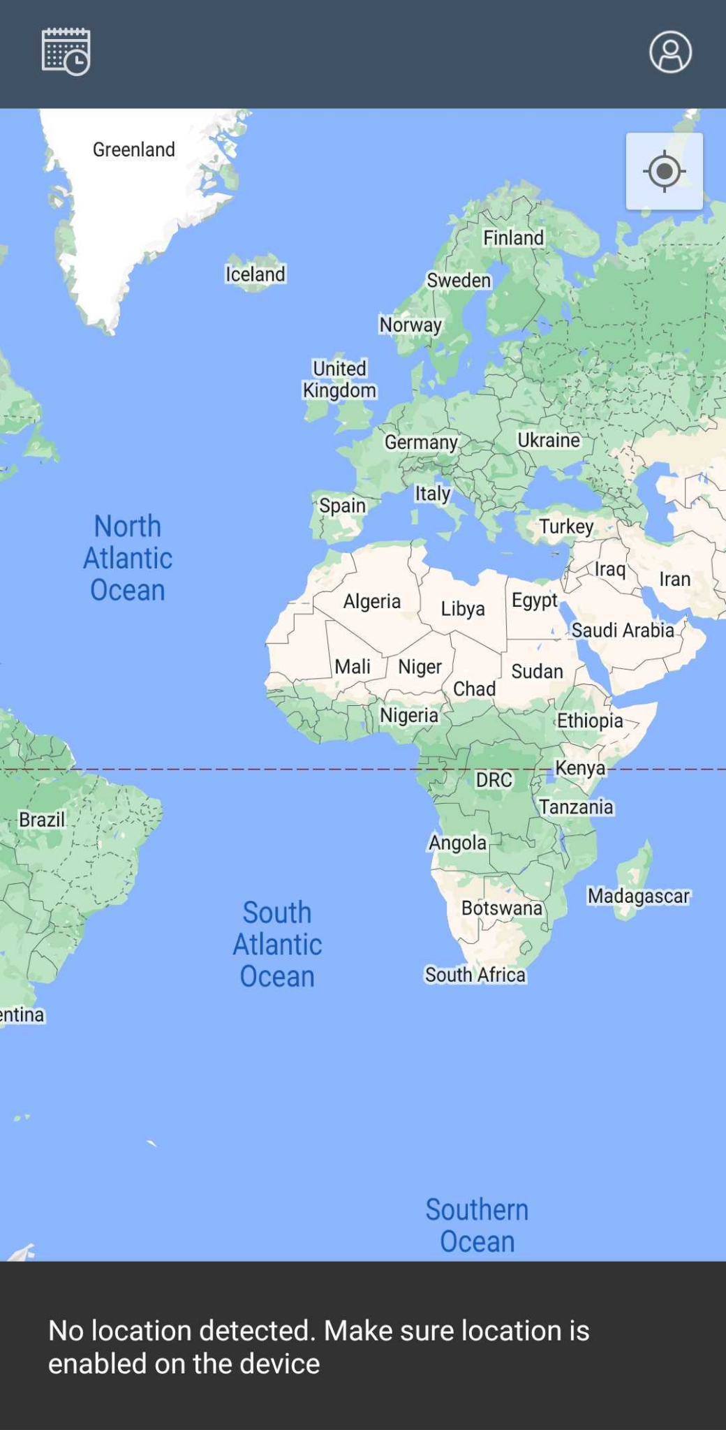
Over the Phone Registration
Goin’ creates an account for clients who have booked a ride via Medstar or the service provider’s Service Admin. If you have previously booked a ride over the phone, you can log-in to Goin’s Rider App using your registered phone number.

Logging-in

- If you already have an account with Goin’, open the app and tap Log in on Goin’s front page.
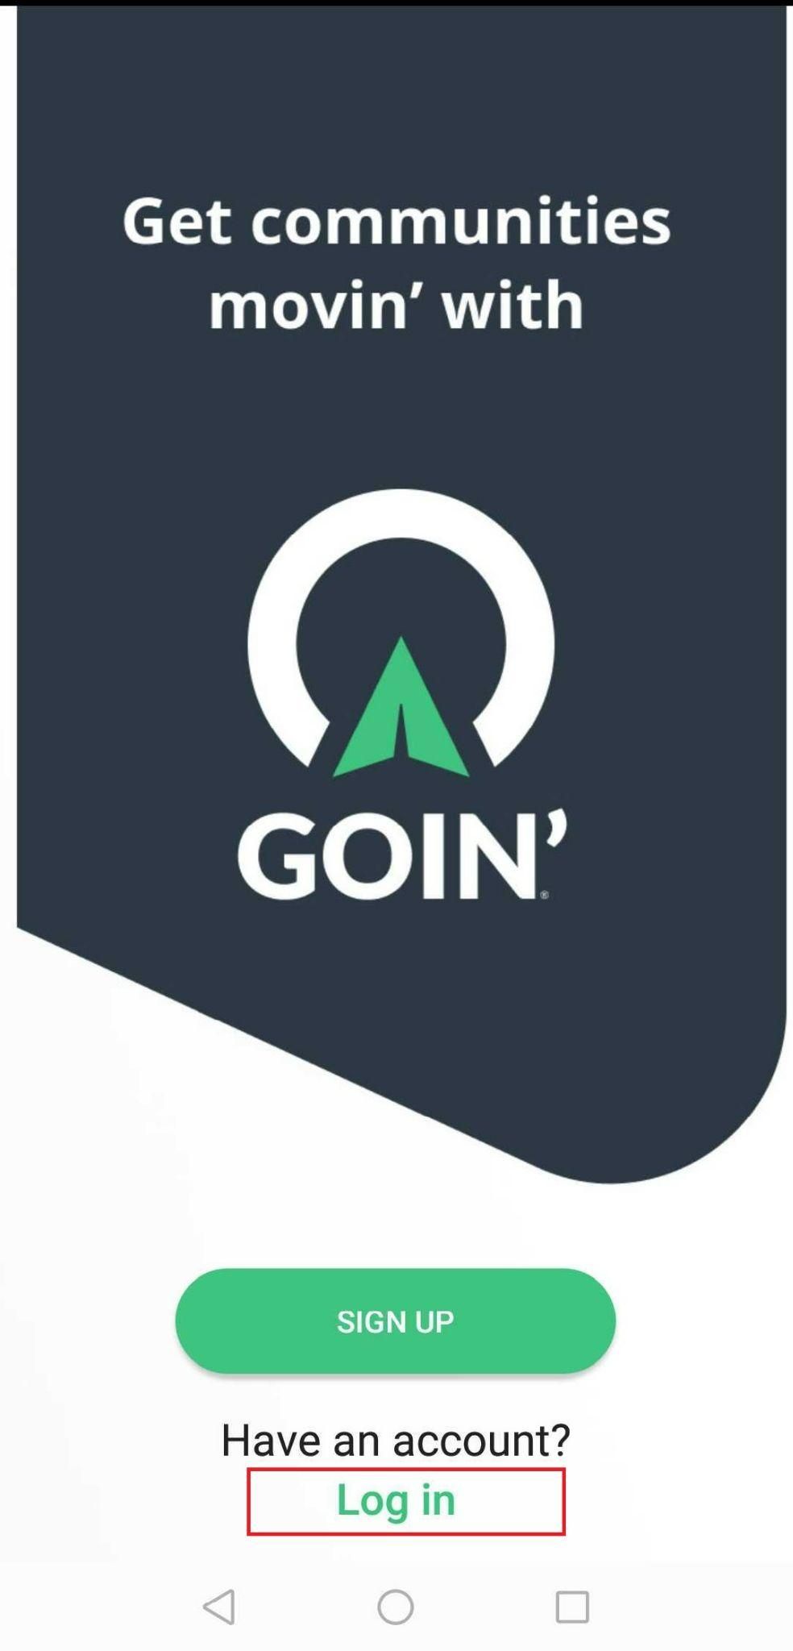
- Type in your registered mobile number in the Mobile phone number field and tap Continue.
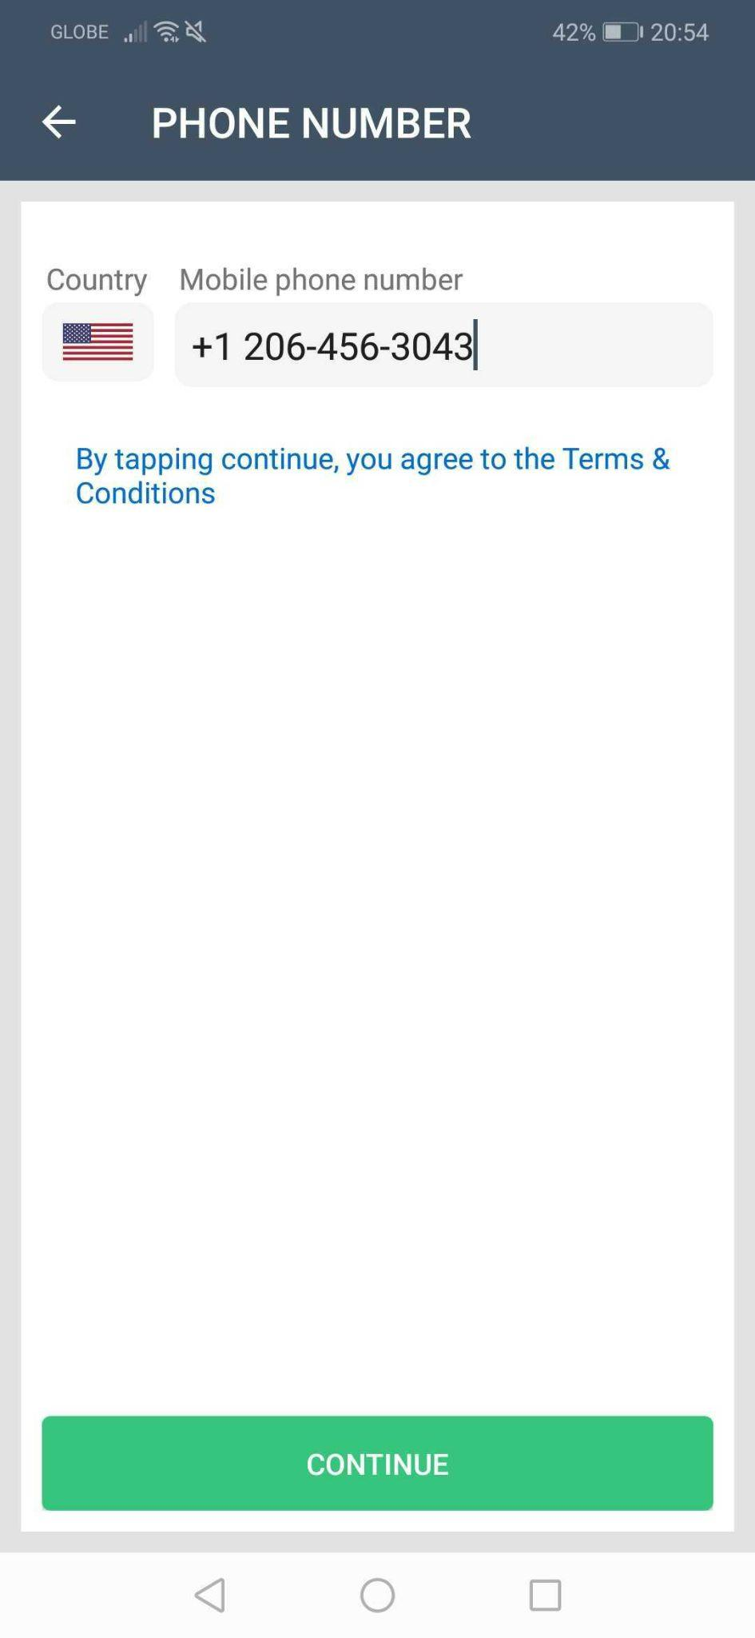

- A verification code will then be sent to your registered mobile number. Once you have received the text message with the pin code, type the pin code in the Verification Code field of the Goin’ Rider App. The code can be resent after 60 seconds.

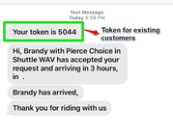
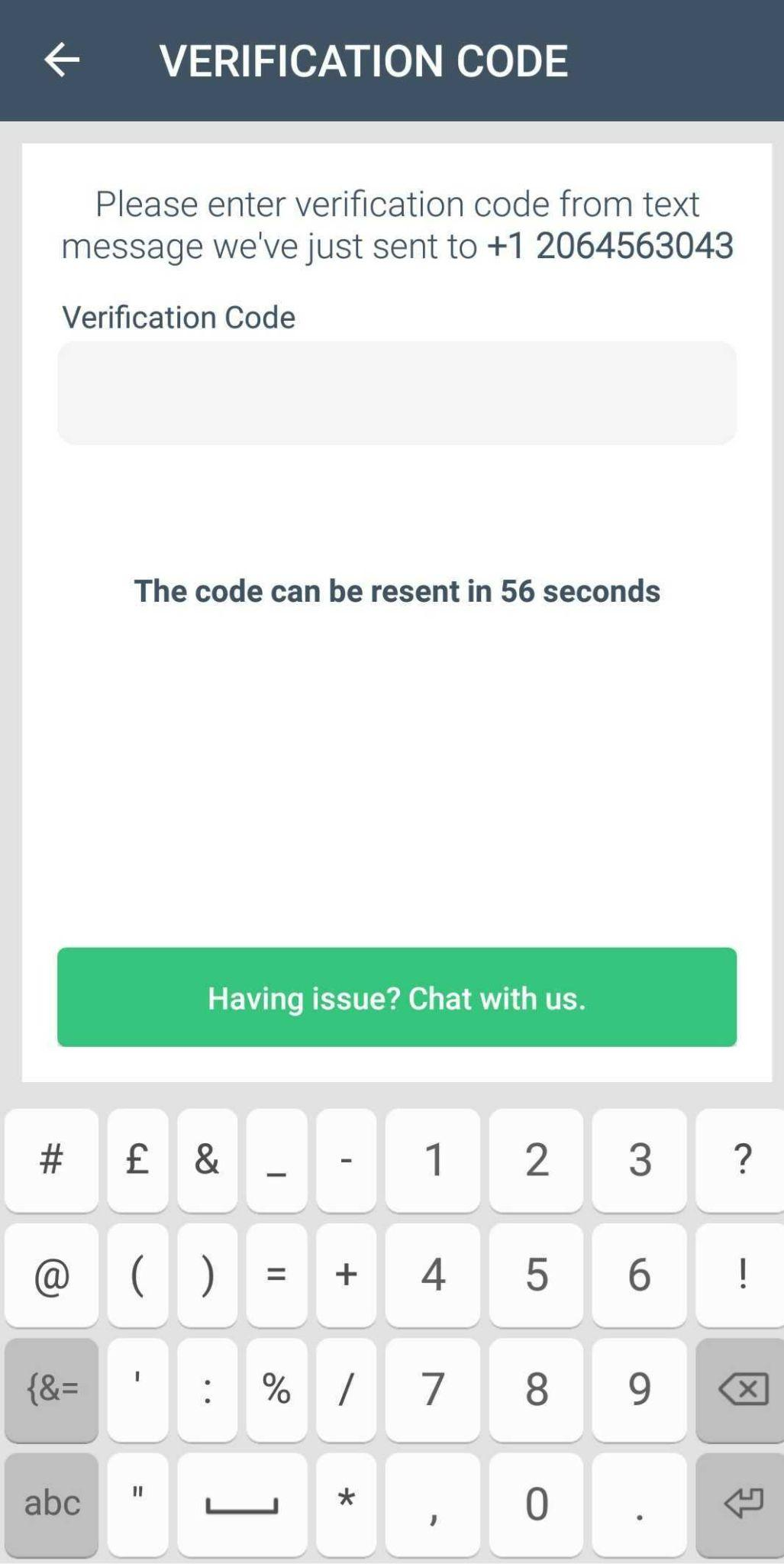

Note: If you are experiencing issues, tap the ‘Having issue? Chat with us’ bar for assistance.

In case the verification fails using your phone number, you can wait after 60 seconds for the pin code to be resent. Another option is to send the code to your registered email address by tapping Send code to email.

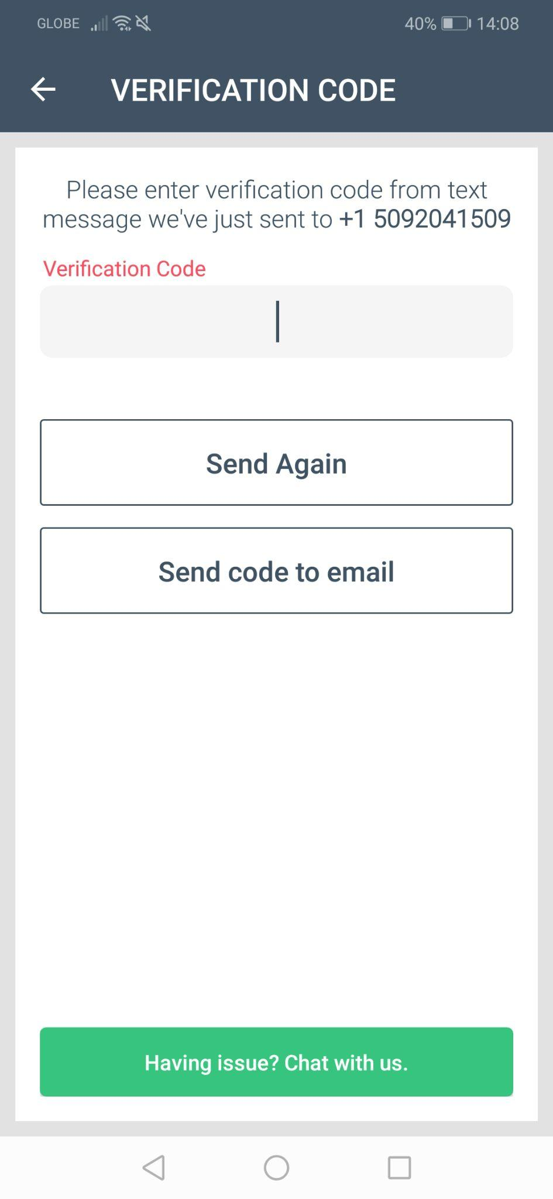

Check the verification code that was sent to your email and type it on the app.

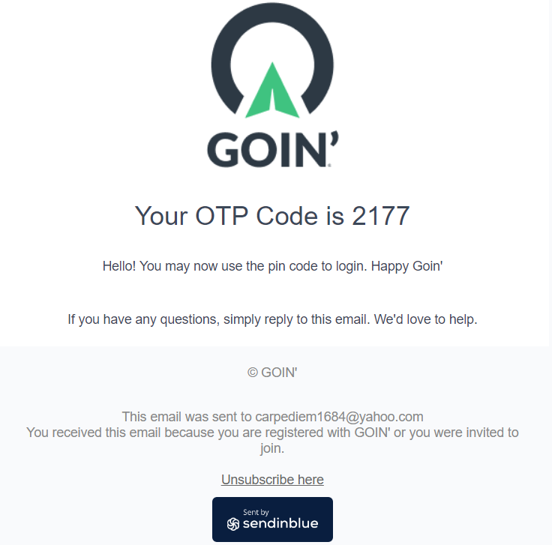

- After you have successfully verified your account, you will be taken to Goin’s main screen to start booking your rides.

Requesting an On-demand Ride

- On the home screen a list of services that you are eligible for will be displayed. Tap the Service that you want to use for the ride.

- On the next screen, the service zone, description, service hours, and other information about the service will be displayed. Drag the service window up to see more details. Confirm that this is the service that you will use by clicking Next.

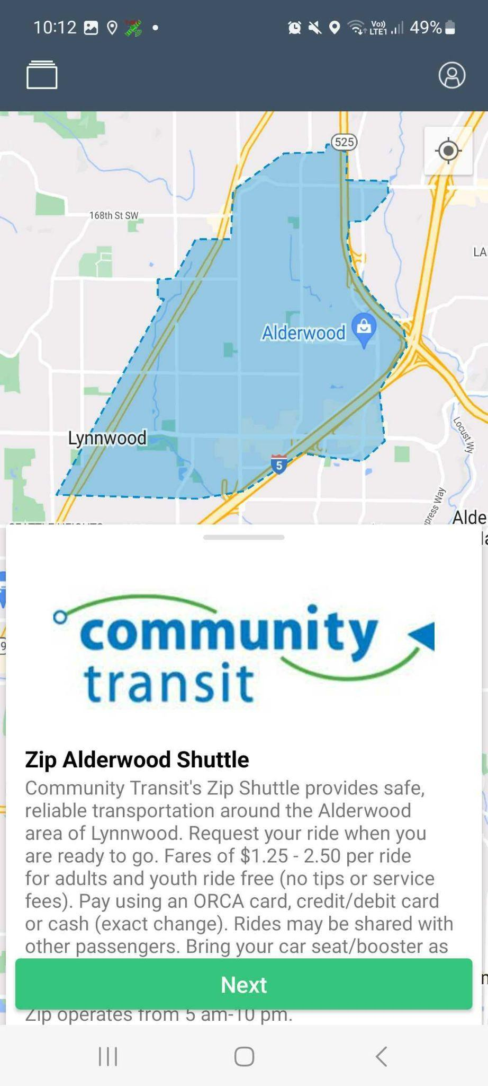
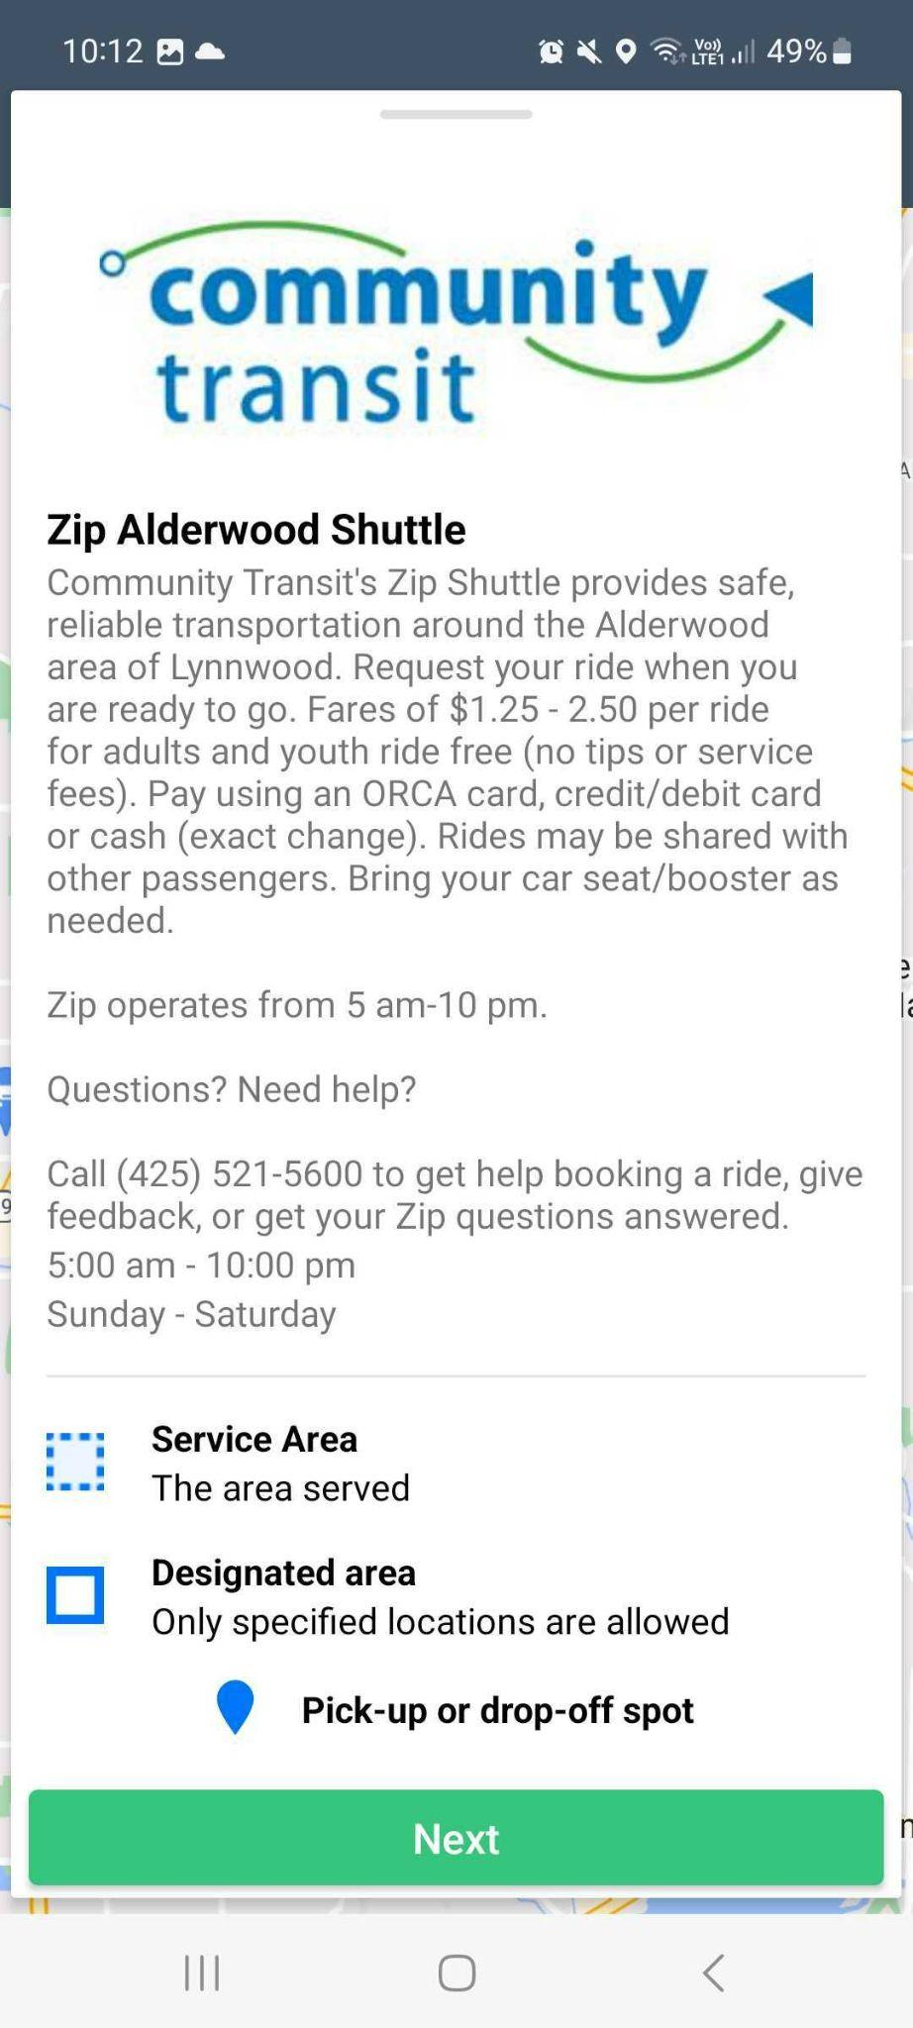

- Set the drop-off location. The drop-off location can be set in different ways. You can manually type the address on the address field. A drop-down of nearby locations will be displayed for you to select from. You can also select the drop-off location from the list of Suggested Locations, Saved Locations, Frequently used, or pin the location on the map by tapping Choose from Map.
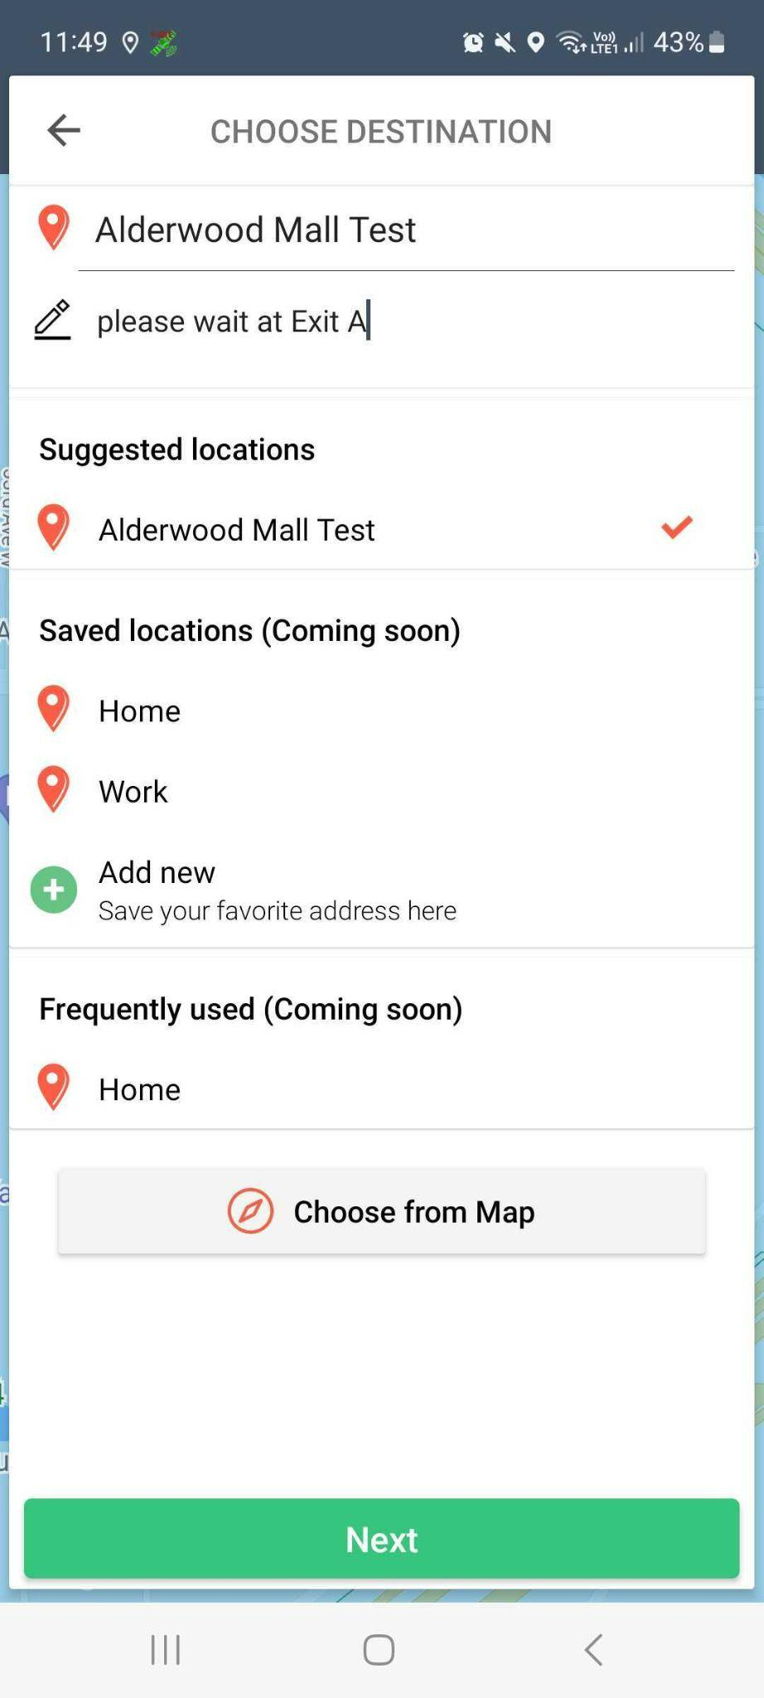

You can type additional instructions to the driver on the Add note for driver field just below the address field.

Once you have set the drop-off location, click Next.

- Confirm the drop-off location by tapping Confirm. If you need to correct the drop-off address, tap the back arrow to go back to the previous screen.

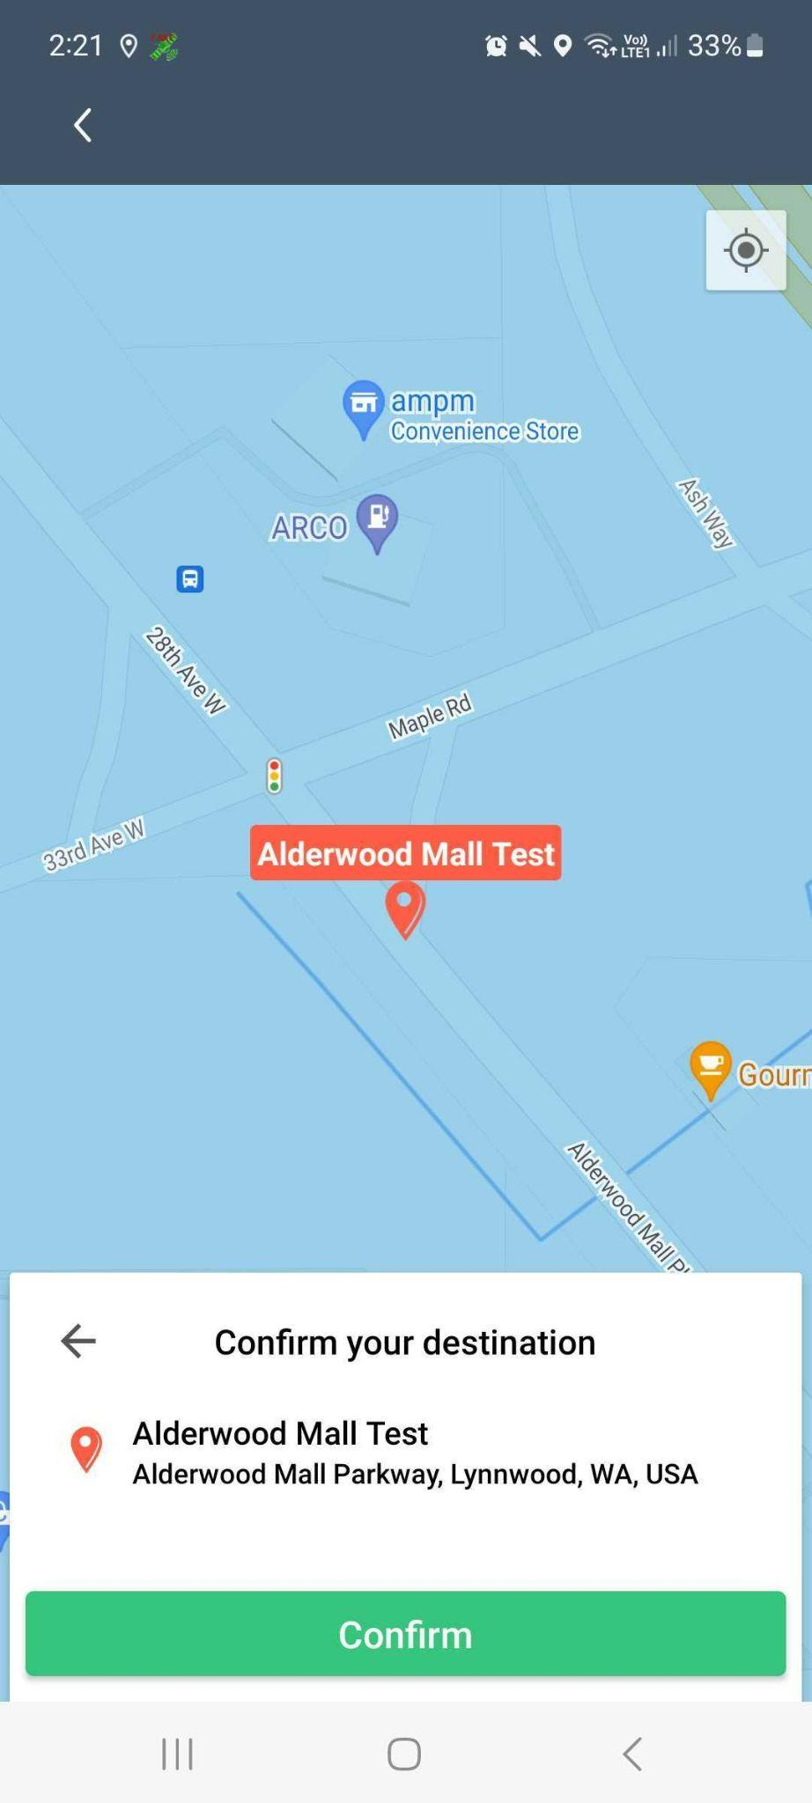

Note: If the destination falls outside the service zone, you will see the following message on the screen:

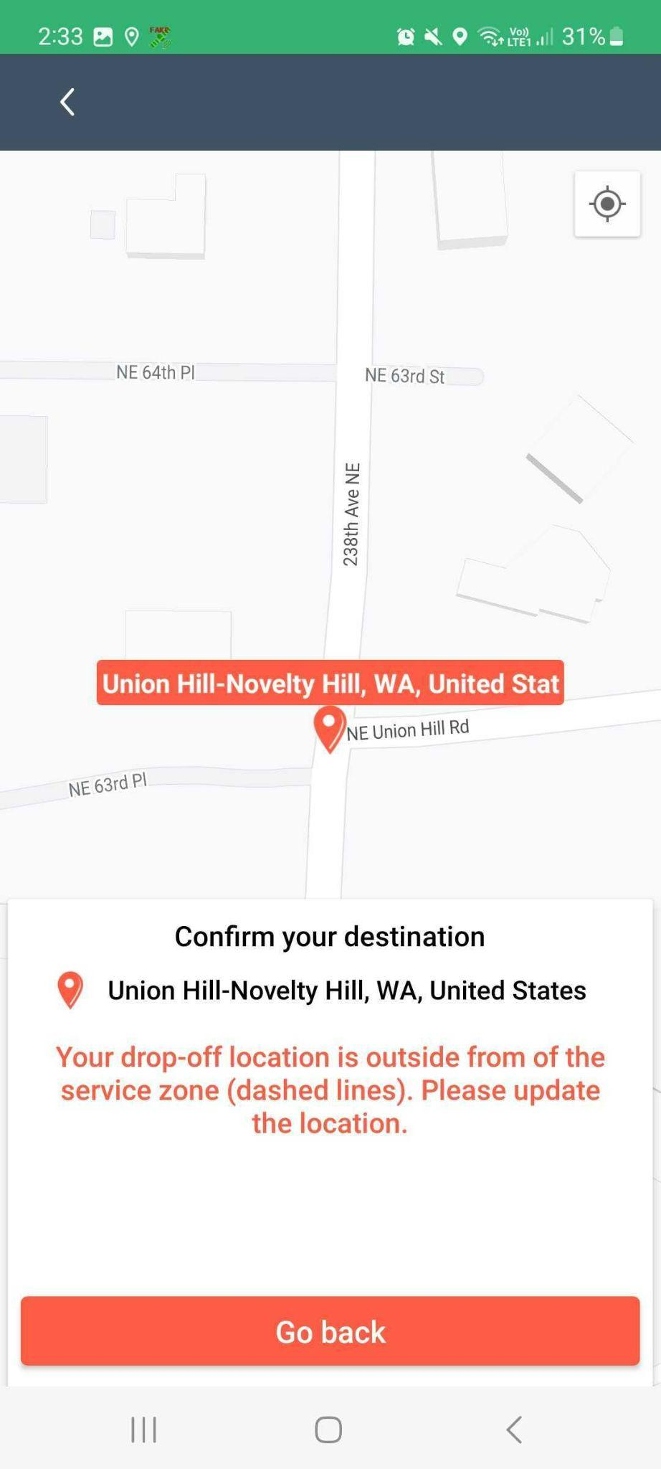

- Select the product that you will use for the ride and tap Next.
Note: On the product’s tab, you will see information such as the fare, the number of passengers that can be accommodated, and the average waiting time for the driver.
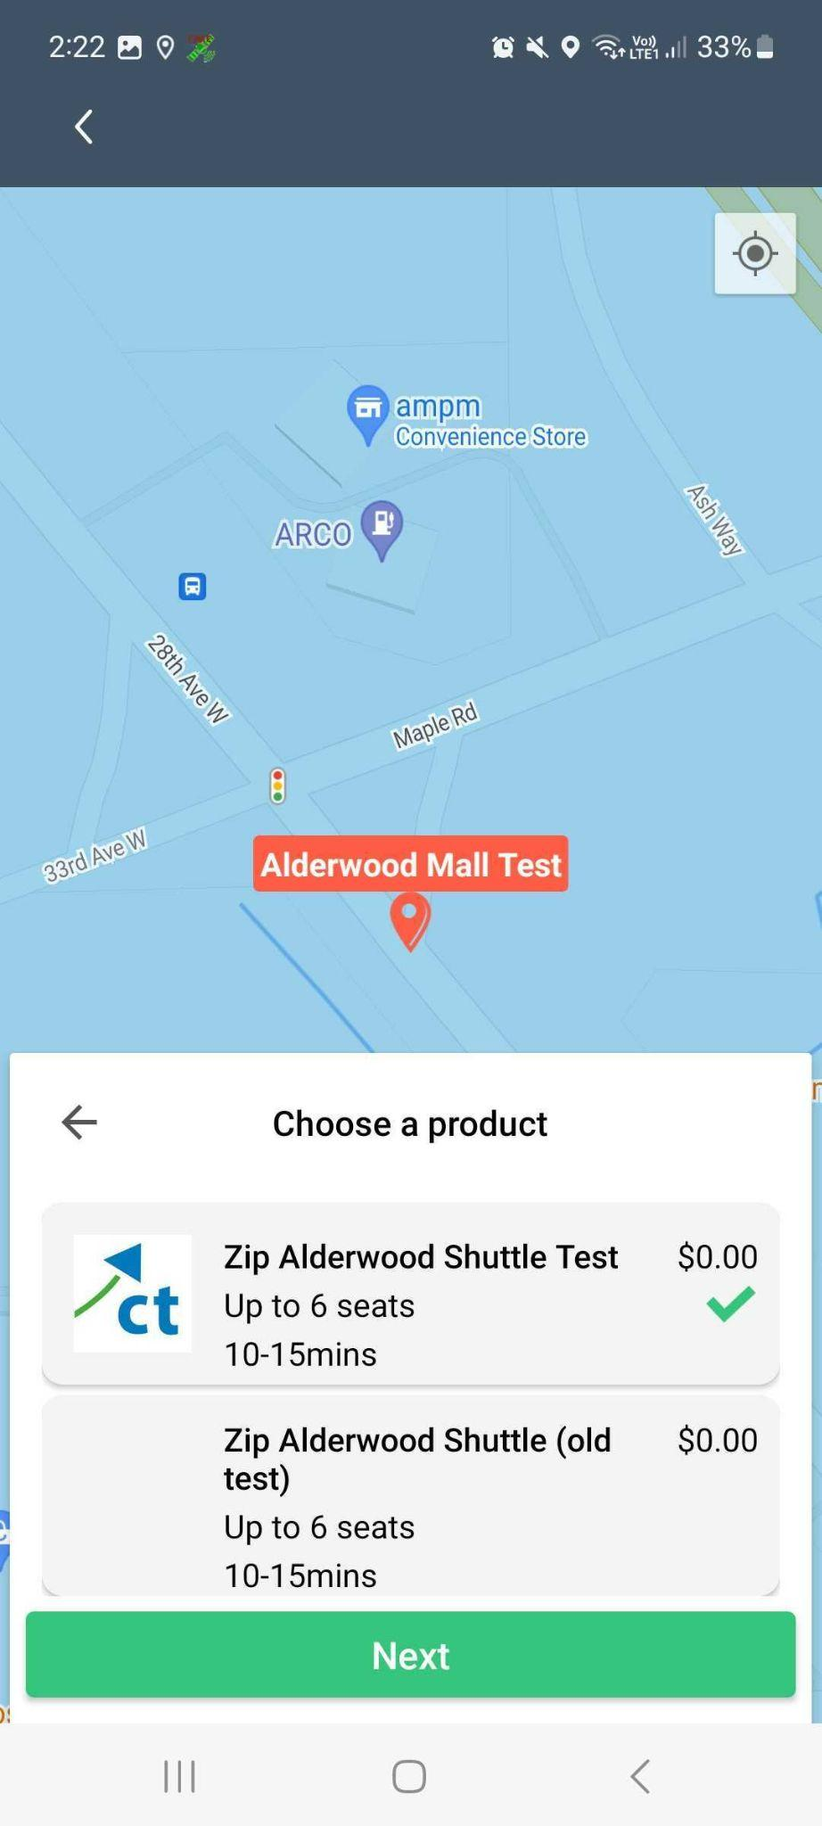

- Set the number of riders for each passenger.
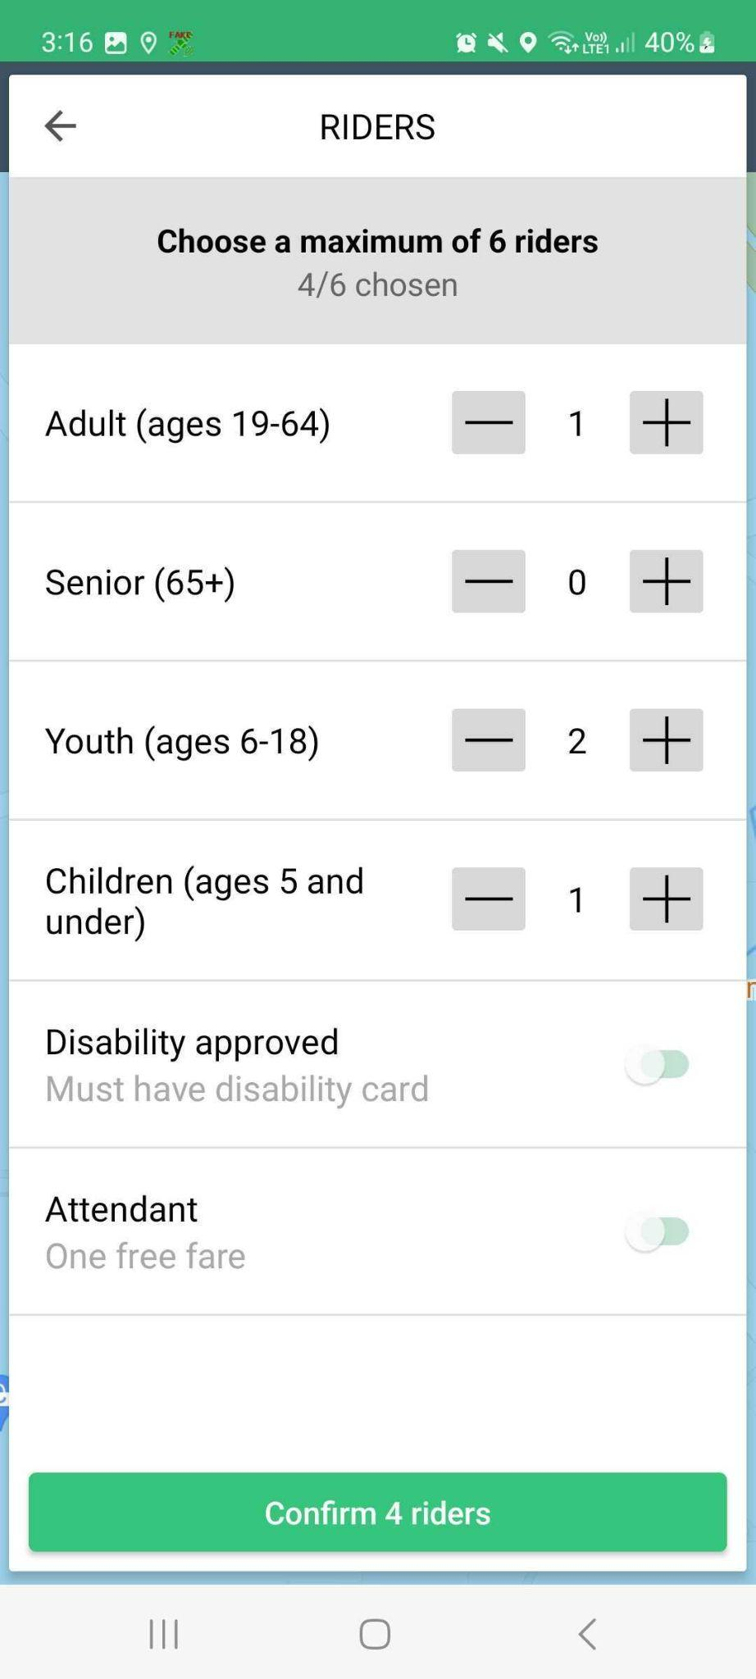

- Set the payment method for each passenger type.

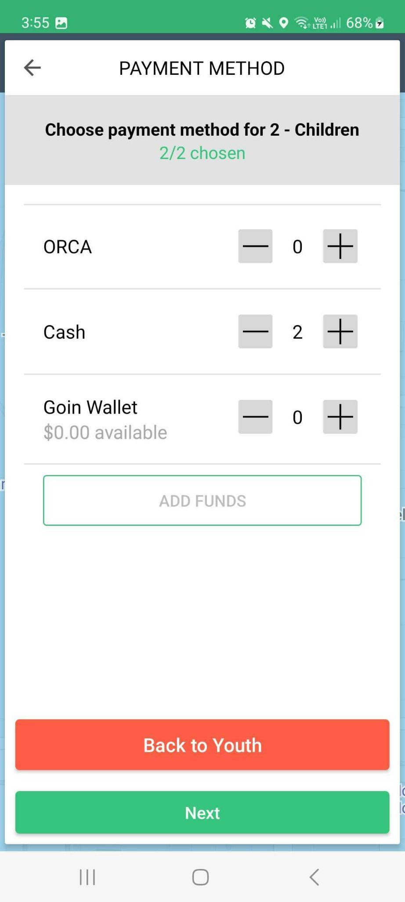
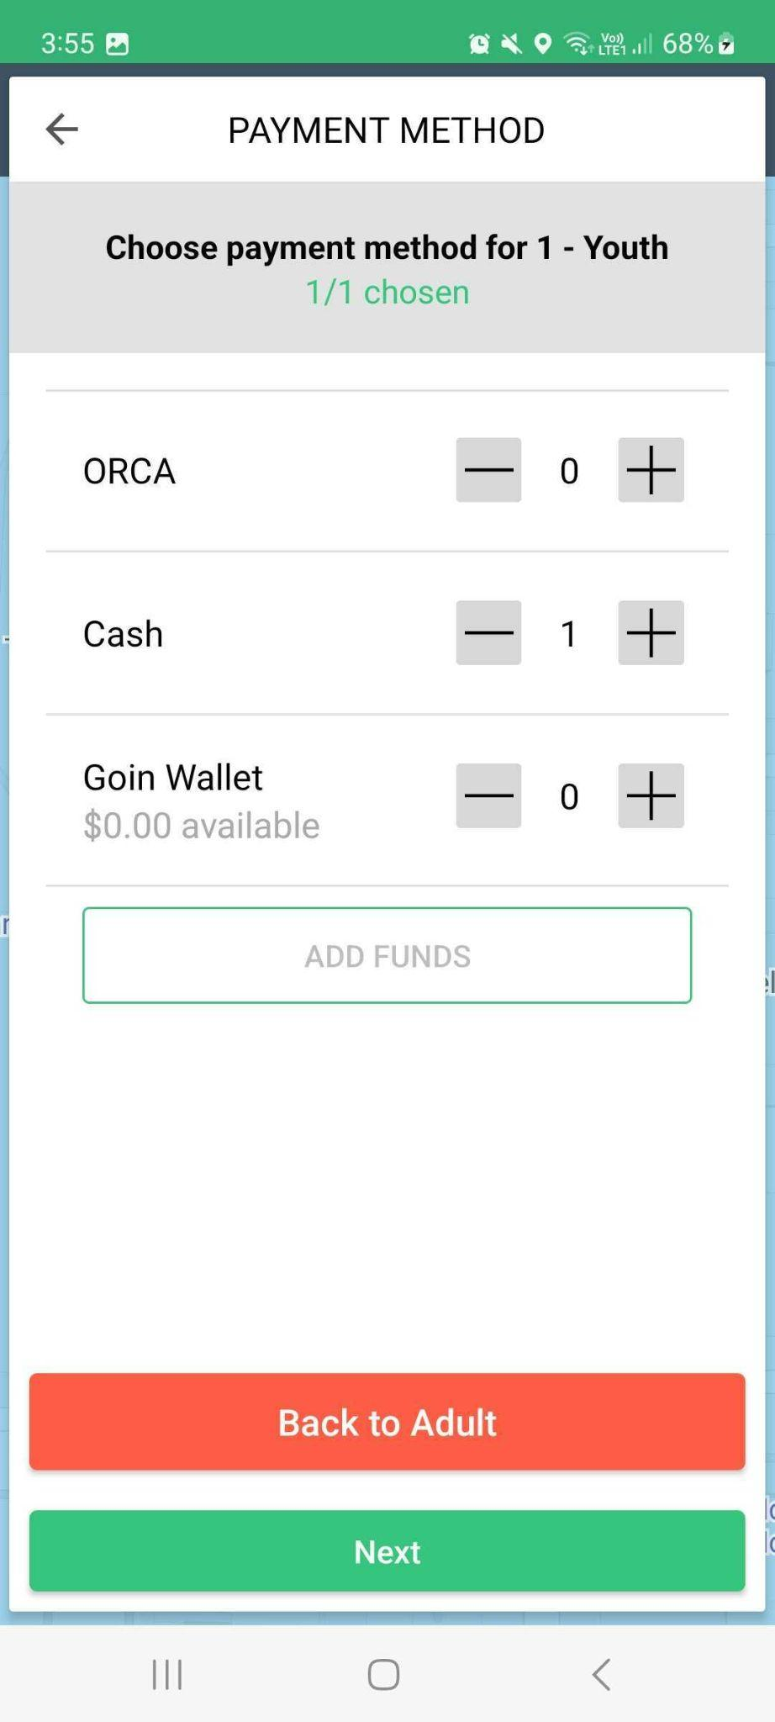
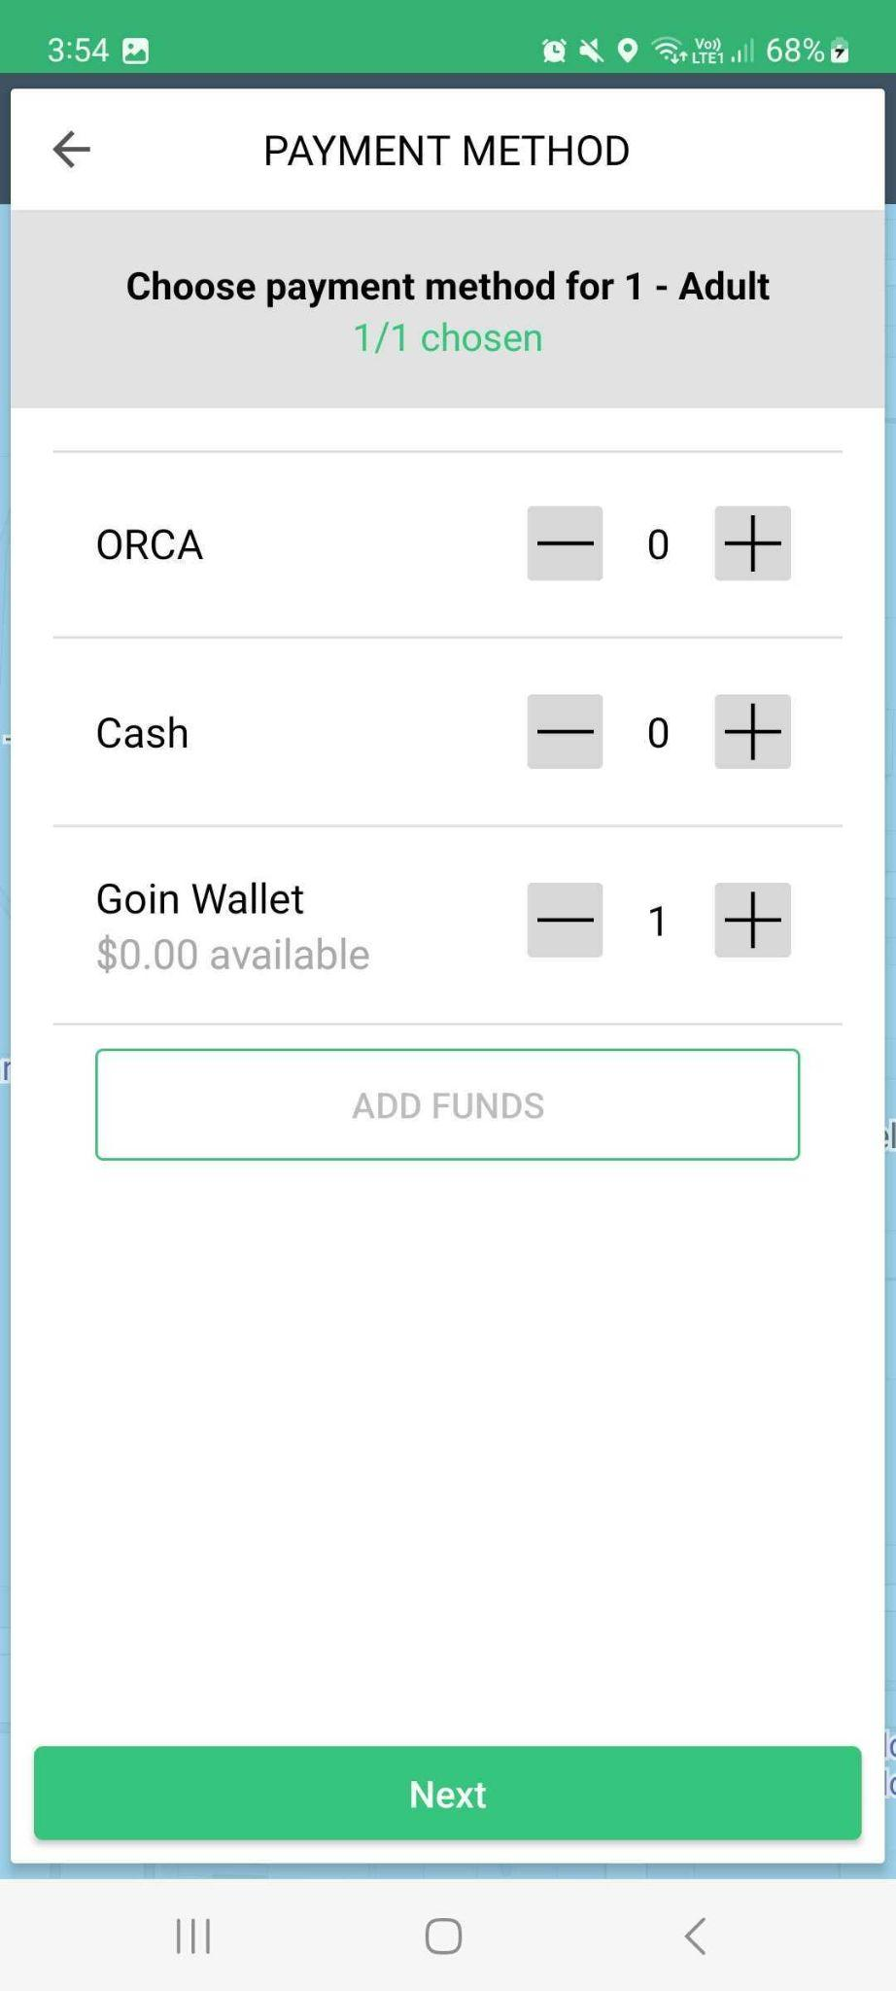

Note: If you prefer to use your Goin’ wallet, make sure that you have enough funds to cover the fare. Otherwise, you will not be able to book the ride with this error.

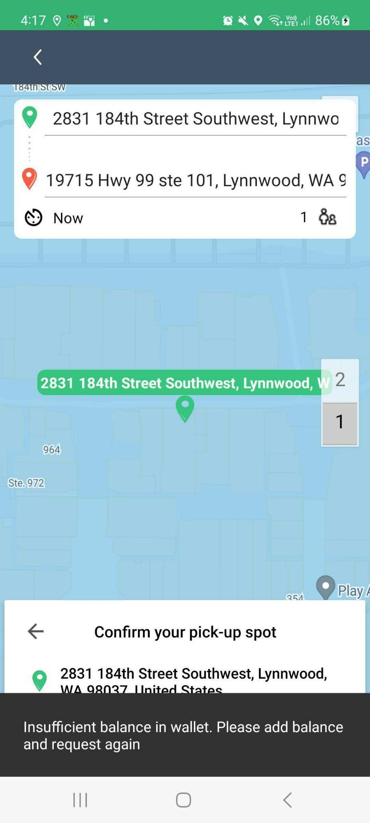
If you run out of funds, you can always choose to pay by cash or your ORCA card.

- Set the pick-up location. The pick-up location can be set in different ways. You can manually type the address on the address field. A drop-down of nearby locations will be displayed for you to select from. You can also select your current location for your pick-up location. Moreover, there is a list of Saved Locations, Frequently used, and Nearby places to select from. Lastly, you can pin the location on the map by tapping Choose from Map.

You can type additional instructions to the driver on the Add note for driver field just below the address field.
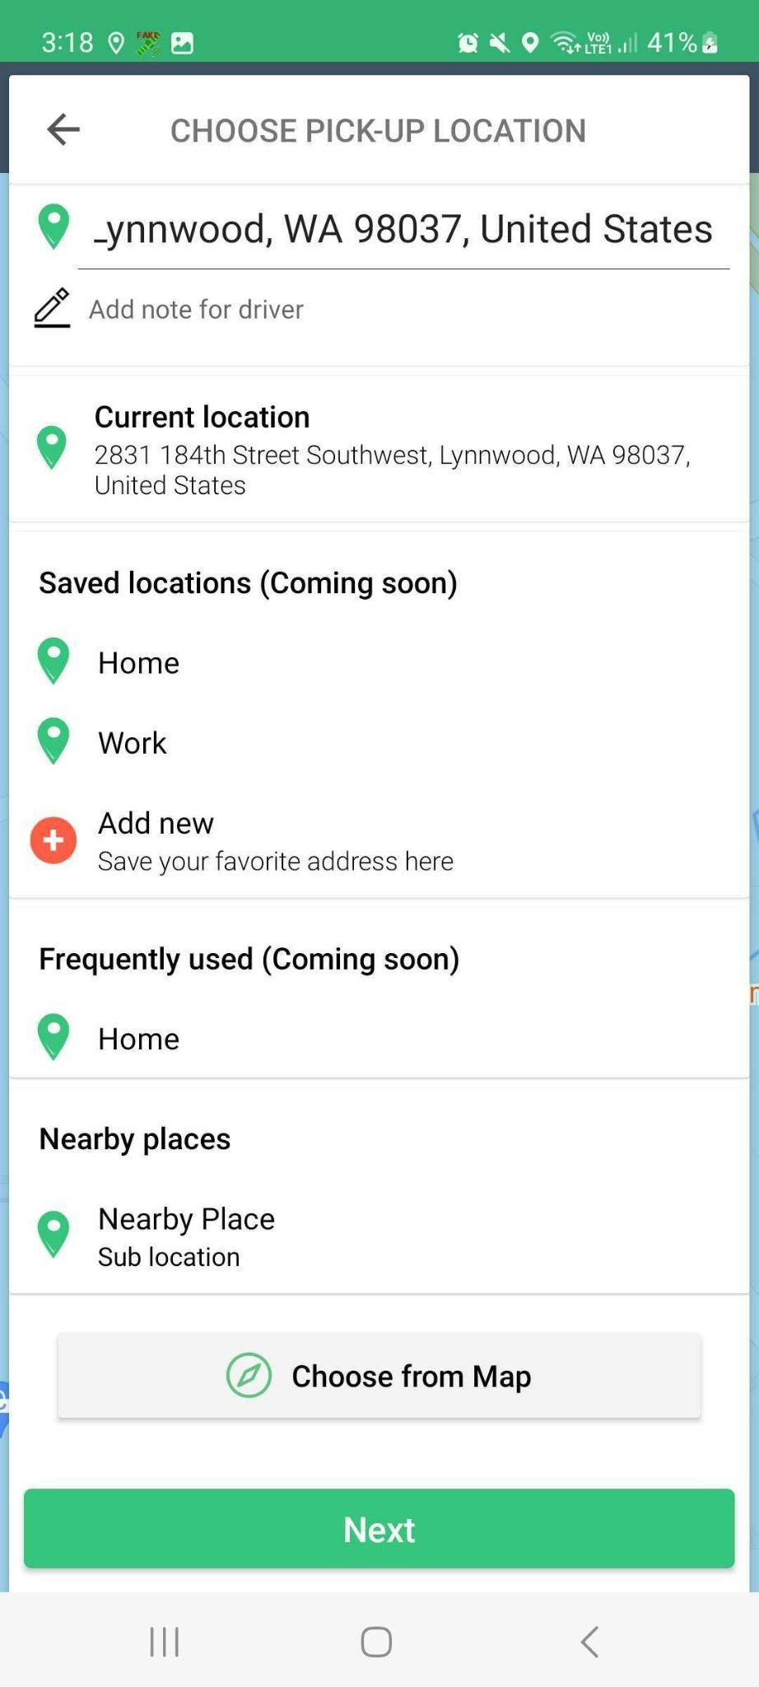

- Confirm the pick-up location by tapping Confirm Request. If you need to correct the pick-up address, tap the back arrow to go back to the previous screen.

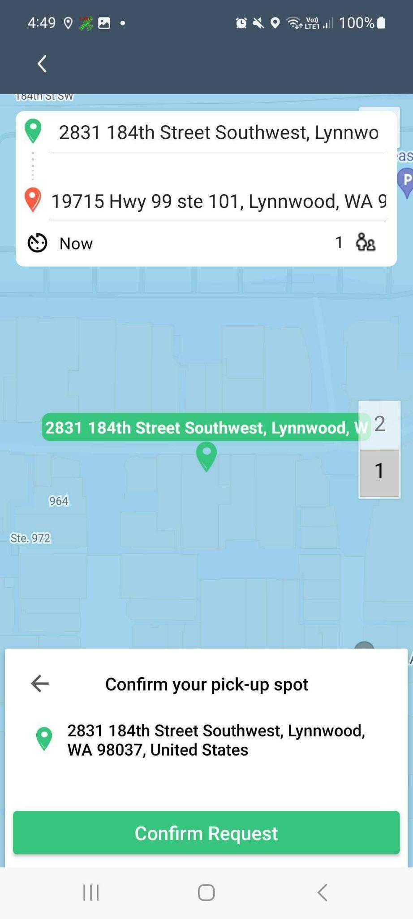

- Once you have submitted your request, Goin’ will find the nearest available driver for your ride.
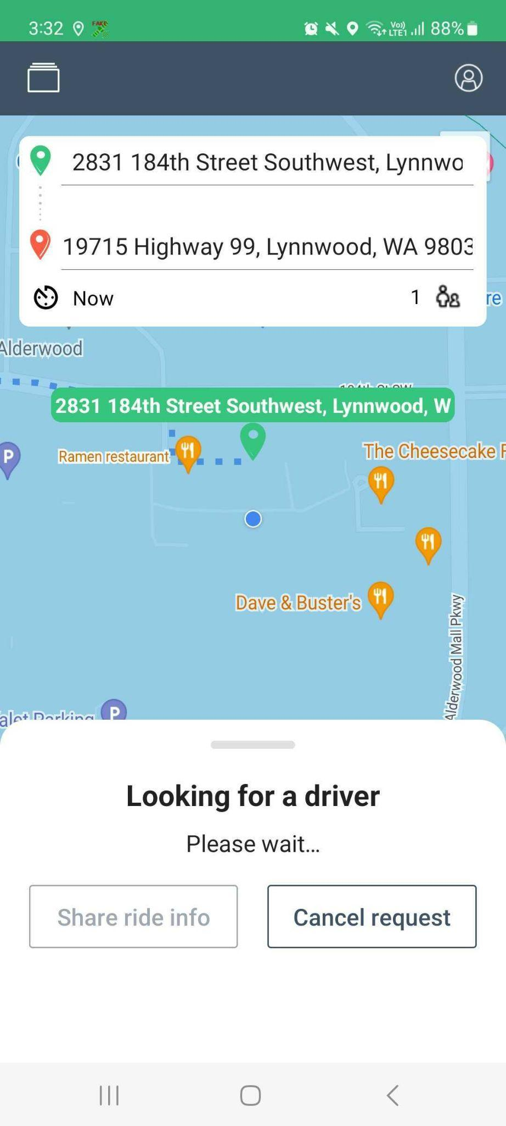

- Once a driver is matched with your request, you will see the average waiting time, driver’s name, vehicle make and model, and license plate number.
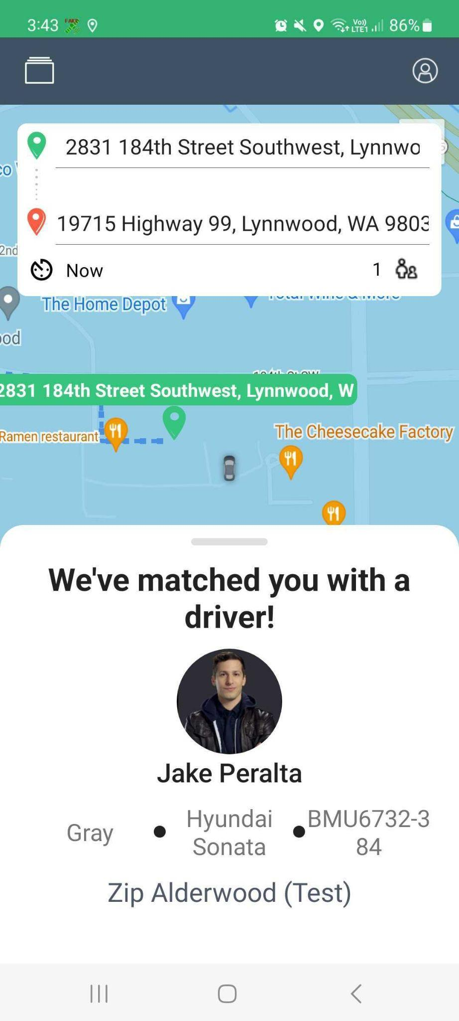

Cancelling a Trip
Trip cancellation is allowed once you have submitted your request up until the driver has reached the pick-up location. If you cancel the request while the app is looking for an available driver for your trip, it will simply go back to the home screen.

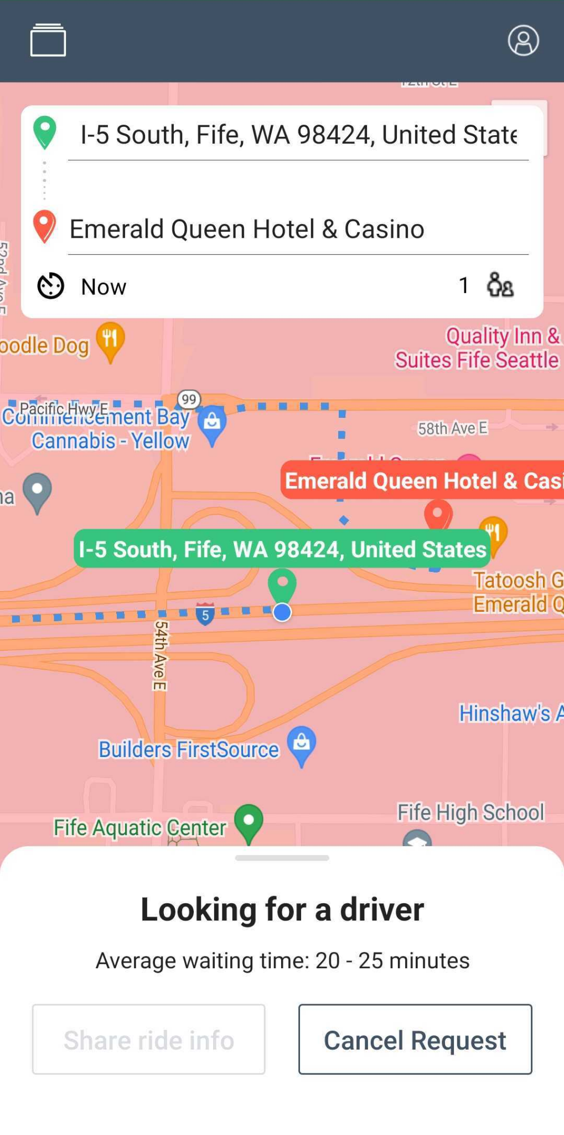

If you cancel the request after it has been accepted by the driver or when the driver has arrived at the pick-up location, select the reason for cancellation and tap Send.

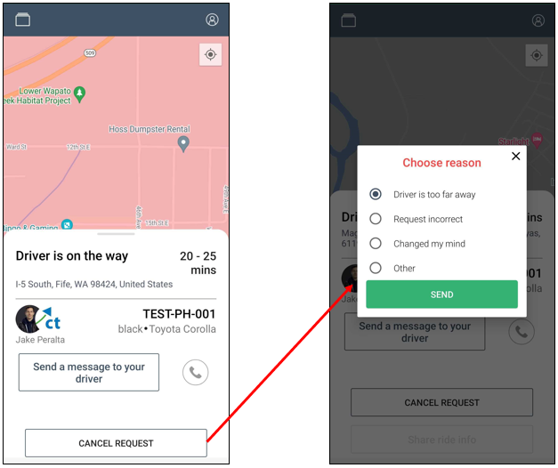
Note: After cancelling a trip, you will only be able to request for another trip after two minutes. Once the countdown timer is done, tap the New Trip Request window to request for another trip.
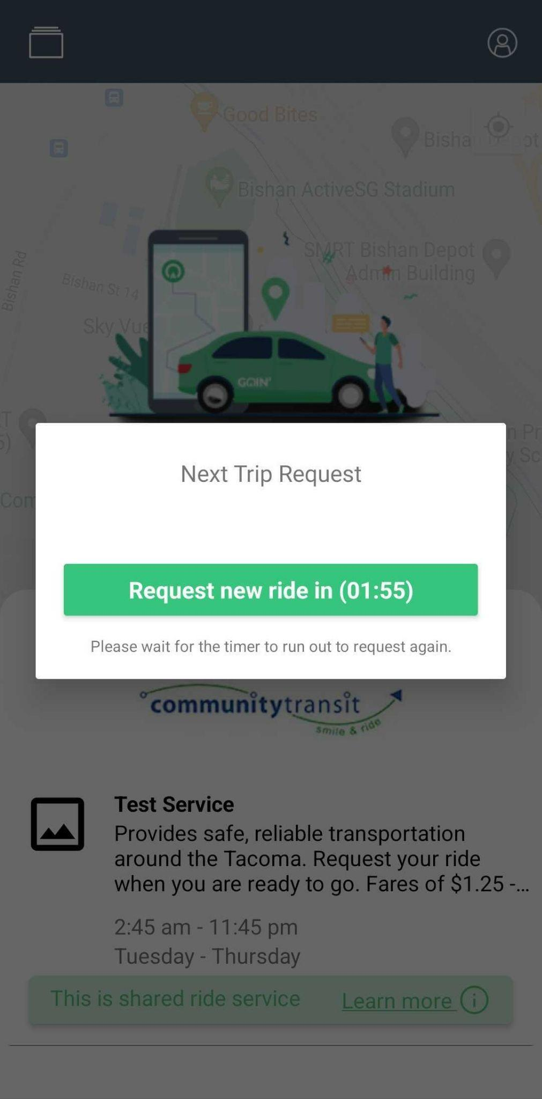

Favorite/Saved Locations
You can save the locations that you frequent to make booking your trip faster and easier. Below are the steps to save your favorite locations.
- Log-in to the Rider App.
- Tap the Profile icon.
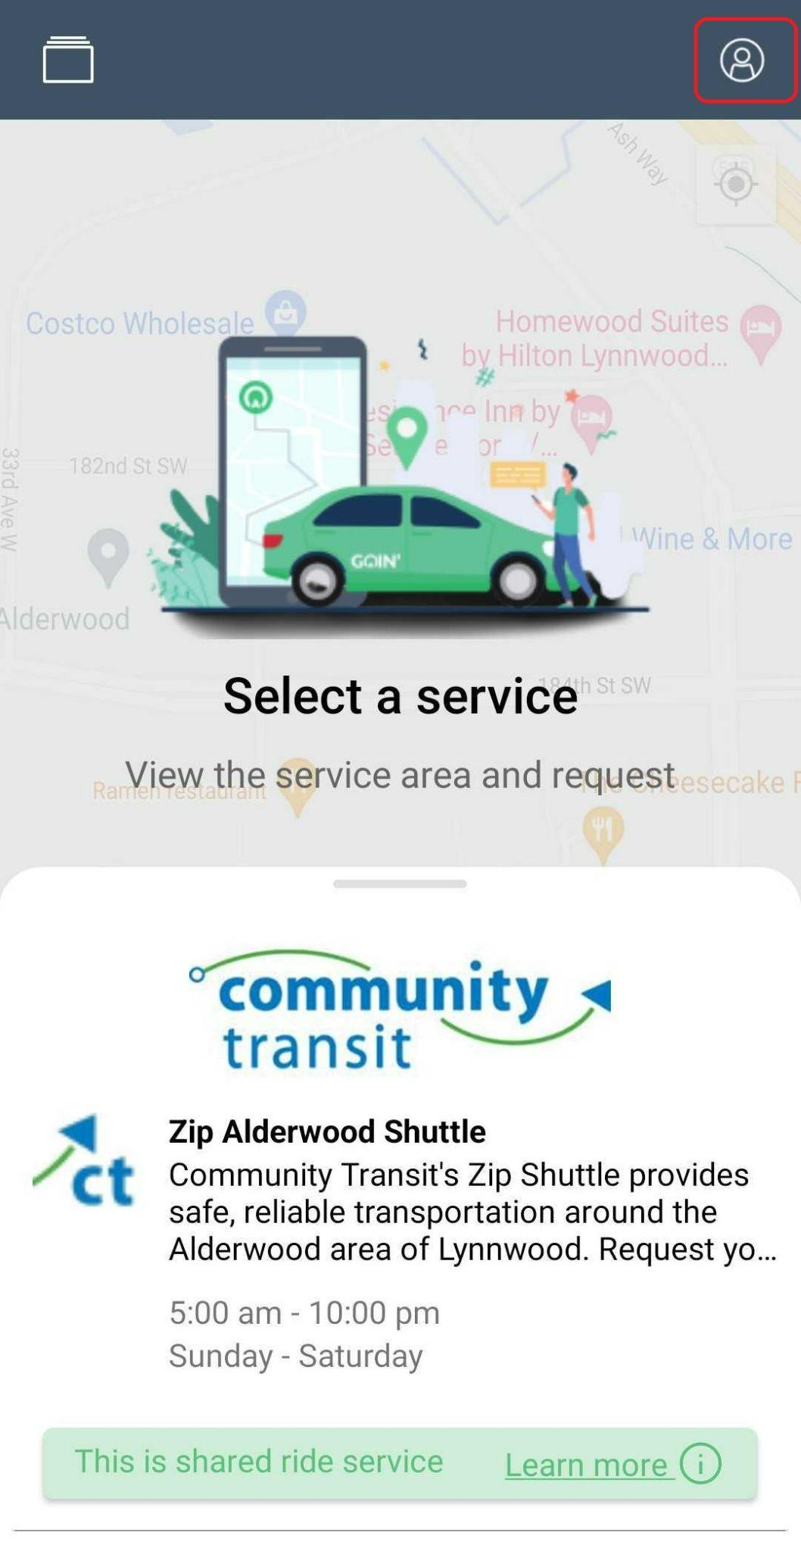
- Tap Favorite Locations.
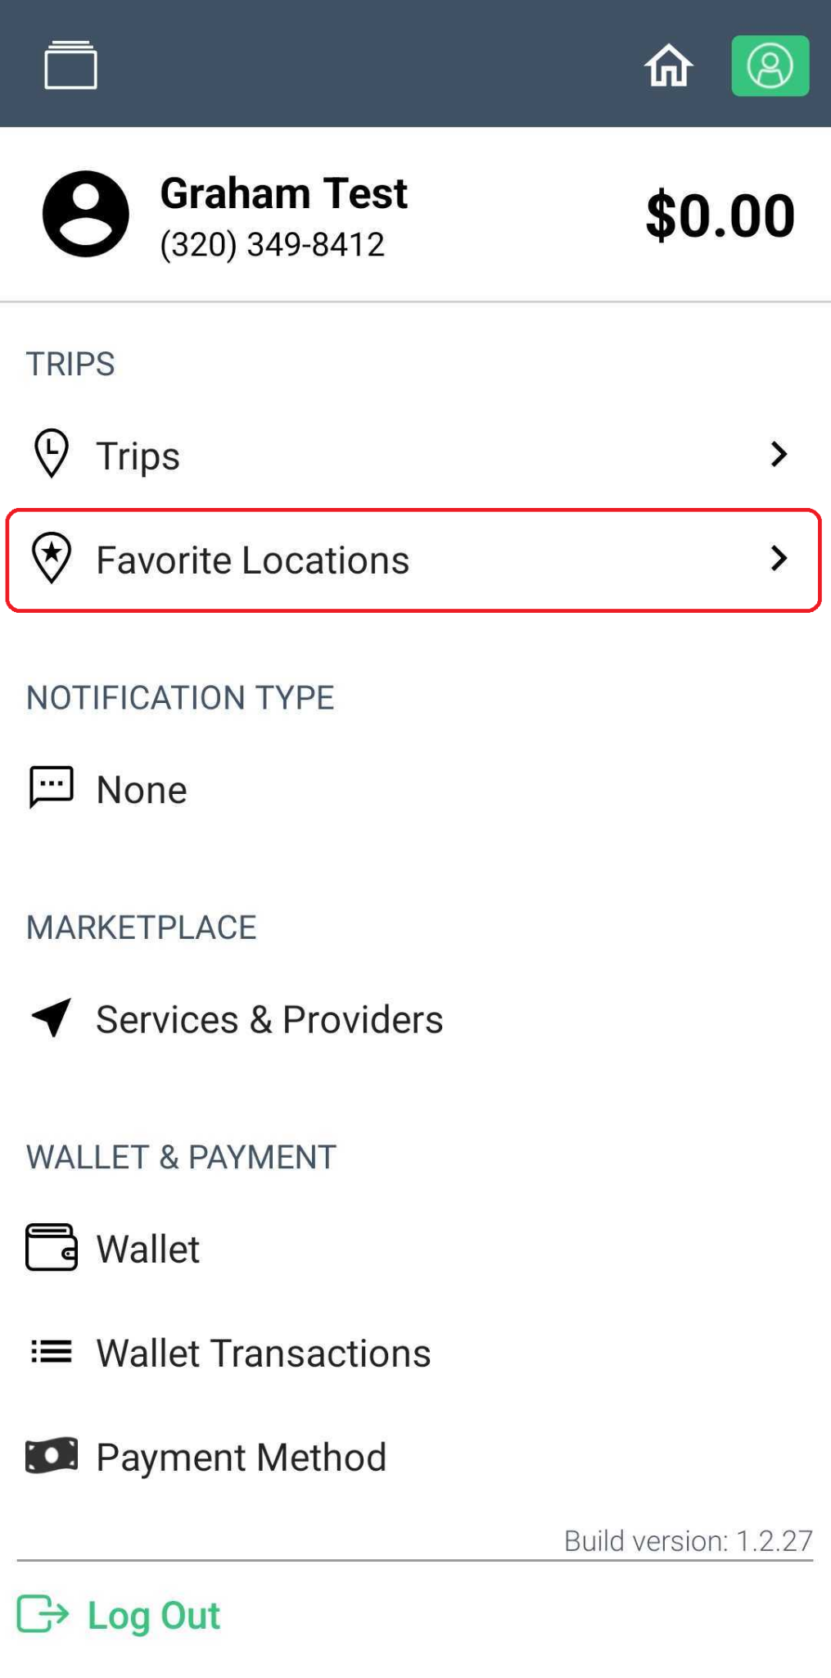
- Tap 'Add new'.
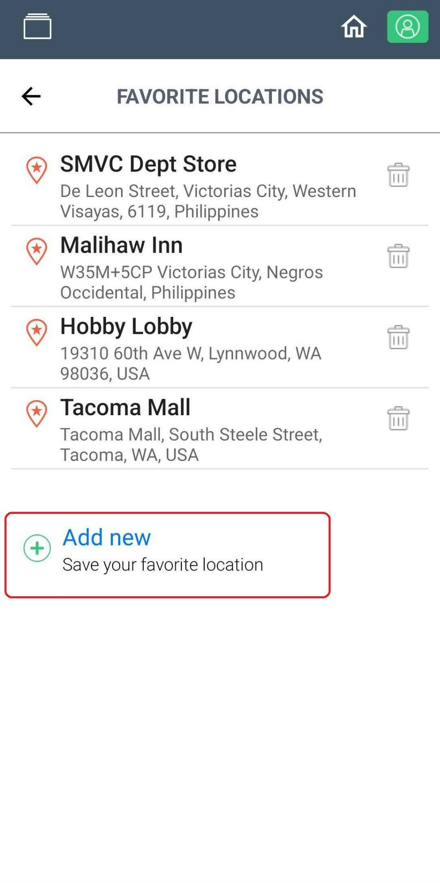

- Type in the details of the new location and tap ‘Save location’.
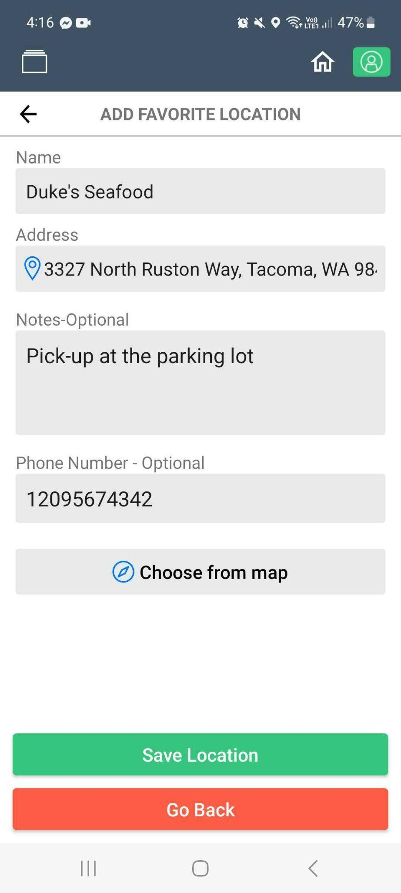
- The new location should be on the list of Favorite Locations.
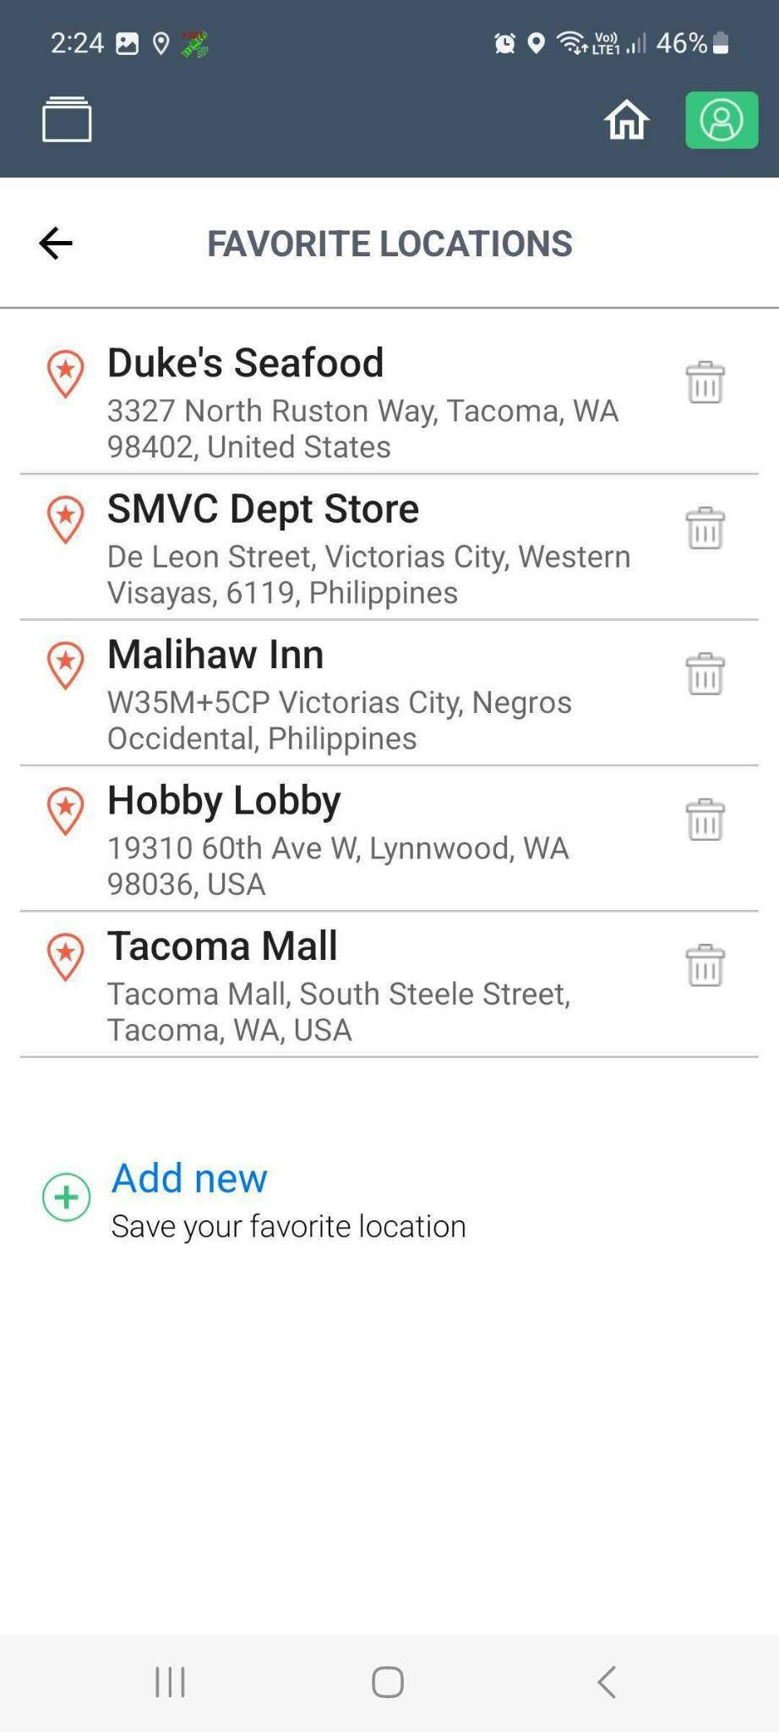
- The new location should also be on the list of Saved locations when selecting the Pick-up and Drop-off Locations.
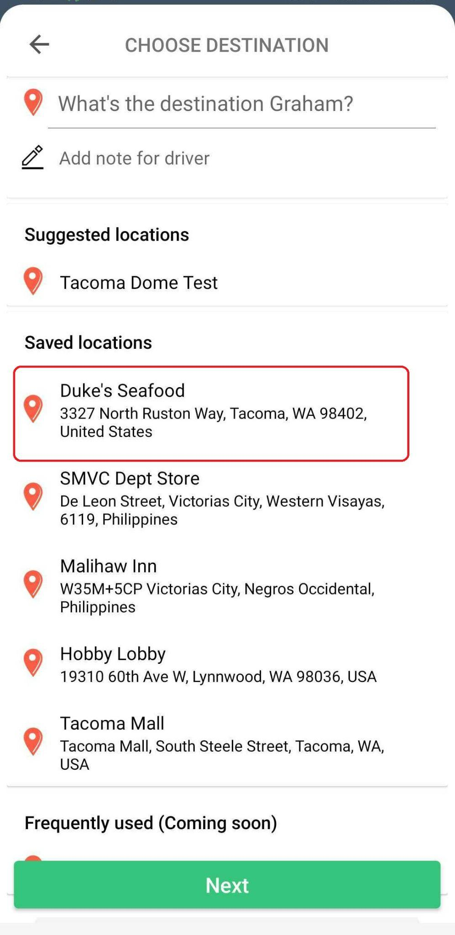

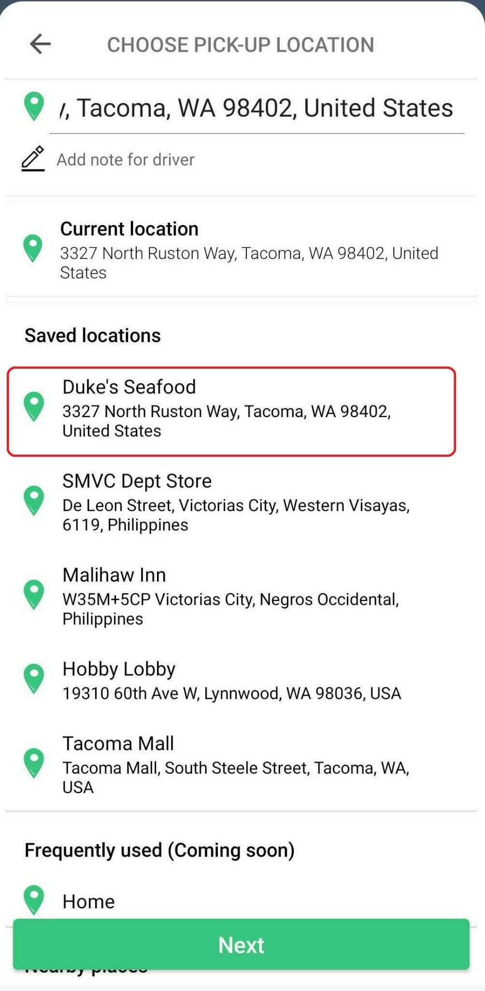

Nearby Places
To make booking of trips easier, the app detects and displays nearby places on the pick-up location page. If the rider’s pick-up location is on the Nearby Places, the rider can simply tap the option and it will automatically be set as the pick-up location.

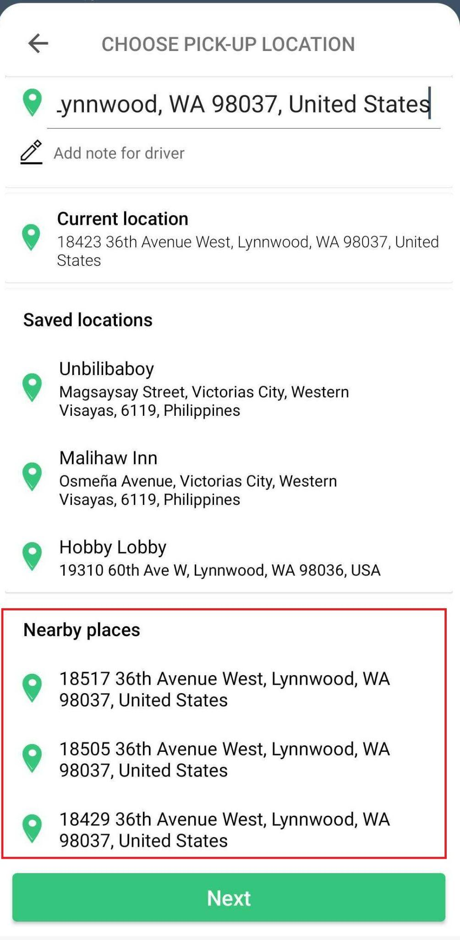

Chat Feature
Goin’s Rider App has a built-in chat function that allows riders to send a chat message to the driver assigned to their trip. This bridges the gap between the rider - driver communication.

To send a chat to your driver, tap ‘Send a message to your driver’.

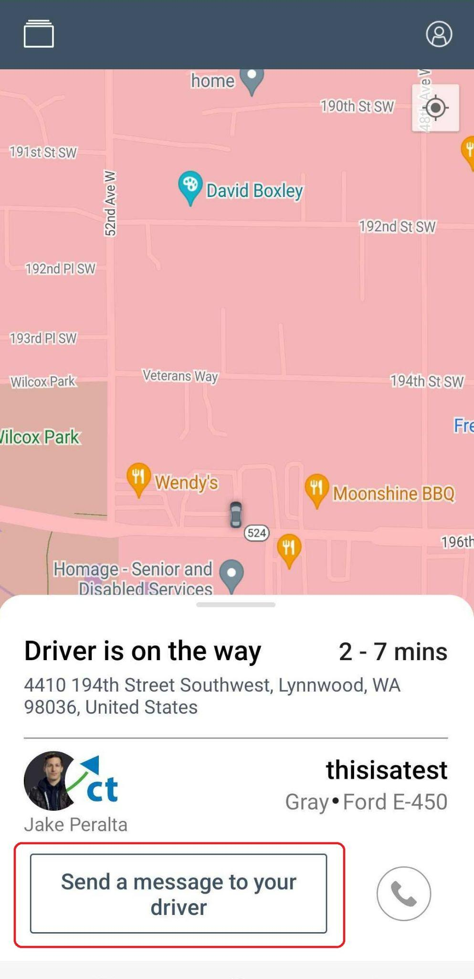

Type your message once the chat screen opens and press send.

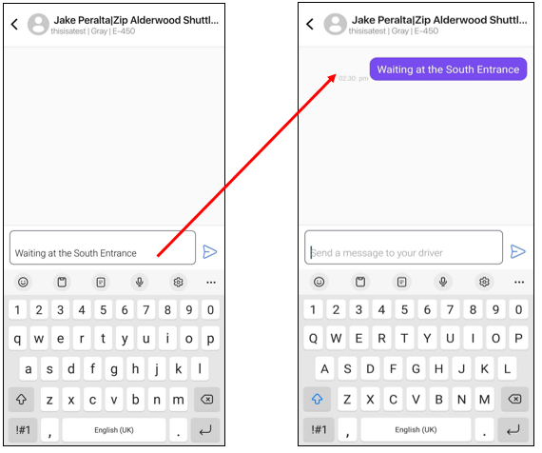

Likewise, the driver can send you a message. When you see a red dot on the top right of the ‘Send a message to your driver’ bar, that means that you have a message from the driver. Tap the ‘Send a message to your driver’ bar to view the message.

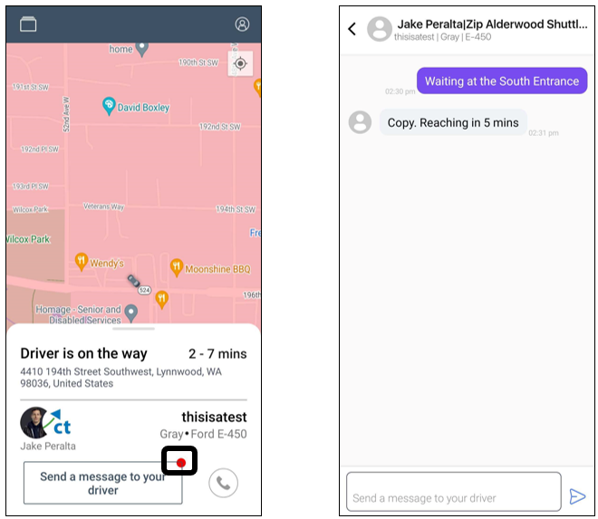

Payment Methods
Goin’ accepts the following payment methods:

- Credit cards
- Debit cards
- Prepaid cards
- ORCA cards
- Cash
- Checks

Notes:
- Electronic payments are processed securely using Stripe.
- Cash or check payments should be turned in to our Service Office. The amount will then be applied to the rider’s Goin’ wallet.

Confirmation Texts

If your request for on-demand or scheduled ride is successful, a confirmation text will be sent to your registered mobile number with your ride details which include the following information.
- Driver Name
- Service Requested
- Status of Trip
- Estimated Arrival
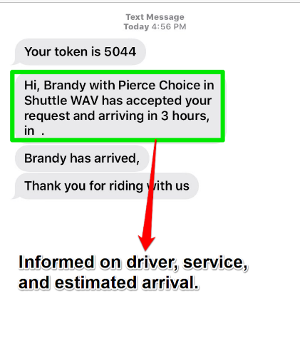
For scheduled rides, you will receive a text message an hour before the scheduled pick-up time with the scheduled date and time, pickup location, and the product that you selected for the ride.

You will receive another text message once the driver has arrived at the pick-up point.
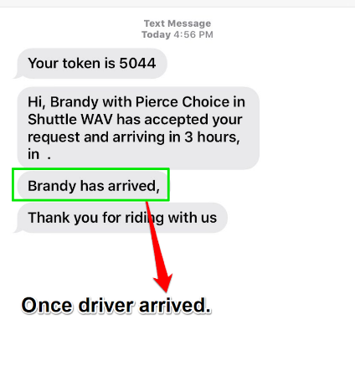
Once the ride is completed, you will receive another text message, after which you can provide feedback.
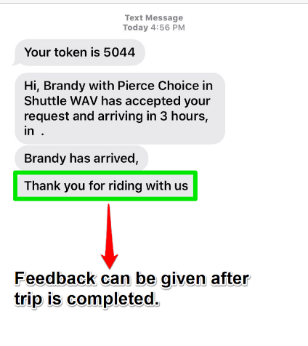

Status Updates

The Goin’ Rider App also shows the current status of your ride. Here are the different status updates.
On-demand Trips
Status | Screen
Looking for a driver - Goin’ is looking for the nearest available driver that matches your request. | 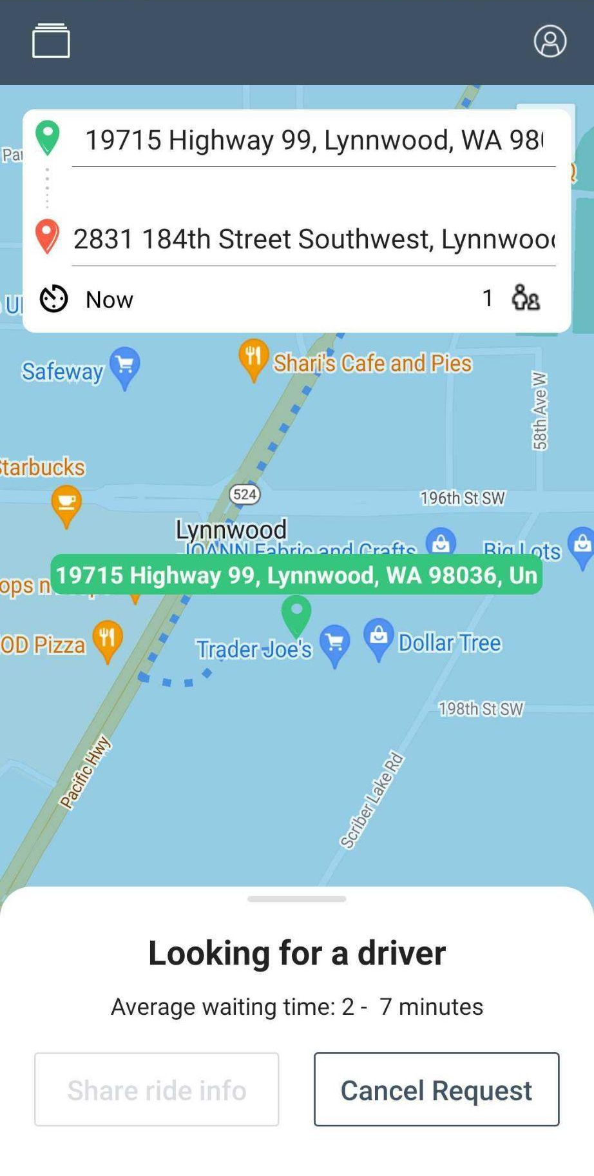
Accepted – driver was matched and accepted the request. | 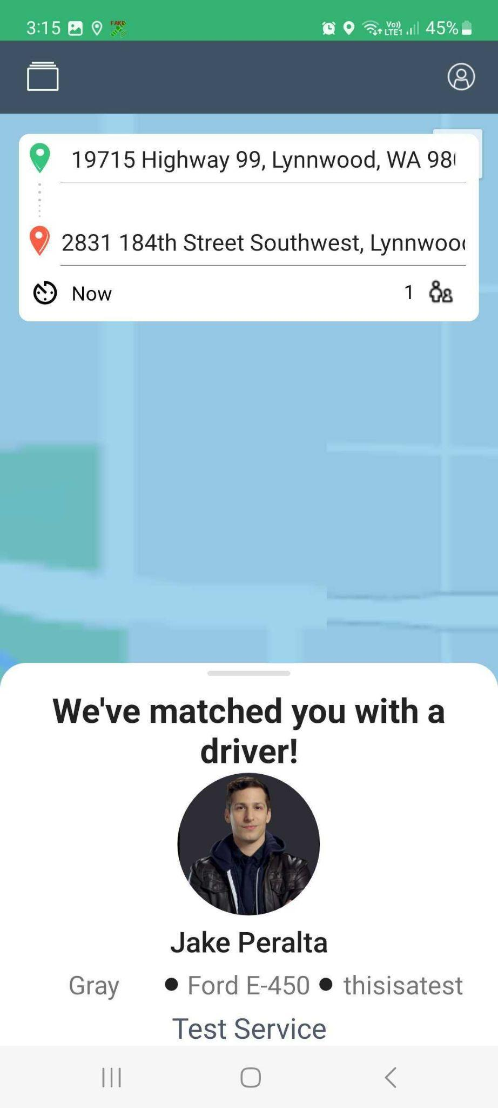
Driver on the way – driver is on the way to the pick-up point | 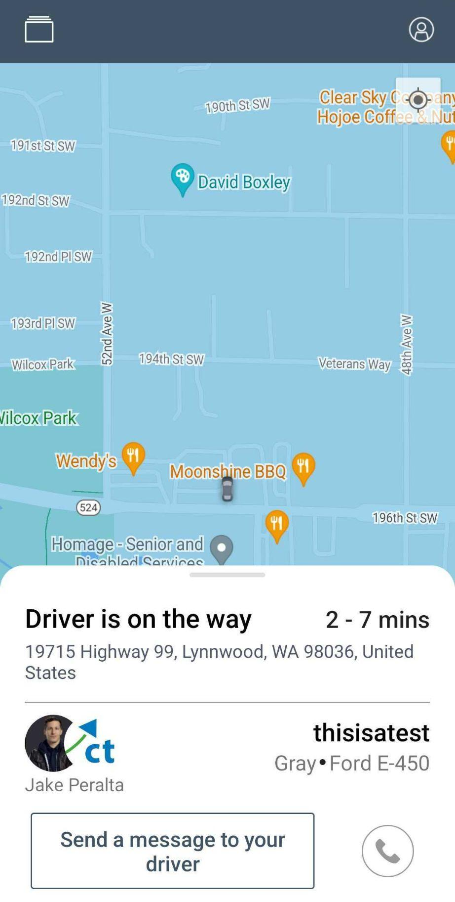
Arrived to pick up – the driver is at the pick-up point, ready to get you. | 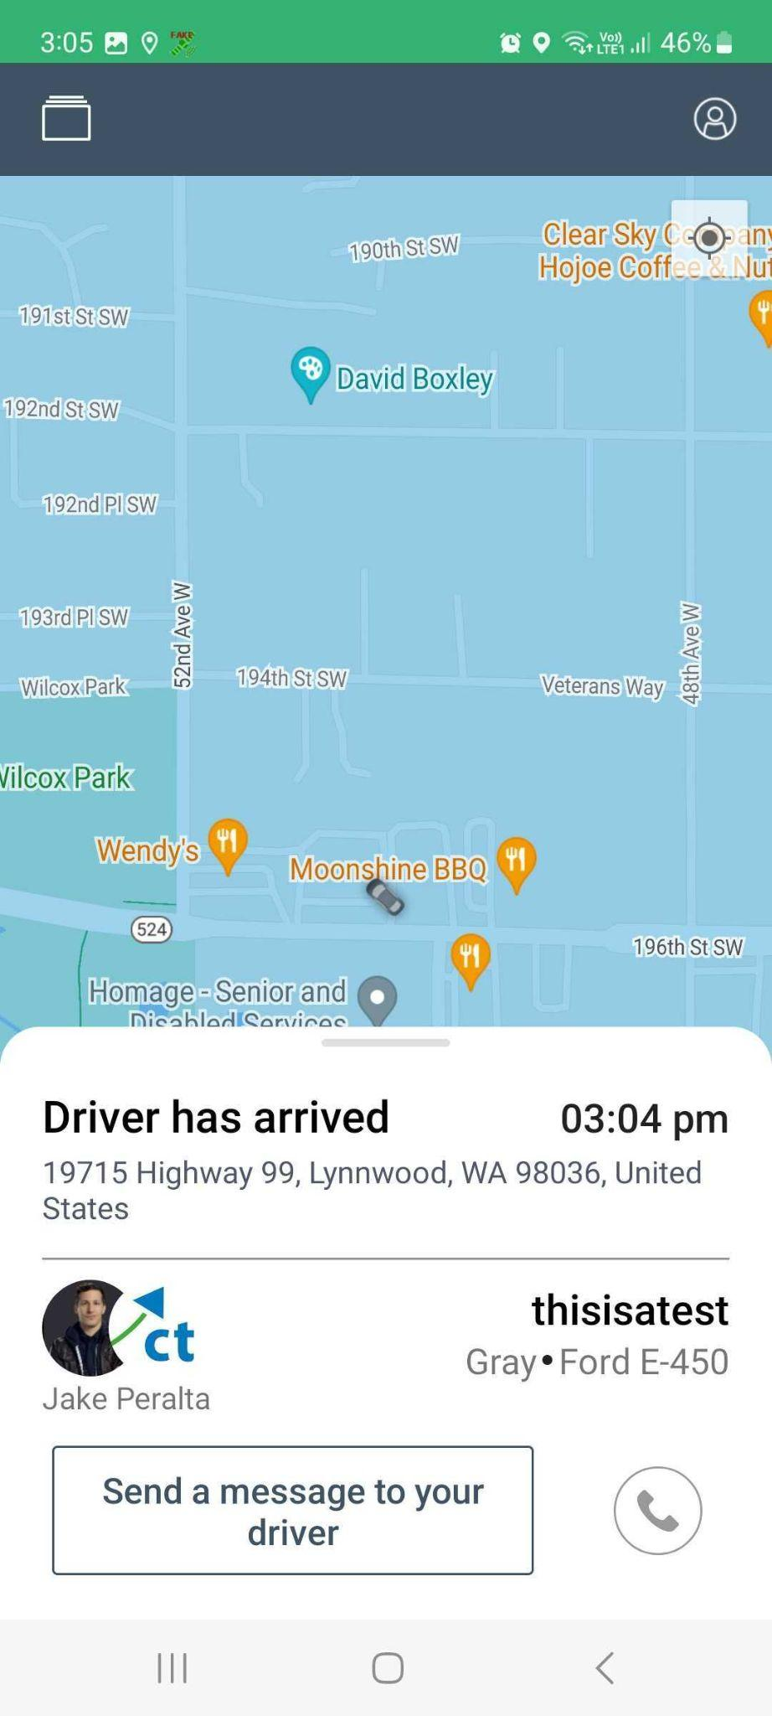
Picked-up – driver has picked you up and you are already inside the vehicle. | 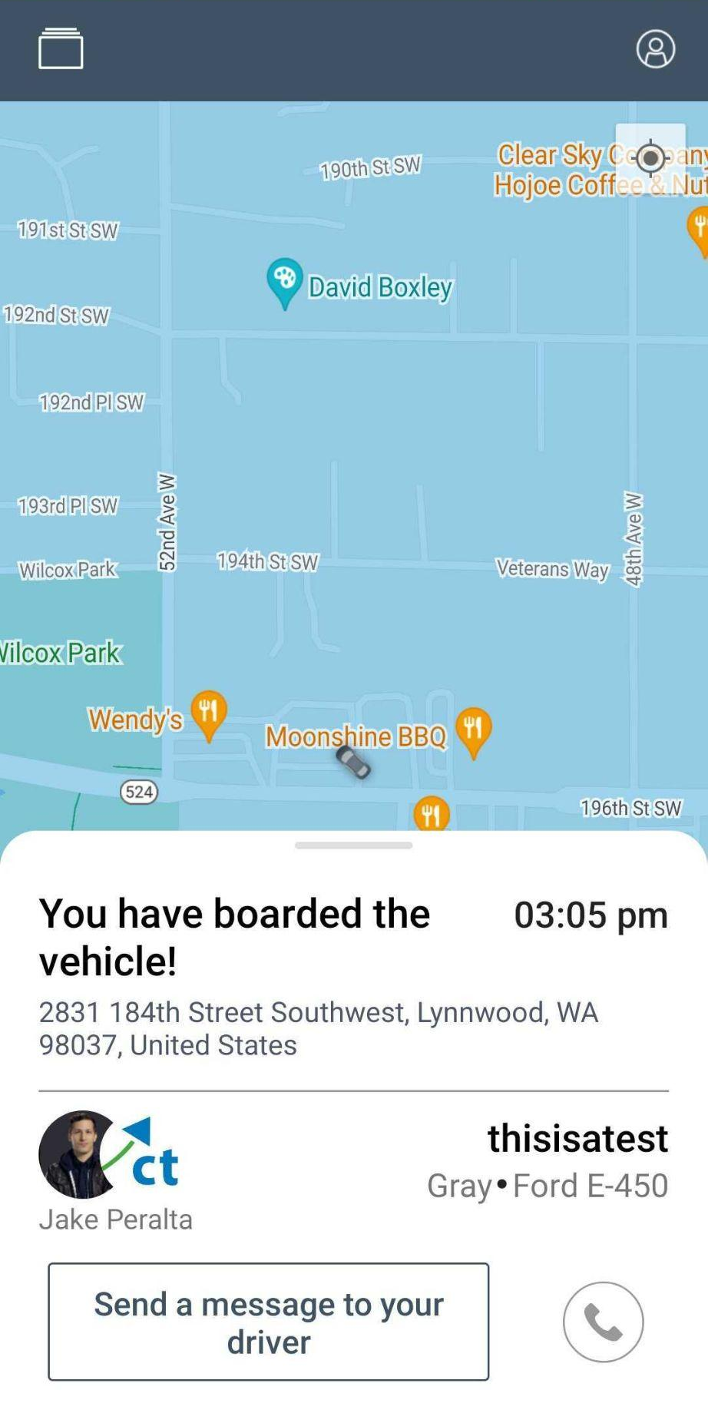
Arrived at drop off – you have arrived at the drop-off location. | 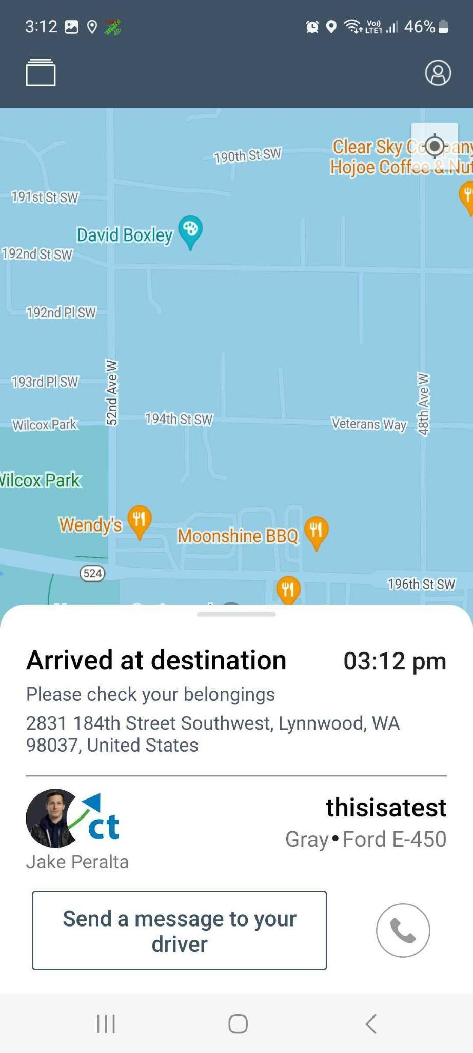

Scheduled Rides
Status | Screen
Schedule Requested – the request has been submitted and waiting to be scheduled by dispatch. | 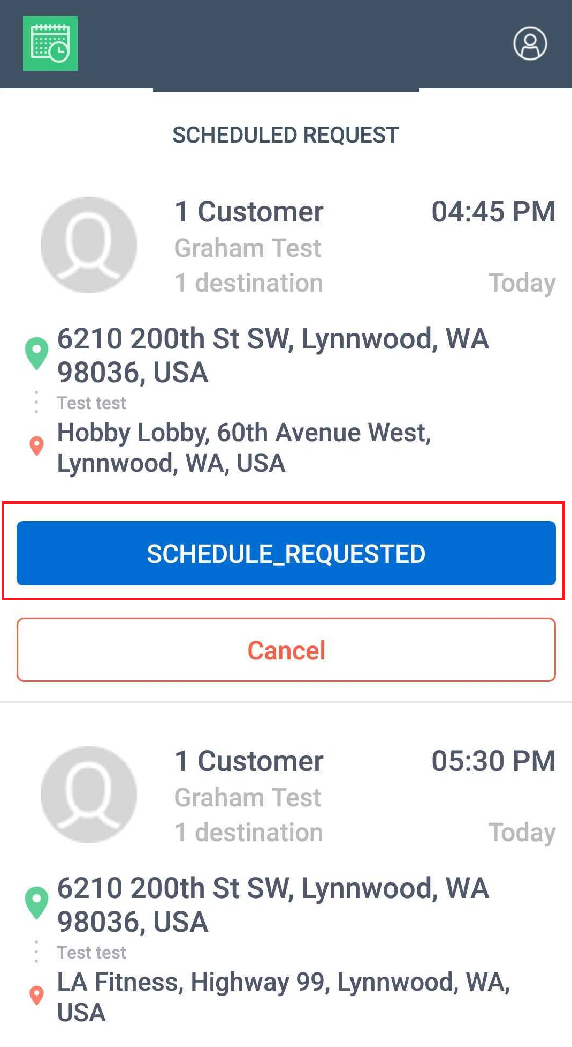
Driving to pick up – the driver that accepted the request is on the way. | 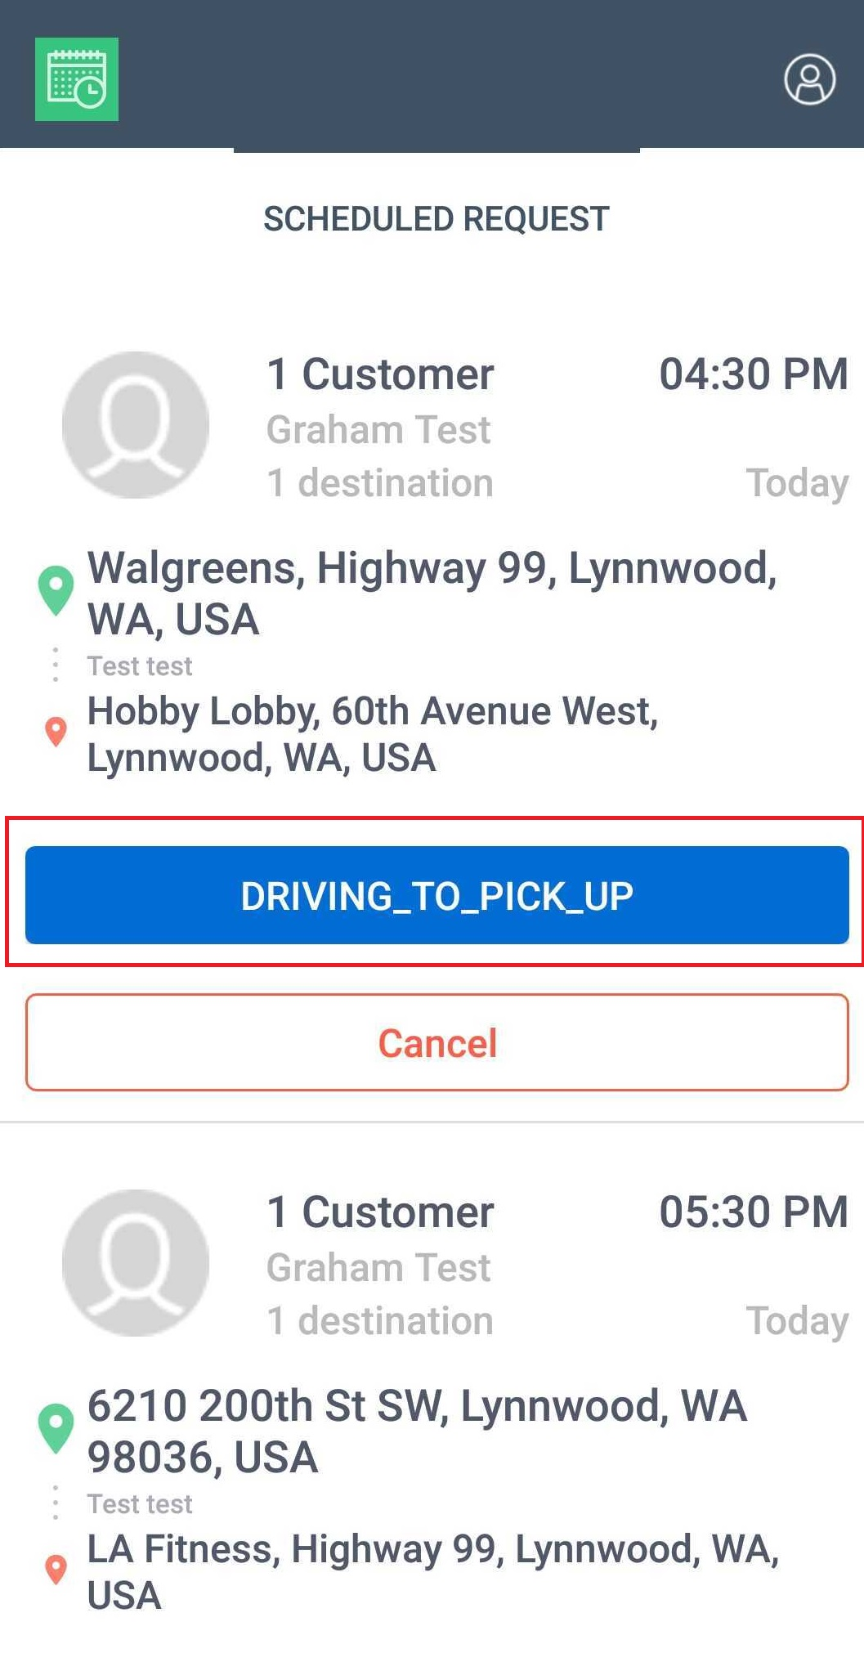
Arrived at pick up – the driver is at the pick-up point, ready to get you. | 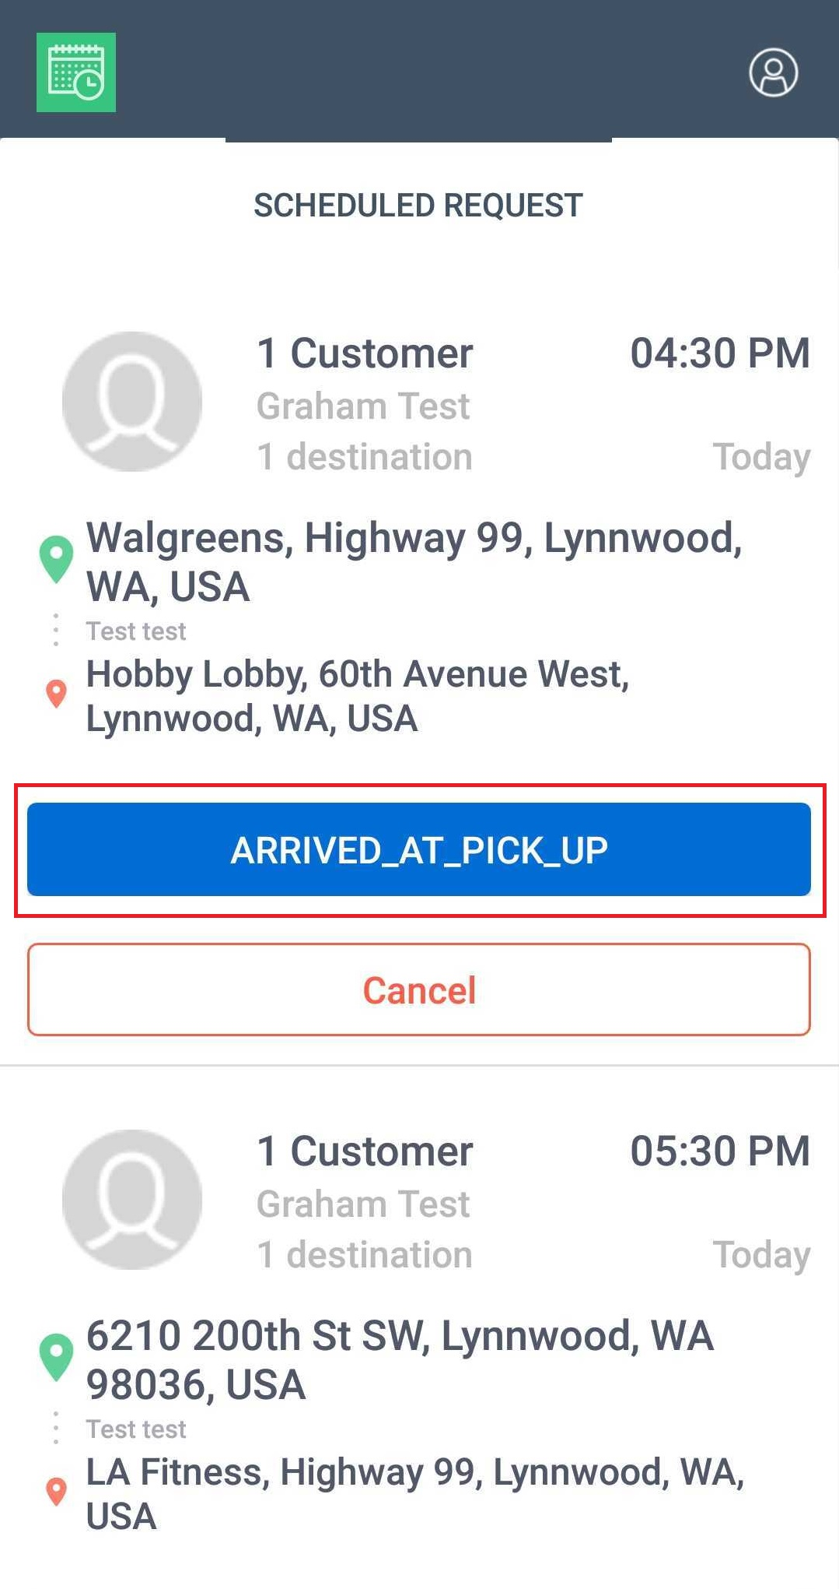
Picked-up – client is already inside the vehicle. | 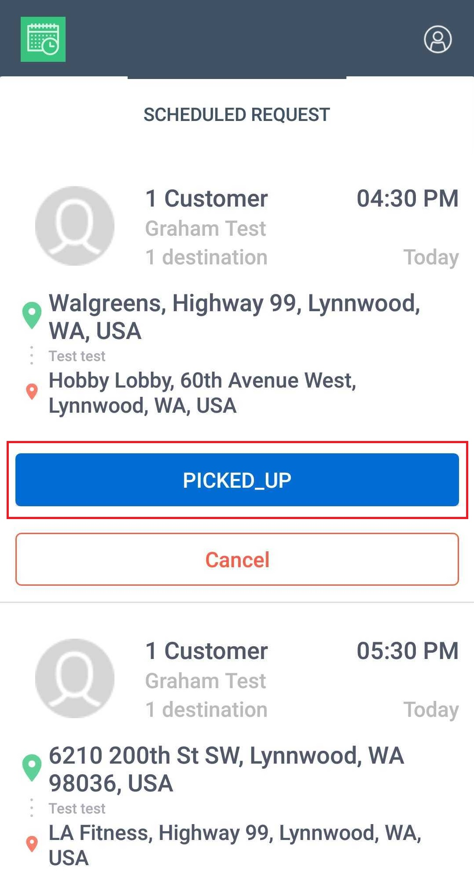
Arrived at drop off – driver and client have reached the destination location. | 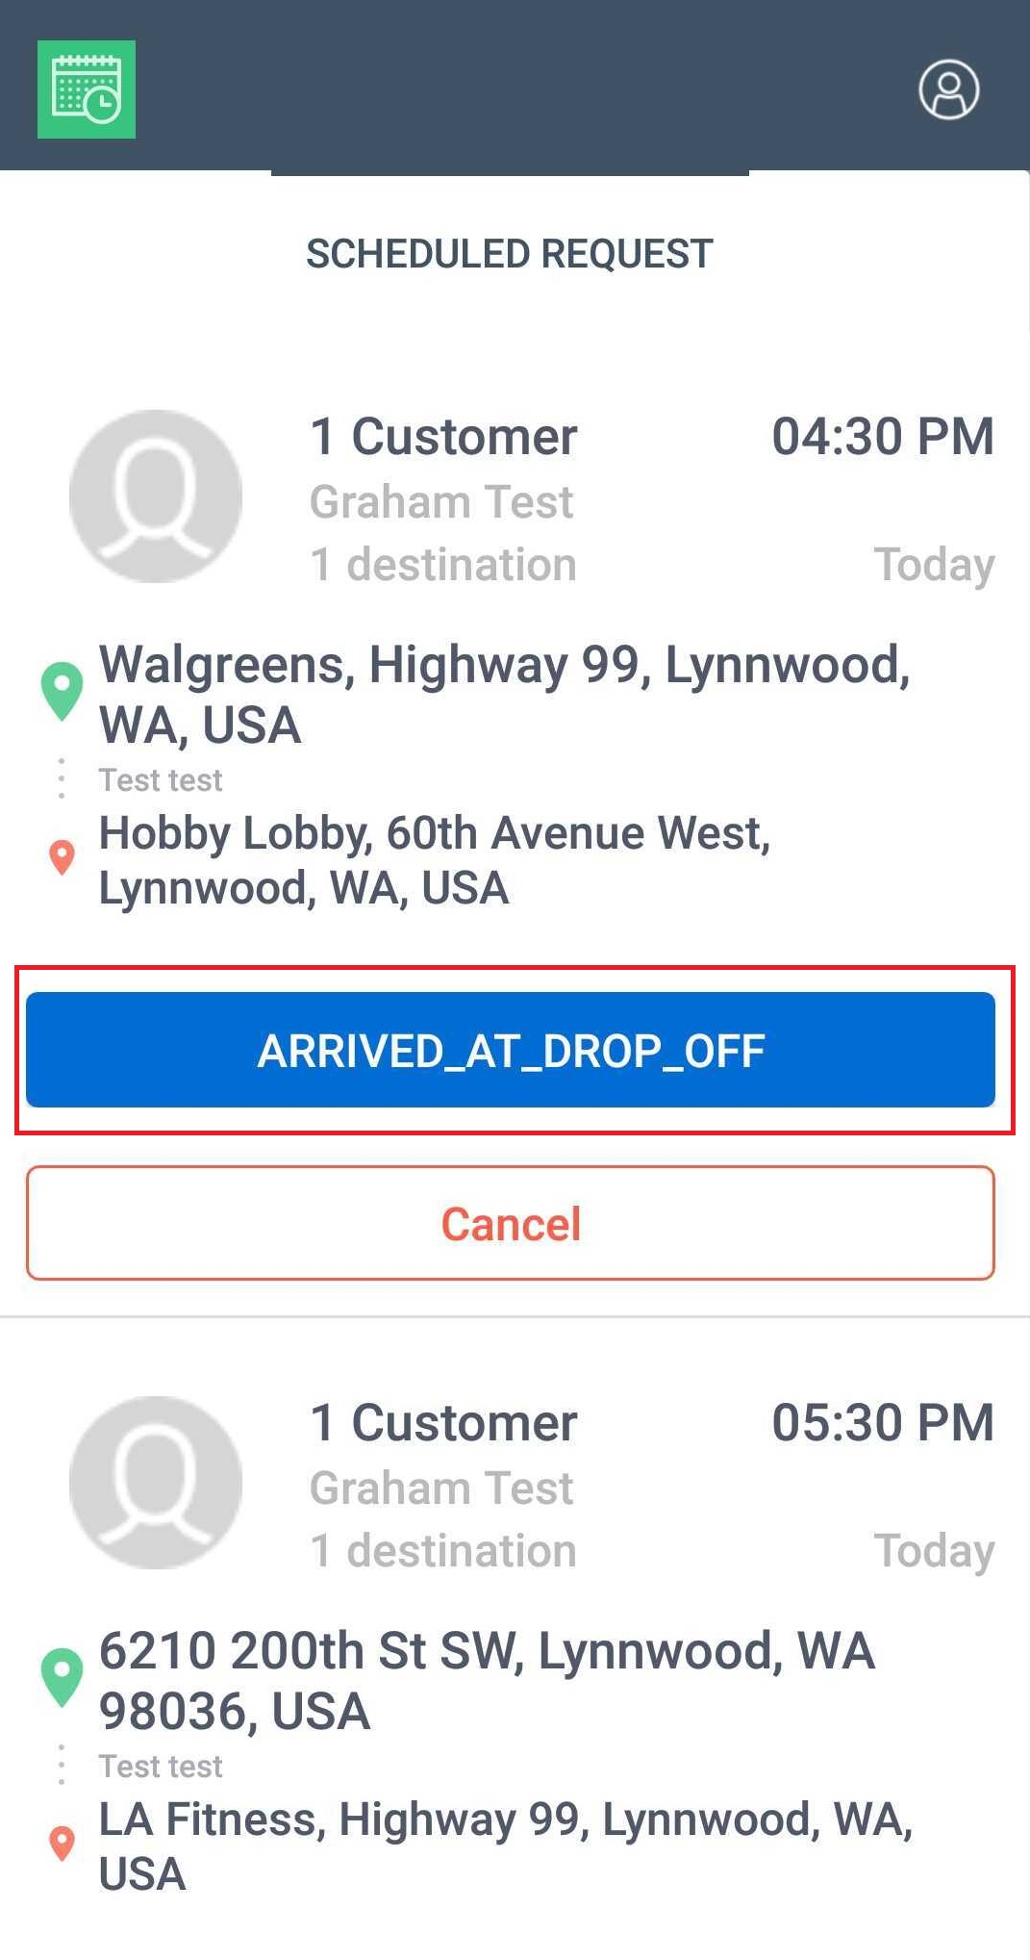
Completed – the Trip is finished. | 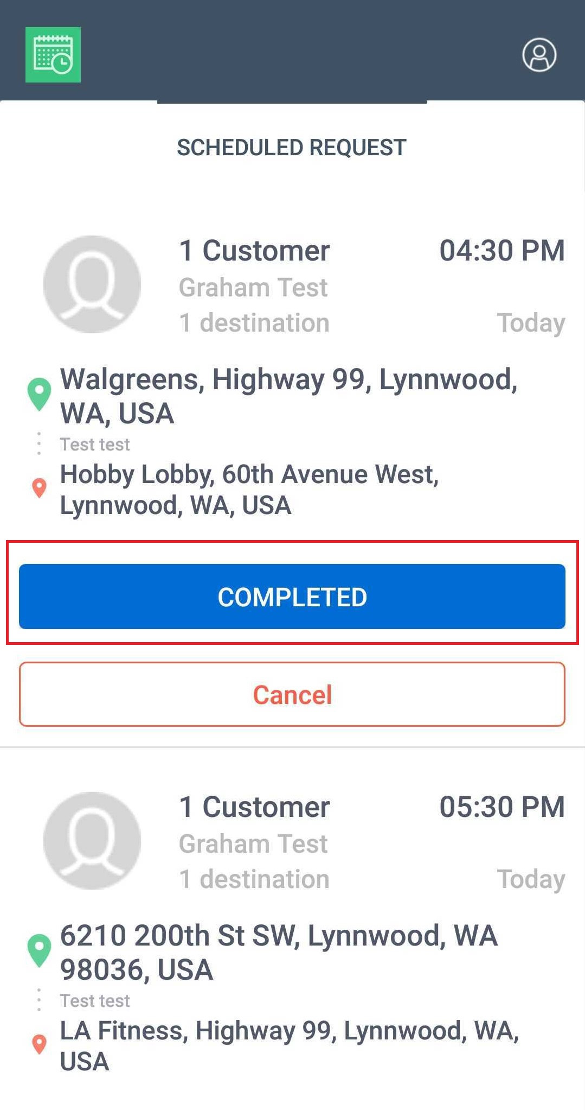

Feedback

Once the ride is completed, you can provide feedback and leave comments about your ride. This will help us improve and make your experience with us better on your future rides.
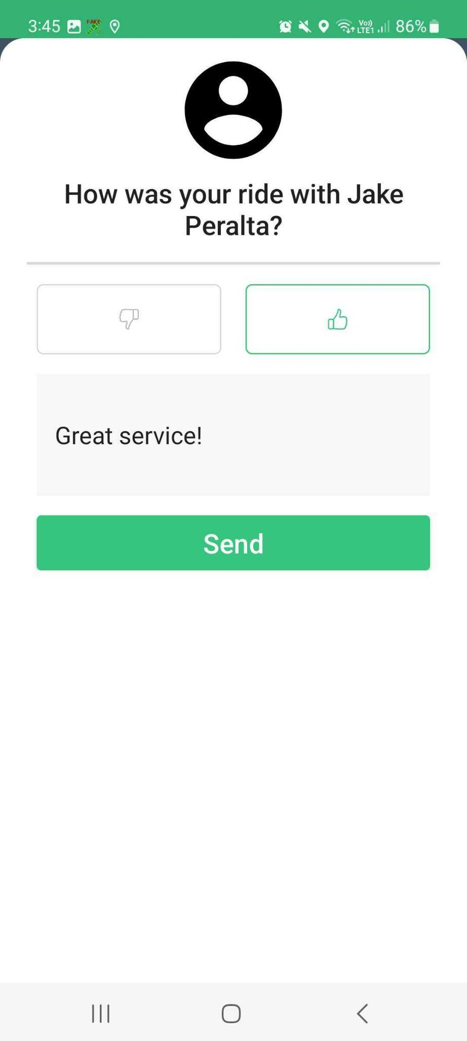

Checking Scheduled Rides

If you have booked multiple scheduled rides, you can check the requests from the Scheduled Rides page. Simply tap the Goin’ logo in the upper left-hand corner of the screen and you will see the scheduled trips that you have recently booked. Rides that were recently completed or cancelled are also displayed on the same page.
This shows requests from the mobile app or that were called in over the phone and entered through the web app.
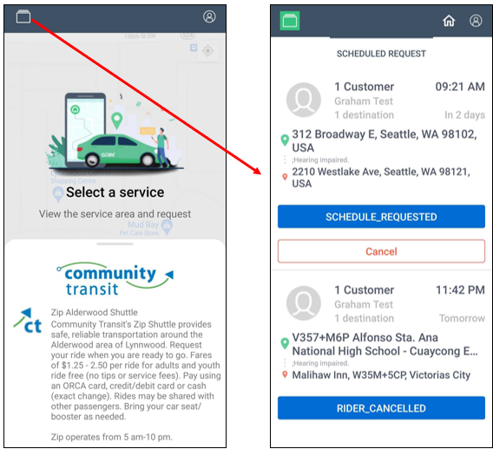

Personal Profile

To access your personal account information, tap the person icon in the upper right-hand corner of the screen. Tap the profile tab to view or edit your profile info which includes your First Name, Last Name, Email, and Notes to Driver. Click Submit after modifying your details so it will be updated in Goin’s system.
You can also check your current account balance from the same page. The Personal Profile page also contains settings for Notification Type, Marketplace, Wallet & Payment. You also have access to our customer support from this page. To return to the home screen, tap the Home button.
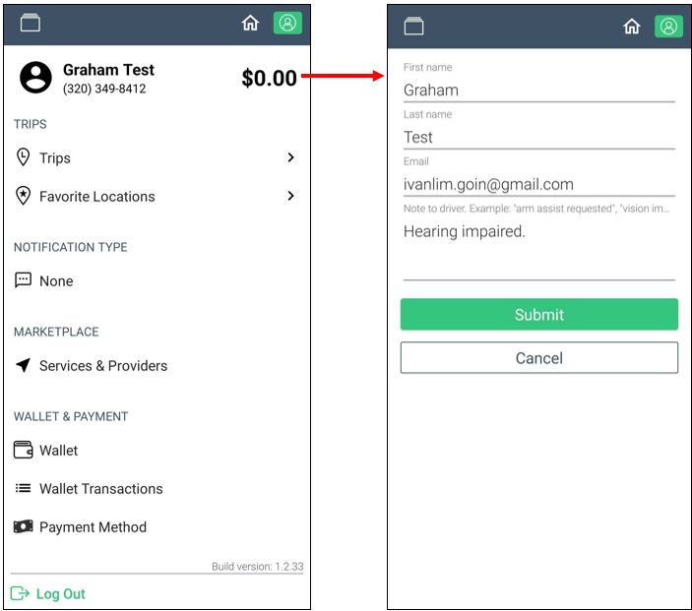

Trip History
Riders can view their entire trip history from the Personal Profile page.
To view the Trip History, tap Trips. The list of all your booked trips will be displayed.
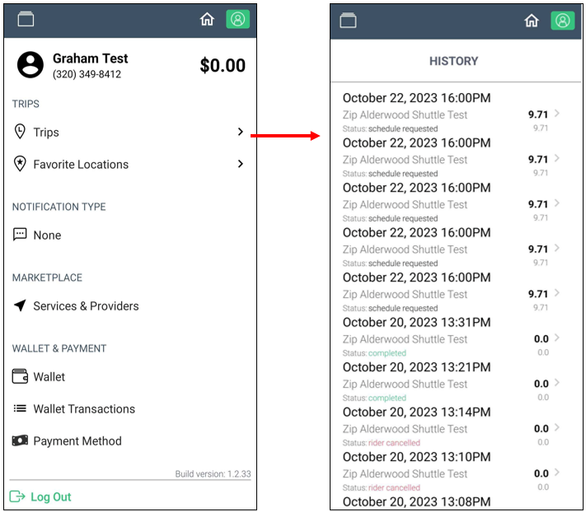

Favorite Locations

Favorite locations are the locations that the riders frequent to. This makes booking easier with just a tap of a finger instead of typing in the address. The rider’s saved locations can be viewed or edited in the Personal Profile page.

To view the saved locations, tap Favorite Locations. The rider can view, add, edit, or delete a saved location from here.

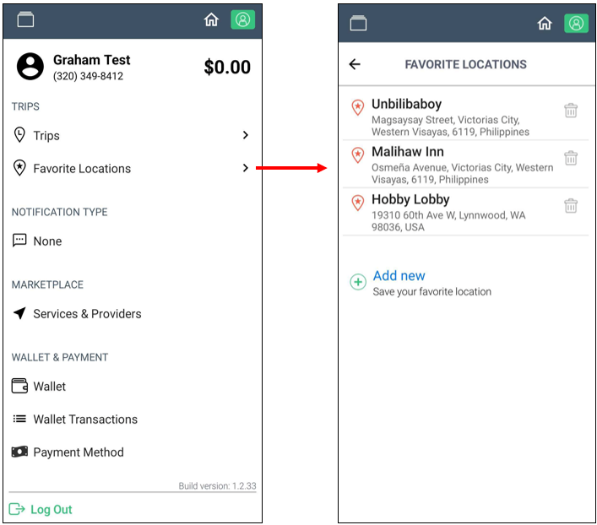

Notification Type
Notifications are sent to each rider once a driver has accepted the trip, arrived at the pick-up location, and for customers to provide feedback once the ride is completed. By default, this is set to ‘Text message’ but you may change it according to your choice
You can change the notification settings from the Personal Profile page. Available notification types are:
- Text message
- Voice = automated voice message
- None

Once you’ve selected a new notification type, tap Save. If you want to use the same notification type, tap Cancel.
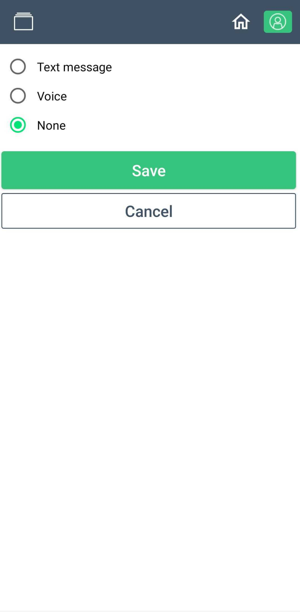

Marketplace
Riders can also view the available services in their area from the Personal Profile page.
To view the available services, scroll down to Marketplace and tap Services & Providers. The list of available services will then be displayed. To join a service, tap the service and tap Join on the next page.
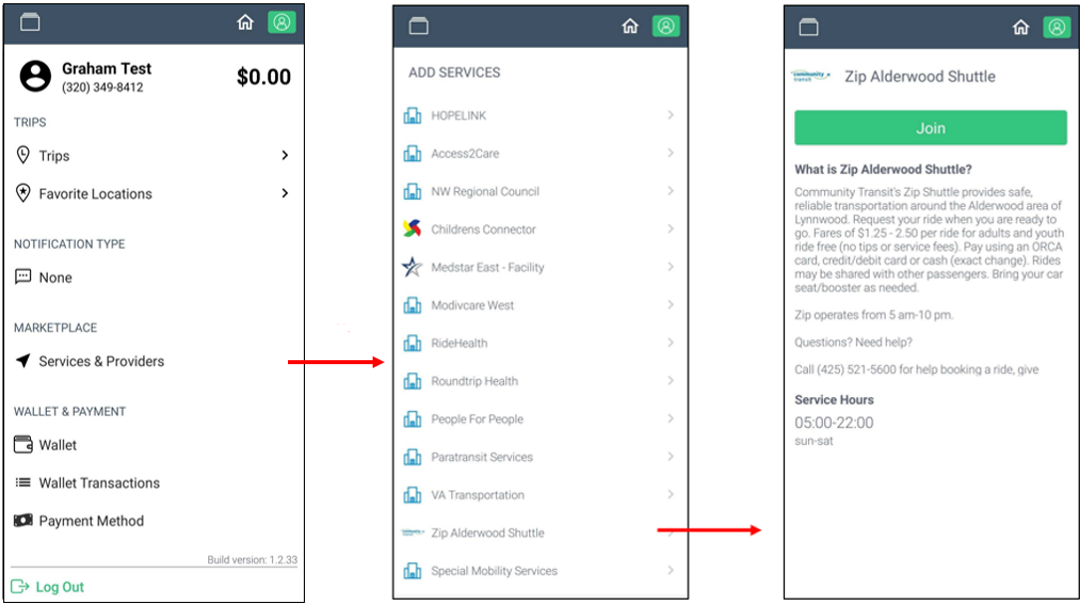

Wallet & Payment
The Wallet and Payment section shows the total balance on your account, the available payment methods, and the payment history.
Adding Payment Methods
You can add payment methods by tapping ‘Add Payment’ and register a credit/debit card.
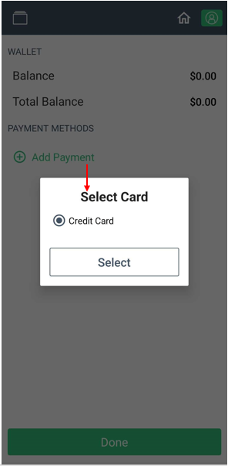
Adding a Credit Card
To add a credit card, fill-out the following information and click Save.
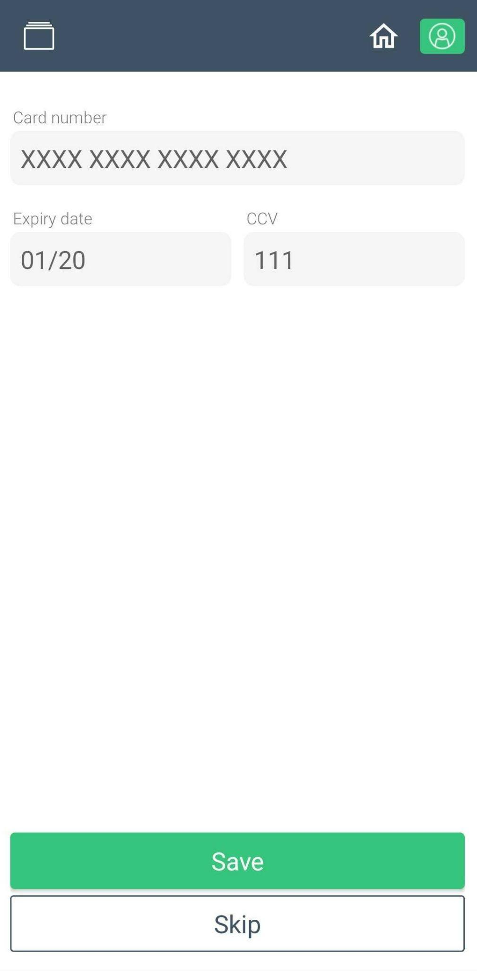
Removing Payment Methods
You can remove the existing payment methods by tapping on the bin icon beside the payment method.
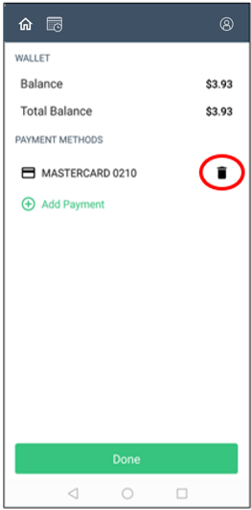
Viewing Payment History
To view the wallet transaction history, tap Wallet Transactions under Wallet on the Personal Profile page. The entire transaction history will be displayed.
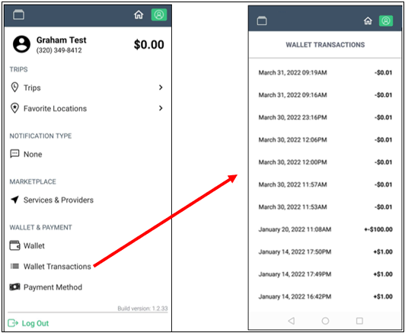

Payment Method

Riders can select the default payment method that will be used to pay for their rides. To select the default option, tap Payment Method below Wallet Transactions, and select the default payment method to be used.

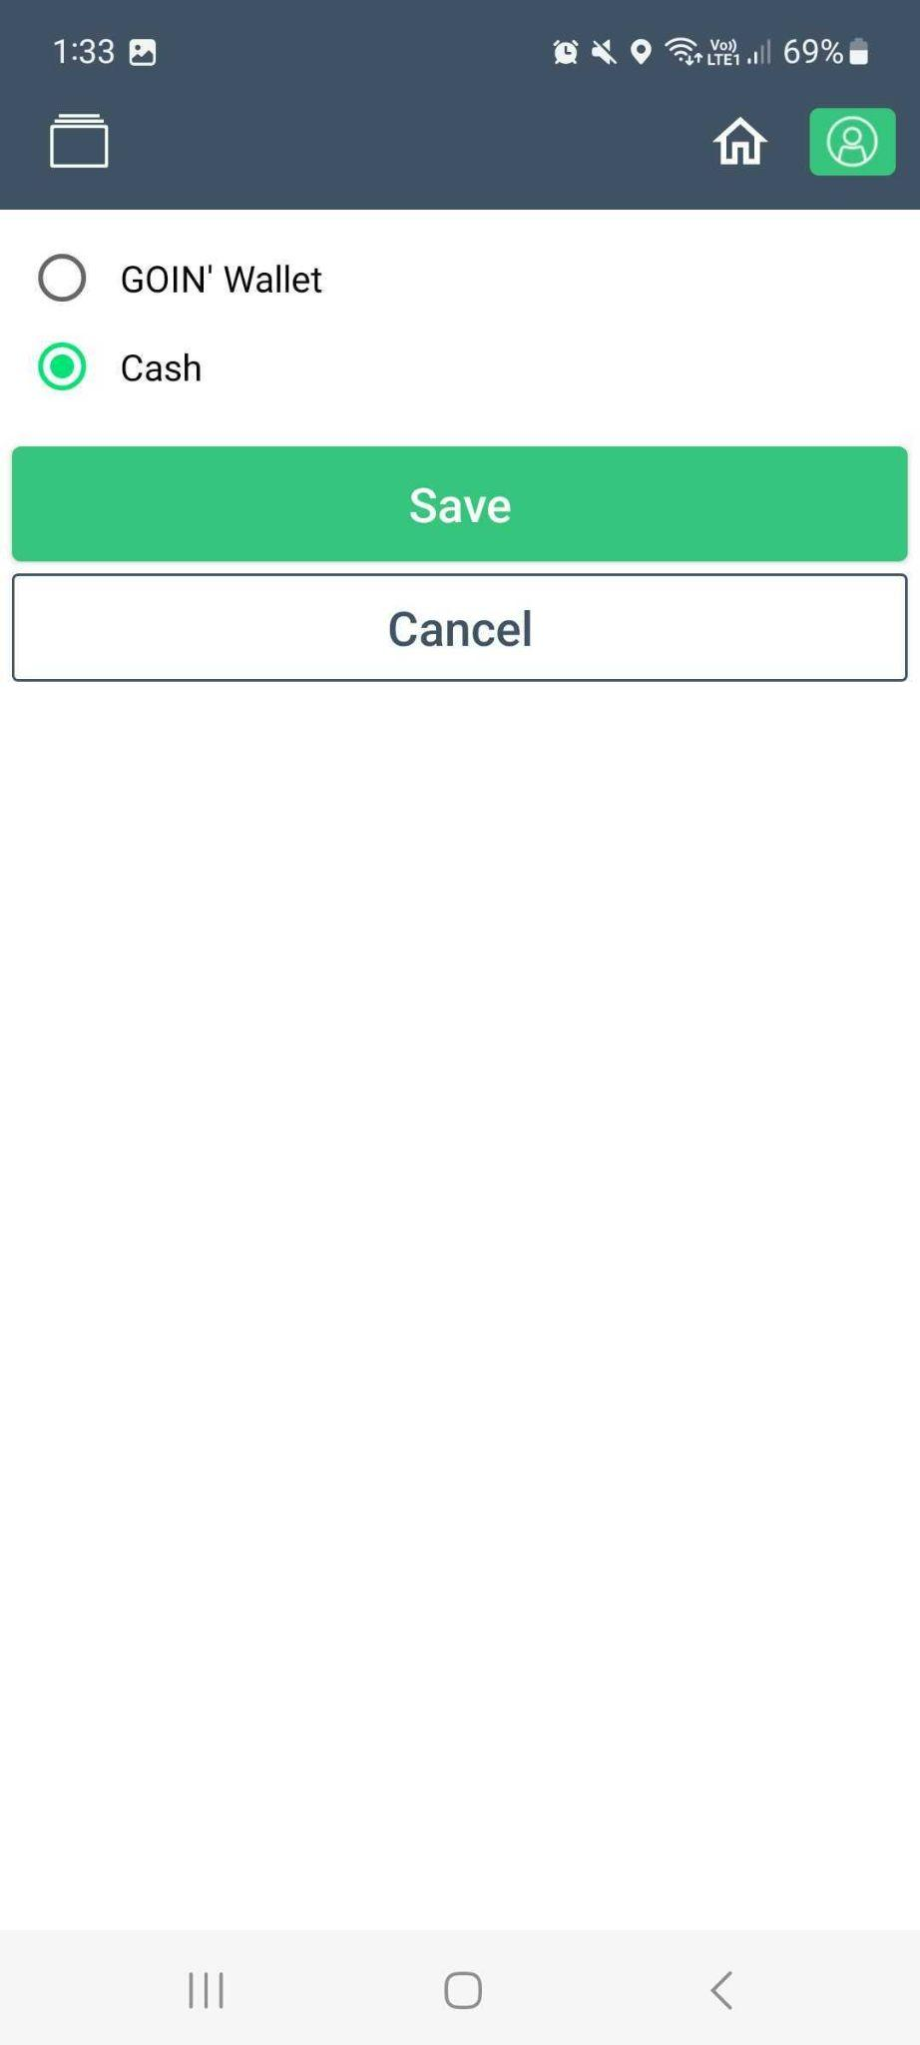

Customer Support
If you have questions, encountered errors not mentioned in this guide, or need help with your account, scroll down to Support and tap Having issue? Chat with us for assistance.
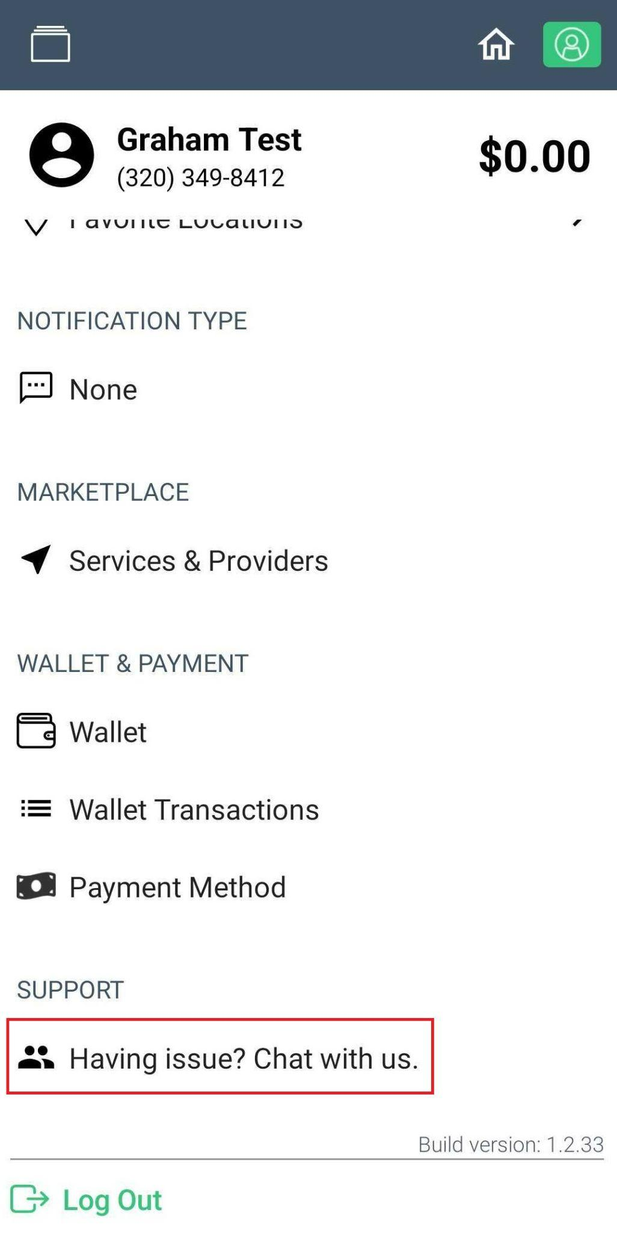

Logging Out
To log-out from the app, access the Personal Profile page and tap Log-out at the bottom-left corner of the screen.
